Digital Game Overview

Game Concept

Initially, the main goal was to develop a game in which the player controls a character that is sliding through a water slide and needs to avoid obstacles, like certain levels of Sonic Forces, a video game from 2017 that I played on Nintendo Switch.

But then I remembered a game mechanic that I thought about some months ago – a mechanic related to colors. Depending on which color the player would collect, he could pass through some obstacles or be hit by them.

To supplement the mechanism shortly described in the last paragraph, I also had the idea to make some sort of points system, based on the obstacles that the player could pass through or could not so the goal was to achieve the end of the game with a certain minimum of points – take the game Detroit: Become Human as an example, when Connor, an android inspector, needs to interrogate other androids without making them feel too much or too less stress.

These are the main characteristics that I wanted to be present and crucial to the game. Later they will be expanded for better understanding.

Synopsis

It was a dreadful day for Nanail. A guy fully in love with his girl, finds out that she is cheating on him!

Heartbroken and desperate to fall asleep, he searches for medicine to make him go to sleep. Until he finds some strange gum-shaped pills that look like candies and gives them a try.

He will regret that.

Hallucinations or not, reality or fantasy, a new battle of survival in a neon-psychedelic world starts now!!

Game loop

So, as the synopsis suggests, the protagonist will face a dreadful hallucination while he is asleep. This world that he discovers seems a happy one with such flashing colours – but it is a deadly one; if he dies in it, he dies in the real world as well! So, in other to avoid that, he needs to survive and reach the end of the hallucination, so that he can wake up. For this, he needs to avoid obstacles and, most importantly, collect special objects that will change his colour, allowing him to go further. Each night, he would take the pills to go to sleep, have hallucinations, and if he survives and wakes up, we do not remember anything; at night, he would take these pills again – and that’s how the game would have different levels.

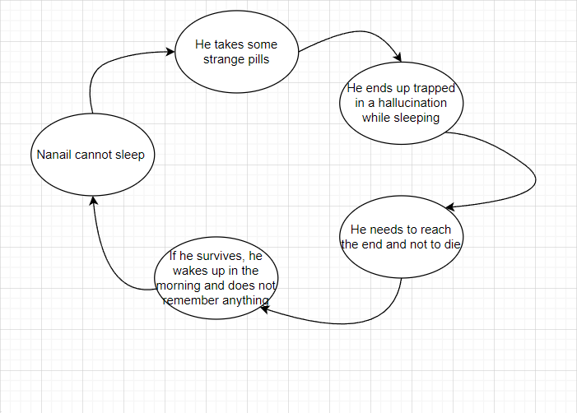

Title Meaning

This game’s main title, Magic Jelly Beans, has two main objectives:

* Present the game’s main plot – a guy that takes drugs and ends up having hallucinations while sleeping;
* Present the game’s main mechanic – these “magic jelly beans” are the collectibles of this game and allow the color system mechanic to exist.

The word “magic” is a double reference – “magic” because they allow the protagonist to “imagine” things and enter into a new “magic” world, and is linked to “magic mushrooms”, an existent drug known for creating hallucinations as a side-effect of taking them.

The words “jelly beans” are a reference to candies with a bean shape.

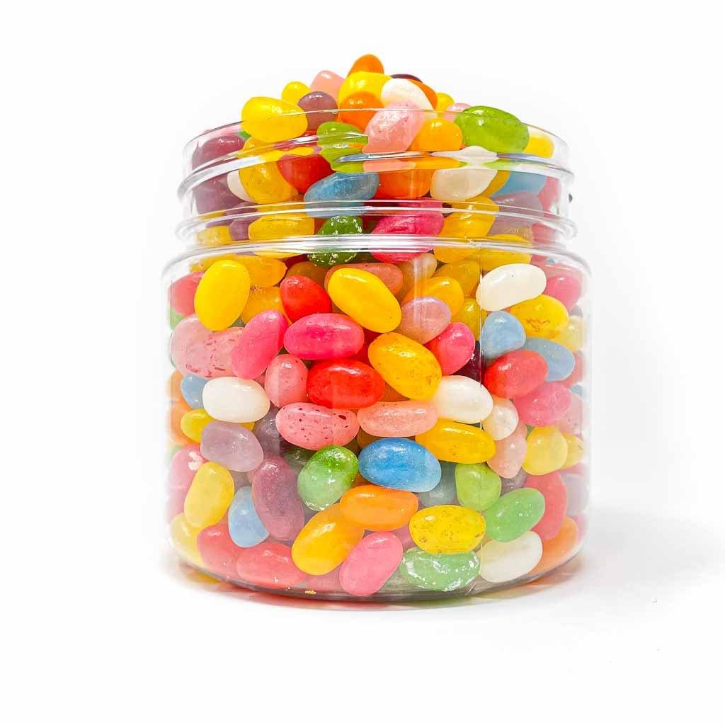

Protagonist Name Meaning

Nanail is a variation of the name “Daniel”, which has Hebrew origins and is related to a prophet cited in the Bible that can interpret dreams. It also contains the Portuguese word “nana”, which is a verb form from the slang verb “nanar”, which means “to sleep”. <https://momlovesbest.com/names-that-mean-dream>

Target Audience

The target audience for this game should be people older than 16 years old. The main reasons for this target audience are the presence of sexual content, which can be mild or explicit, and an ironic mild reference to illegal drugs (the magic jelly beans that the protagonist takes). This decision was based on the PEGI 16 description.

Game Genre

The genre for this video game will be action (game) since it consists of a fast-paced game that requires quick reflexes from the player. More specifically, this game will be an auto-run platformer, a subgenre of platform games in which the character is forced to run forward and needs to stay alive for as long as possible while avoiding obstacles or other challenges that come their way. The opposite of the endless runner games, where the game is infinite, this game would consist of multiple levels, each one focusing on different mechanics and challenges, while the main goal remains the same – to survive and reach the end of each level. Basically – each night, Nanail takes the pills to sleep and then he gets the deadly hallucinations and needs to survive.

The perspective adopted for this game is the third person one, the common one used on this type of games (such as Boson X) that also allows the player to have more control about whether it collides or not with a certain object – it’s more visual than it could be with a first-person camera, at least, because you see the character moving.

Game Engine

Since this game was developed by only one person in a small amount of time, the only two options that were considered were Unity and Unreal Engine.

Firstly, only Unity was considered to be the chosen game engine, mostly because of the already previously acquired knowledge taken by me. Unity is also well suited to developing 3D games and has a huge community always available to help others. The online resources are endless too. So, for all this, adding to the fact that I have such a limited time to make this game and would not have time to learn to work with a new game engine, the decision to pick Unity seemed very predictable.

But then I realized there was some news online about the Unity company merging with IronSource, a company that developed a malware installer. Starting to think my game development would be compromised, I thought about switching to Unreal Engine.

Unreal is one of the most popular game engines nowadays, often used to make AAA video games. Although you could need to write code in C++, which can be hard since it’s a low-level programming language, Unreal also offers the possibility to write code visually in the editor itself, using the Blueprint functionality. Very promising.

In the end, it doesn’t even matter. I ended up picking Unity again, because of my previous knowledge.

Unique Selling Points

* Explore an “out-of-the-box” mechanic that is easy to understand – colors!
* Play an unusual platform game – with a premise that involves cheating and horns!
* Experience a platform game in which every decision you make can make the difference between reaching or not the end!
* Submerge into a neon-colorful-psych world of hallucinations!
* A game where you could end up losing so that you can win!

Game Play and Game Mechanics

Conceptual Map / User interface

At the beginning of this project’s development, it was defined that this game would have three menu interfaces – a main menu, a pause menu, and a menu to select the level that will be played. But shortly after, and even because of the teacher’s advice that it would be better to only make a good unique level, this last menu was immediately dropped.

For both main menu and pause menu, I wanted a simplistic design based on glowing wireframes – as I had as inspiration the game *SuperHyperCube (2008)*.

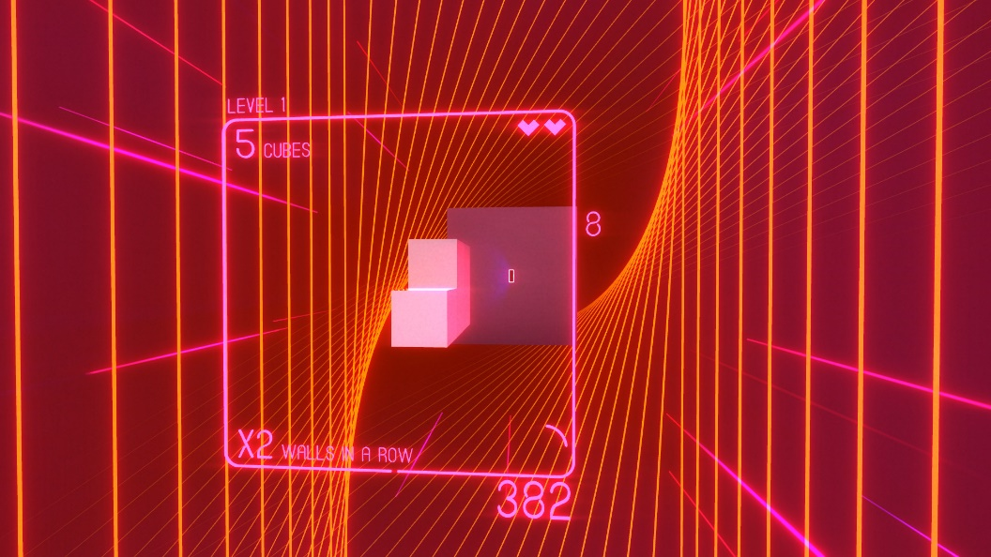

Example of user interface

I started looking for more examples for my mental mood board, and I reached out to the following ones.

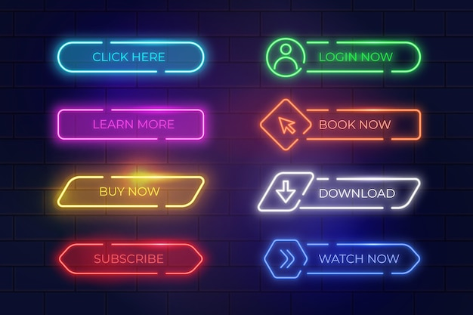

This one would be good as example to make the buttons.

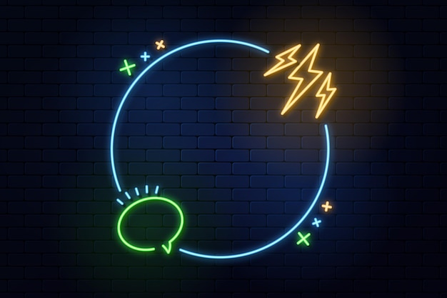

This one remembered that I could make the main menu’s outline with only a simple wireframe line, and then apply some empty spaces to fill them with the collectibles!

Main Menu

I first made a sketch based on my inspirations and my main goal – to make a wireframe-based menu.

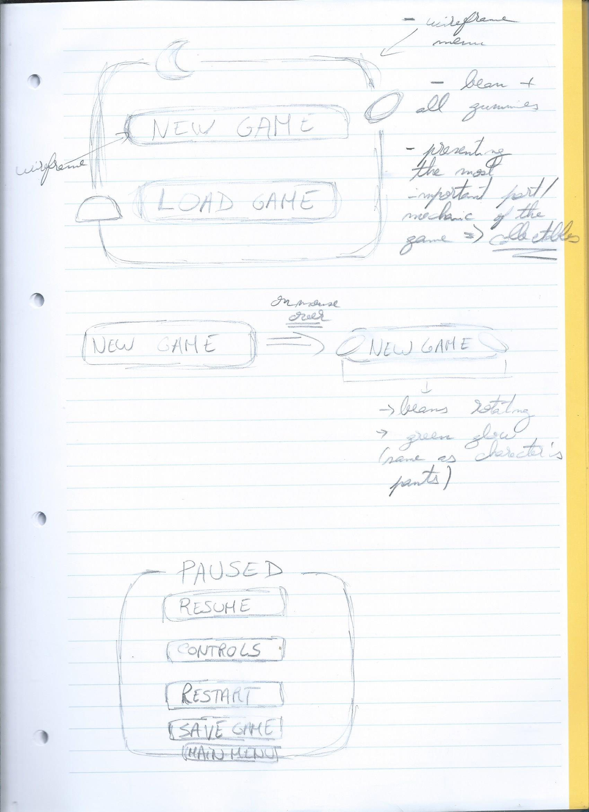

Fig. X – Main menu sketch that was done by hand. I wanted to explain that this menu would have an outline with some holes where would be some collectibles (I decided not to add the bean, since it is not used as a collectible during the game) that would be rotating as well, to give more dynamism to the scene. And since I removed the beans, I decided to add them differently – by hovering the buttons! Initially, when the mouse would hover a section, two beans, one for each side would appear and start rotating. But in the end, I did not make the rotation for them.

Satisfied with the general outcome, I started modeling the main menu in Blender.

Later, because of the need of colliders to make my buttons work (since I did not use any canvas or button from Unity), I also added the main character to the main menu, this time only with a swimming default animation from the Mixamo website.

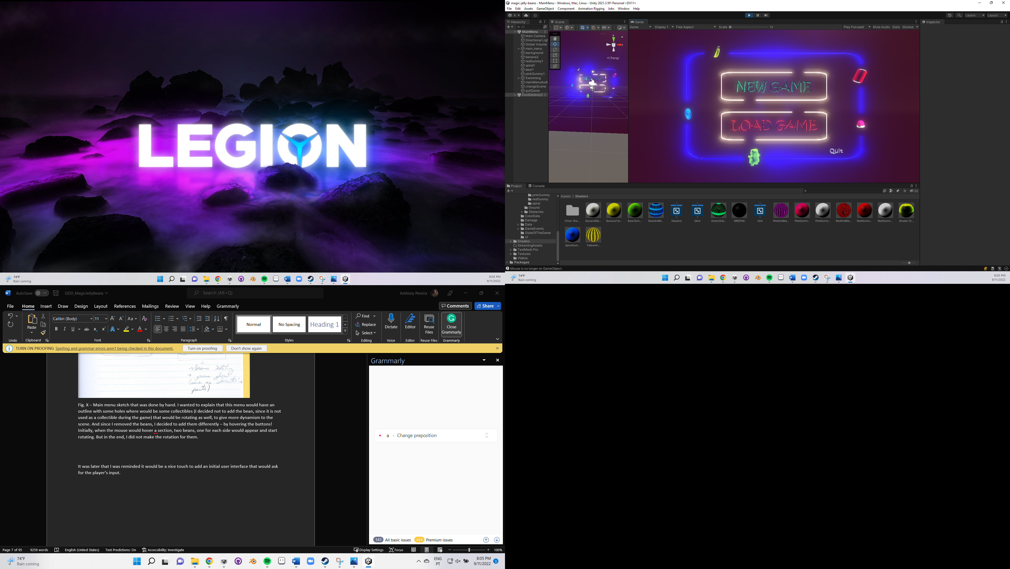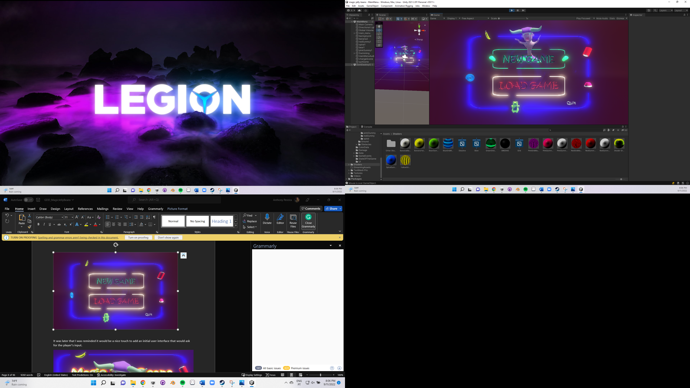

It was later that I was reminded it would be a nice touch to add an initial user interface that would ask for the player’s input.

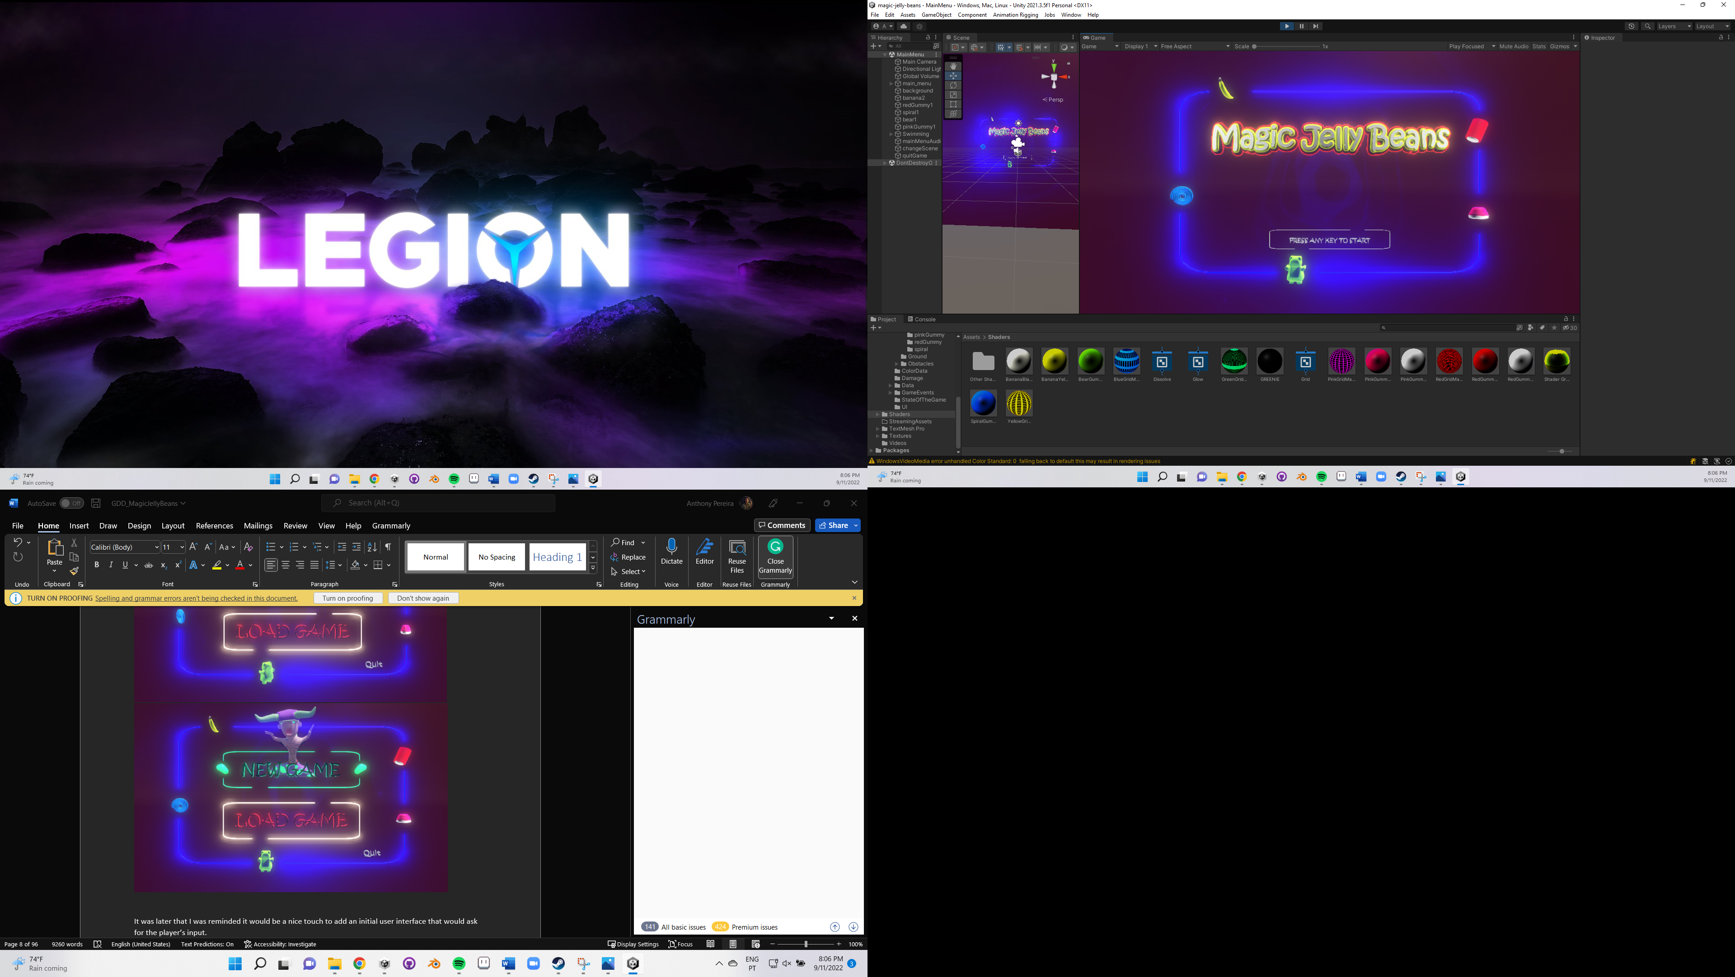

Pause Menu

I applied this same principle to the pause menu, while simplifying some things – because the pause menu should be poorer than the main user interface.



I initially sought only one outline hole at the top of the menu, to fill with the word PAUSED, and then five buttons for five functionalities – resume game, check controls, restart, save game, and return to the main menu. I ended up eliminating the controls one because I thought it could be a little bit useless, and because of lack of time since I needed to make a whole new menu for their display. Also, it seemed like too many buttons for me.

Afterward, I checked that my main menu outline had five holes, one for each collectible in the game. And the word “PAUSE” has also five letters! Why not split them all?

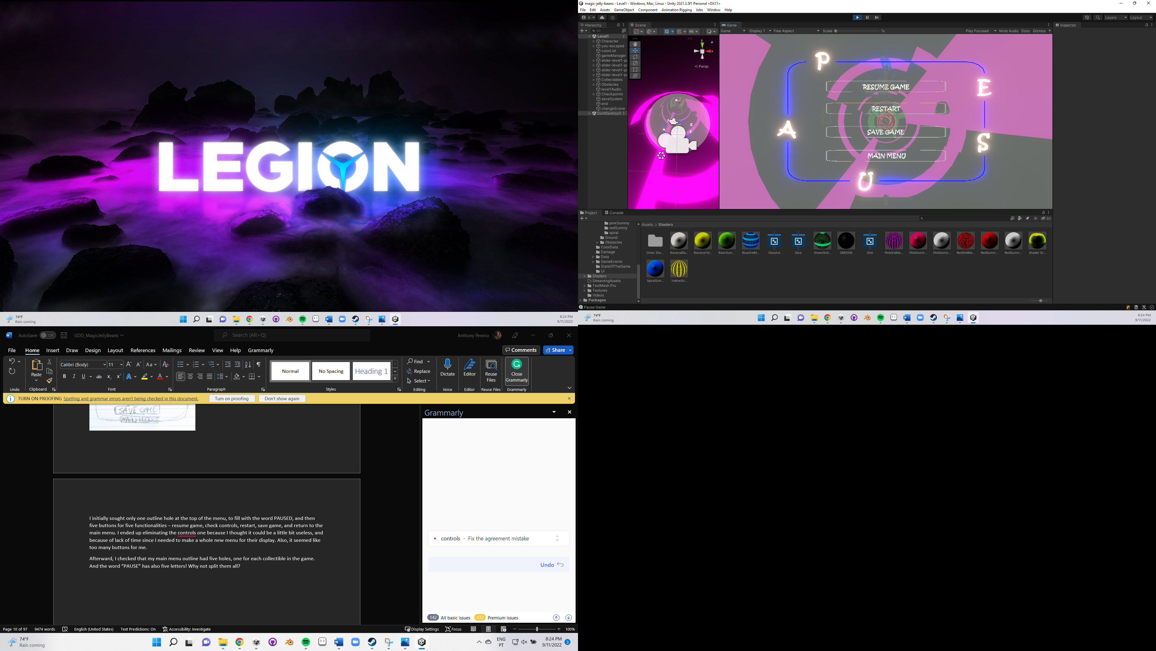

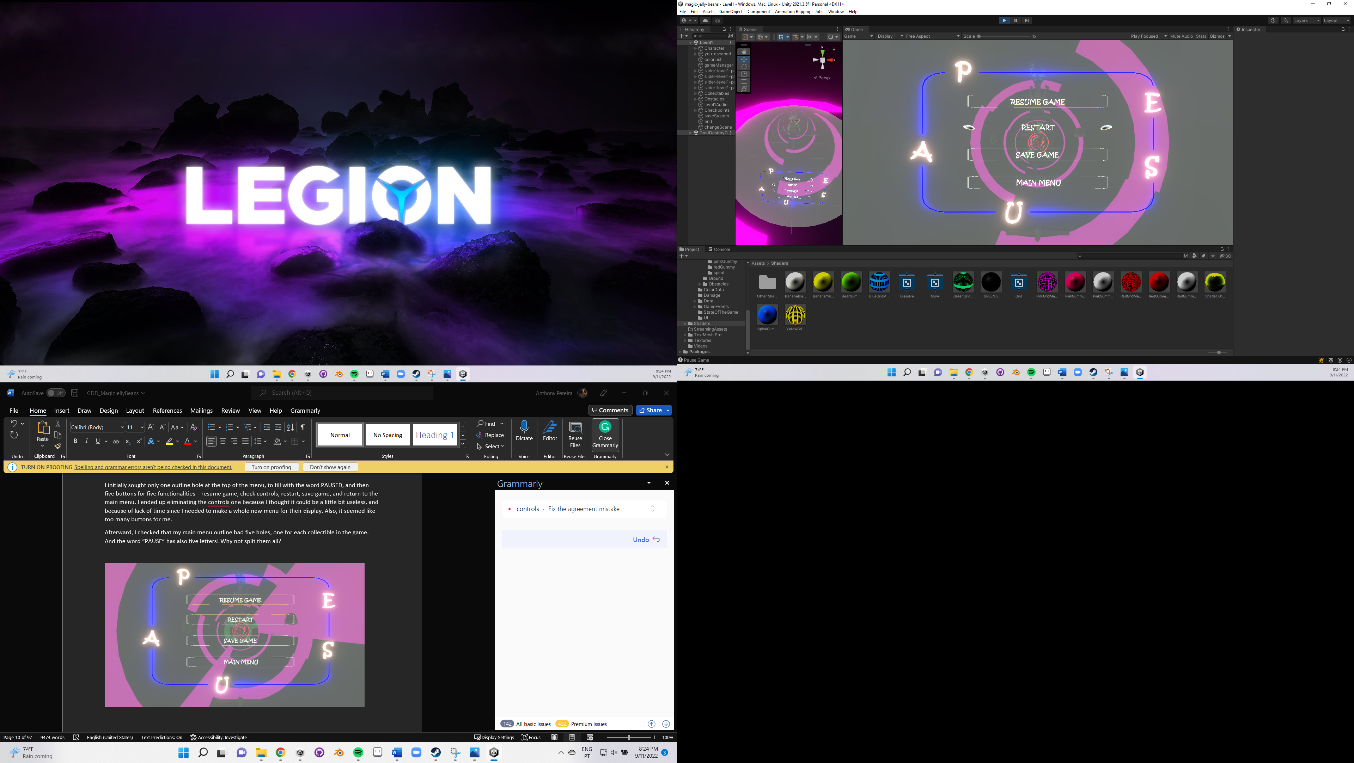

Heads-up display

The only HUD that is part of this game is the stress level bar, which objective is to tell the player if the actual character's stress level is close enough to be out of bounds.

Since originally I sought something similar to what happens in Detroit: Become Human, I first made some sketches to think of the ideal interface to display the stress level information.

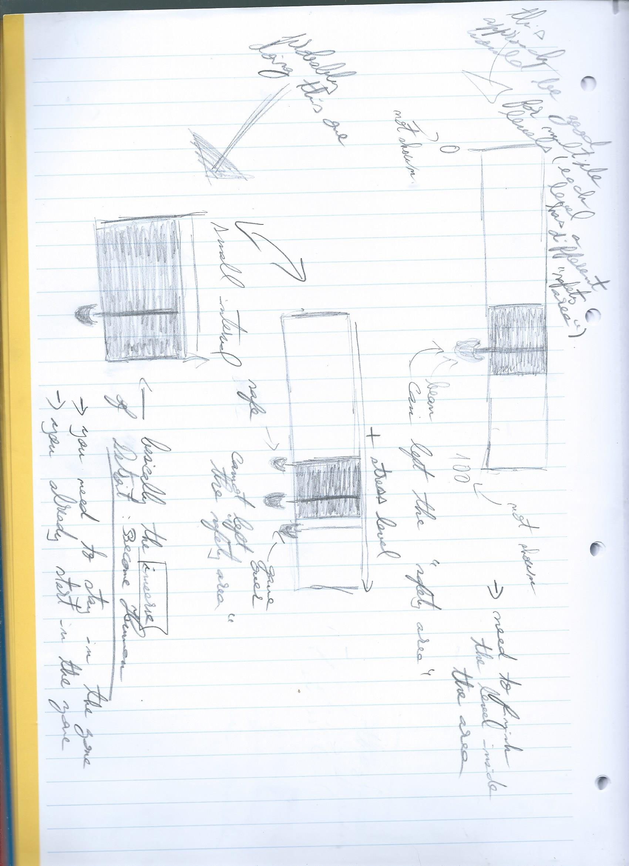

I was confused about adopting one of the previously shown approaches – was it better to assign a small stress level range so that the player needed to end the level inside of it (let’s take an example: the character’s stress level could fluctuate between 0 and 100, but at the end of the level, it needed to be between 30 and 50) or only obligate the character to have a stress level between 0 and 100 (or a smaller interval, like 0 and 50)? The first approach seemed interesting at first, but then I thought that it could be frustrating to the player to believe that he made everything right and then be unable to finish the level and know about it just at the end of it. Not only this, but the first approach also would obligate me to have such small damage values associated with each obstacle in my head, so that the stress level would never drastically change. At least that’s what I thought. Anyway, I dropped it and stuck to the second approach that I started to like. And figure it with me – it makes sense; if the character is colliding with too many obstacles, he starts to panic too much, so his stress level increases; but if he does everything right, he becomes even more immersive in the side effects of the drug he has taken and the hallucination itself, which is also harmful.

After this, I kicked off thinking which way would be better – adding the bean below the rectangle or in front of it. Also, would it be better that the player would die if the bean goes completely out of range or this arrives when it passes just a little bit?

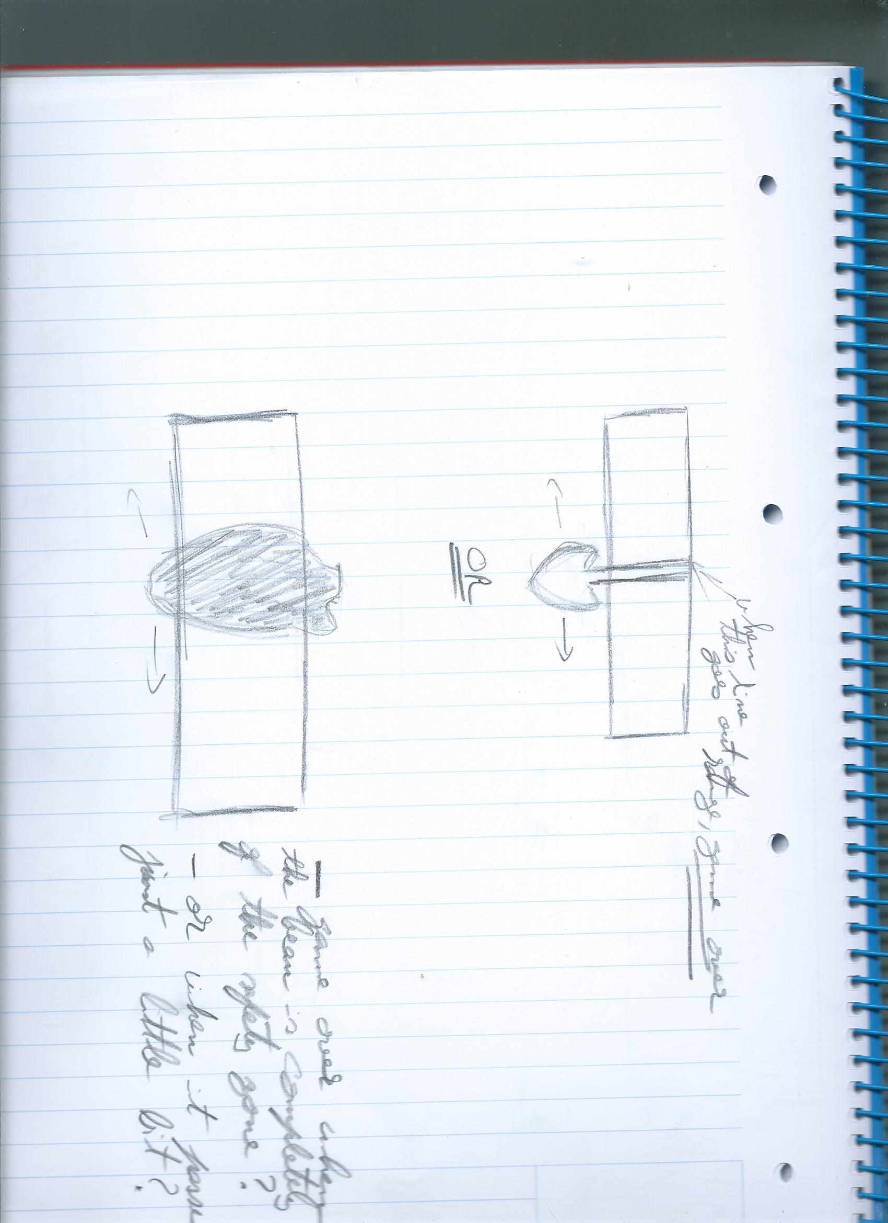

I decided on the second approach in both – the bean in front of the bar and assigned that the player would die even if the bean just surpasses a small amount.

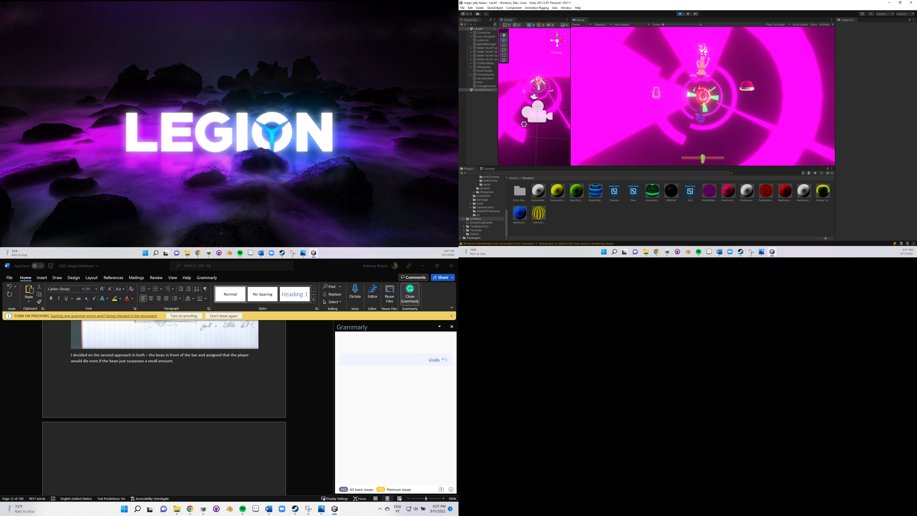

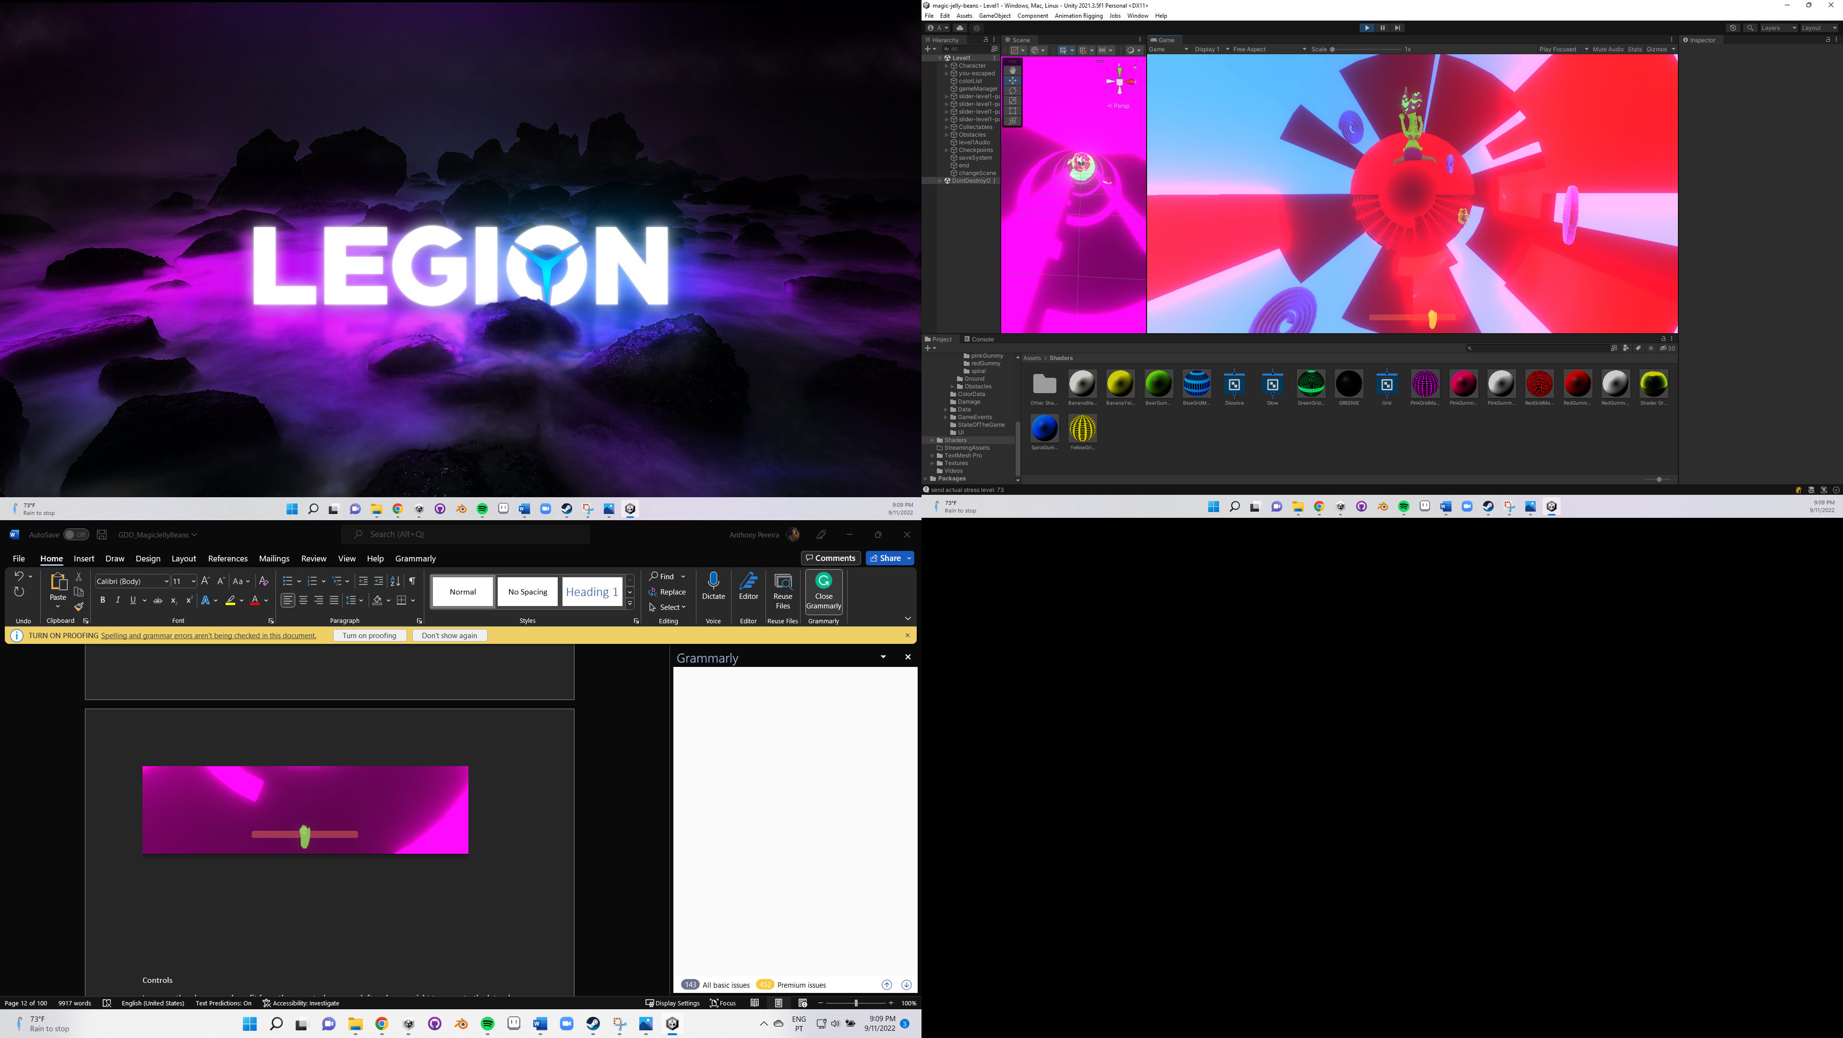

Controls

In-game, the player may benefit from three controls – arrow left and arrow right to move to the laterals, and the arrow up for dashing (which has an associated cooldown).

The user can also take advantage of the Esc key to go to the main menu, and resort to the mouse for user interface (button) interactions.



Rules and goals

Rules are an important component of game mechanics since, according to the operational rules defined by David Parlett, are essentially the actions that the player is allowed to do to play the game.

This game’s rules are:

* + The player can move the character to the left and the right;
  + The player is able to dash forward;
  + The player can collect special objects – collectibles – that have a gum shape (look like candies) to change the character’s color;
  + The player can pass through obstacles if the character and obstacle have the same color;
  + The player is not able to pass through obstacles if the character and obstacle colors are not the same;
  + The character falls if he steps into a hole;
  + The character also falls if his color and the slide’s color are the same;
  + The character’s stress level increases when he cannot pass through an obstacle;
  + The character’s stress level decreases when he can pass through an obstacle;
  + The character is pushed back after he collides with an obstacle he cannot pass through, and then he can trespass after colliding for the second time;
  + When colliding for the second time with an obstacle with a different color, the character’s stress level is not increased;
  + The character dies if his stress level goes out of range;
  + Falling and dying have the same meaning – after that, the game continues from the last picked checkpoint;
  + The player may need to restart the level if he made the wrong decisions (picked the wrong collectibles at the wrong time) and then cannot end the level.

This game’s main goal is to make Nanail survive until the end of each level, which each level represents a night in which he took the pills, and for that, he needs to avoid obstacles or be immune to them.

Game mechanics

The main mechanics that were established since the beginning of this project’s development were: not to fall into the slides holes, the colour system, avoiding obstacles, and the stress level.

Other mechanics were noted – a combat system, in which enemies could follow and attack the player and they could kill them with a bullet of the same colour of these enemies, and to make a special obstacle – called The Eye. This object would be an eye that would randomly open and close, and while it is open, it would give damage to the player. The way of not being targeted by it was to literally “Close Your Eyes” – the character needed to close or cover his eyes and the game would turn black (because the eyes are obstructed). An animation to make to cover the eyes would be made using Plask, and recurring to the use of layers and animations being additive, I could conjugate both the running and the covering-the-eyes animation at the same time. But I did not implement them because of lack of time and they started to be a little bit out of the game’s context.

* Slides holes

This is one of the things that the player should avoid, although I prefer not to consider them as obstacles since they are not objects by themselves – but more the lack of them. When walking on a hole, the character should start falling, and then the player restarts at the beginning of the level or at the position of the last checkpoint that he collided with.

* Colour System

The main mechanic of this game. The majority of the objects belonging to the game can have one of five colours – yellow, green, pink, red, and blue. The character may also acquire these colours too.

The core idea was to turn this auto-run platformer game into a puzzle-solving experience. If Nanail collides with an object with the same colour, he passes through the object; if they have different colours, this is not possible.

Let’s deep into some practical examples – imagine that both Nanail and a slide slice have blue as their colour; ok, they are equal, so the character penetrates through it and starts falling (which is not a good experience) – the player then needs to restart from the last checkpoint or the beginning of the level. If Nanail and a slide have non-identical colours – let’s say, blue and yellow, respectively – the player can continue playing the game, as the character does not start to fall.

Now, some examples regarding the obstacles – if both character and an obstacle have the same colour, the character can also pass through it; if they have different colours, he is pushed backward and can only pass through the obstacle only after the second collision. There’s another behaviour related to this – but I will present it in one of the next sections.

* Avoiding obstacles

A priori, how does someone avoids an obstacle? By moving to a place there are none, of course! So, a good movement approach was essential to make this game work.

I first decided to only allow the player to move the character in two directions – left and right. This was determined because of the auto-runner game concept – it automatically runs forward without the player's input.

Later, I remembered to add a new mechanism to avoid obstacles – a dash. It could be useful to dodge a moving obstacle or, after getting a good character position, to dash to advance the zone with such a high density of obstacles.

* Stress Level

For each level, the player starts with a stress level of 50, an average value between 0 and 100. Do you recall that I made a statement about when the character hits an obstacle with a different colour, he is pushed back? When this happens, the character’s stress level increases. If it hits one with similar colour, this value decreases. The character needs to always have a stress level bigger than 0 and lower than 100 – this will be visible by visualizing that the bean, one of the components that make the stress level barm is inside the rectangle range.

Game world

In this game, the game world is the hallucination itself, mostly composed of various slides with objects inside them, and the background video animation that gives an illusion of a loop of eternity.

(inserir foto do overall nivel)

Levels organization

Originally, several smaller levels were thought to be part of the game – to slowly present all the game mechanics; one for the movement, another one only with slides containing holes, other to present the initial part of the colour system mechanism – a level only with slides and collectibles in which the only way that the player could lose was to pick the wrong collectible and make the character have the same colour as the slide. After this one, it would be added the obstacles to better develop this colour system mechanic, and finally, another level with the stress level bar implemented. In the end, it would have a big level with all these mechanics conjugated into one.

Technology

* Technical Implementation

In this section there will be discussed what was going to be implemented, most aspects related to the reasons behind the modeled meshes, and why they ended up being the way they are. In short, I sustain the decisions I made.

Nanail – the man protagonist of this game

I wanted to make a skinny-mature male protagonist. Although my main inspiration was the character Vincent from the game Catherine: Full Body, who is a man in his thirties but completely irresponsible and aimless, I wanted a man that was also in his thirties, but that had goals. To have a wife, to make a family. I tried to make some hints about this during this game’s intro, when I refer he ends up depressed after being cheated to the point that he needs to take drugs to forget the trauma – because he truly loved her, and I tried to give him some emo vibes.

First, since Nanail is a “man in his thirties”, I wanted to make him hairy, to give him a more mature personality and despite, at first glance, people could think he is lazy and careless about his looks (he does not shave), I thought of this differently – it’s because he attained a certain state of mind in his life and at his age that he embraced who he really is.

Second, I wanted him to be shirtless – again, to make him look comfortable with who he is (and to be able to show his hairy torso, back, and armpits), and to connect with the main game narrative. Remember that he wants to sleep, it’s bedtime. Most men turn out to be shirtless when they go to sleep, just like what happens also with Vincent. Consequently, he only wears pants and socks.

Third, I wanted him to have horns – and I think this one is easy to get it. He got cheated by his girl, and in Portugal, we have a slang expression that is “corneou-o”, which means “cuckold”, and “to give horns”. I did not even know that there was also an expression for this in English. We, humans, keep learning things every day. For the horns’ design, I made multiple sketches the check out which one was better, and I ended up with one that looked more like the ox’s horns. Initially, it was supposed to come out through the forehead, but then I realized that, even though my main goal was never going to make a realistic-looking guy, it was going to be hard to make an acceptable hair. That’s why I ended up making some sort of helmet that is stuck to his head.

Fourth – talking about the pants. I wanted them to be large since it’s supposed to be pajama pants and they use to be comfortable, and I added decorative beans to make a reference to the game’s main title and to what has put him on that hallucination-nightmare state – taking some strange gum-shaped pills, some magic jelly beans!

Collectibles

The idea was to make all collectibles based on a well-known candy-gum shape, each one with a main colour. Take as an example the banana gums – they are yellow – or the gummy bears – each one with a different colour! This had two purposes – to show to the player the “magic jelly beans” that the man had taken (so, relating to the narrative and game concept) and to turn the reference to (illegal) drugs milder. It’s cooler to tell that, although they can be (potentially) illegal, they seem just colourful candies that make you change your colour! That’s way cooler.

For this reason, five gummies were selected: banana, red gummy, pink gummy, spiral, and bear. These are all gummies that are even sold by *Haribo*.

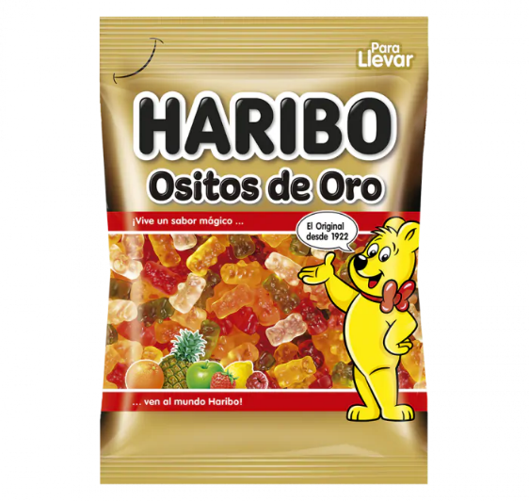

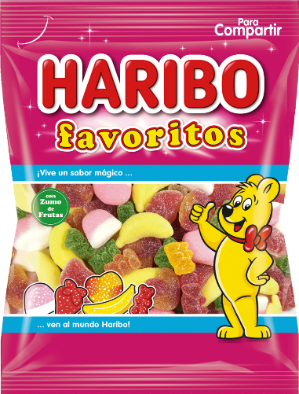

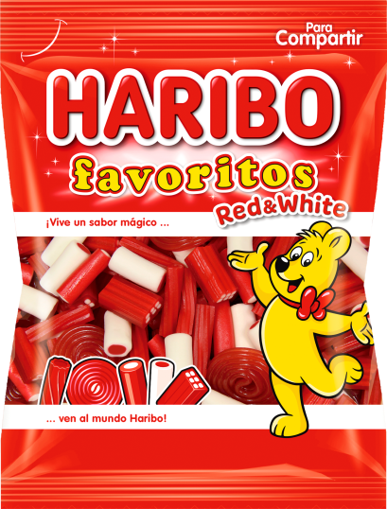

Source all of them: https://www.haribo.com/pt-pt/produtos/haribo/favoritos-classic

Obstacles

Initially, I only thought about ordinary obstacles that can be found in every game of the same genre and/or objective. And what do I mean by ordinary obstacles? Walls. So I started brainstorming about what kinds of walls I could make to add to my game. The first planned walls were the wall slices (only part is obstructed), complete walls, moving walls, wrecking balls (yes, just like Miley Cyrus’ one), and grids. The purpose was to make multiple grids with different hole thicknesses so that in some cases the player can pass through the hole, but in others, that is just impossible. After deliberating a little more, I concluded that a grid with a smaller hole thickness would do the same effect as a complete wall, so this last one was discarded.

However, I remembered that I needed to make more relations and references between the gameplay and the narrative itself – so that no one would think “ok, that’s a good starting narrative but the gameplay doesn't need it anyway, this game could be placed on everything else, it doesn’t matter”. I started imagining good starting points to develop fresh-new obstacles that could integrate the player better into the narrative.

I focused on the fact that he got betrayed. Why did this happen? He seemed a nice guy. The problem should be around some notion that his wife needed and that he was not able to give her. Maybe she wanted better sex… And that’s how I ended up giving more depth to the narrative without really telling something about it, just living it to the player’s creativity and imagination. Although this one was easy – she did not like his penis size as it was already presented in the intro – “Size does matter after all”. So, why not the wife lover's huge penis as an obstacle? Scary as hell.

More ideas. What if, during the hallucinations, he starts thinking that his wife got pregnant? Of course, he would suspect if the child is someone else’s. What if the hallucination itself told him that, in reality, HE IS NOT THE FATHER! That’s so creepy.

More. What if even his wife’s so beloved soft breasts turn against him? And that’s how I eventually added these three obstacles into the game. I also thought about adding a clock, just to the fact that what he was going through was not real and was like a dreamy world, but I ended up discarding it.

The last idea that I had was to make a clock model, so that I could animate the clock hands forward and backwards. And it somehow was related to the story – it could remember that what was happening wasn’t 100% real, even though he could die. But it was a magic world created by the hallucination, a dreamy world, and he was suposelly sleeping, and when we sleep we normally lost the sense of time… At first, I thought it was really interesting. But then, I did not add this model to the game, because of lack of time and somwhow I did not feel it had his place, it started to be a little out of context. Not to mention that I already had a lot of distinctive obstacles, so I preferred to drop it.

Checkpoint

To make the checkpoint, I wanted, again, something that could be related to the main story as well. I tried to think of some subject that he could want (just like a person wants to reach a new checkpoint to stop playing because it’s bedtime). His wife back? Having romantic-not-only-fleshy sex again with the person he loves the most, that he could die for her? Perfect. Sad, but perfect.

This culminated in me wanting to make a vulva. However, I realized it was something too explicit and sexual to be present at a game. So I censured it and made it inside a cut peach, where its pit is usually located.

Ground

There comes the tricky part. In the first instance, I ought to make a complex slide, similar to the ones that exist in aquatic parks, with plenty of bends.

Later, I came to the conclusion that it would be too hard to make the game programming logic work fine with such a complex water slide shape, in such a small amount of time. From now on, all slides were horizontal.

* 3D Design

During this game’s development, Blender was the most used tool, since it is one of the main tools used nowadays for modeling, and because of some previous knowledge – Blender was used during one of the last semester’s classes. Also, the other well-known modeling software, Maya, is not free (although it can be for students) and does not have such a huge community as Blender has. Furthermore, the choice seemed obvious.

In the beginning, Adobe Substance 3D Painter was also used – in this case, it was for painting the first sketch of the character model – texturing basically. I used layers and masks to paint each different colour and ended up baking the recently-created textures. But then I stopped using this, and I’ll explain why later.

At first, I made a bean mesh and wanted it to be the only collectible (so, the object that the player could collect throughout the game, and change their colour) – only one model that could have up to five different colours. But I wanted more. I realized it was better to establish a one-to-one relation between a model and a color – each model should only have one and only one colour throughout the game. What about the game’s main title, “Magic Jelly Beans”? Nanail was supposed to eat some bean gummies! Well, I concluded that, even though this little detail was probably not so important as it came to my mind, it was better to clarify that he took many pills at once, and each one had a different gum shape.

Character’s first model

Nanail’s first model was the first thing I modeled during this project. At the beginning of the development, the goal was to make a low-poly character to give a more *retro* look, because of the shader that was going to be made for the slides (where there are a bunch of squares – for more details, check the Shaders section), and because of lack of modeling experience (I had some classes about it, that’s fair, but my background is programming, ok? Don’t tell me to make some realistic character. And talking about realism – the purpose was to make an unrealistic-neon-visual game, that can also look a little bit childish sometimes. Because, for me, games don’t need to be realistic to be fun. Do you recognize that it is a human being? Ok, fine.

So, while I was looking for good ways of making low-poly characters, I discovered an add-on called Auto-mirror – that “automatically” was making the mirror of my character, so that I could check in real-time both sides of them while only modeling one. I later discovered that I could only enable the Mirror Modifier on Blender early and continue the modeling that it would be the same thing (that’s what the add-on does), but I really enjoyed it, it was faster and good for me.

The first character’s model was made of mostly loop cuts, extrudes, and scales while making attention to making an overall human-looking model.

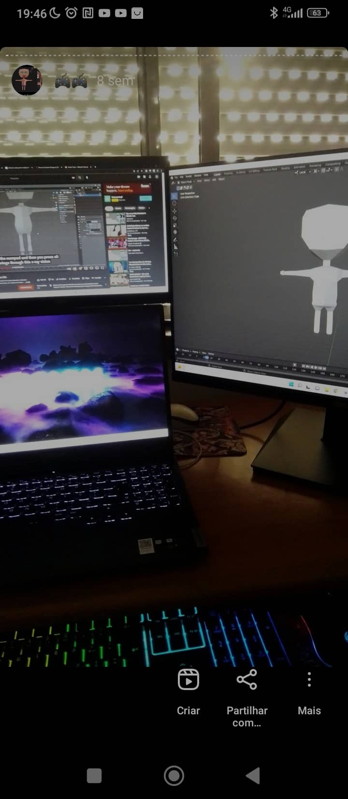 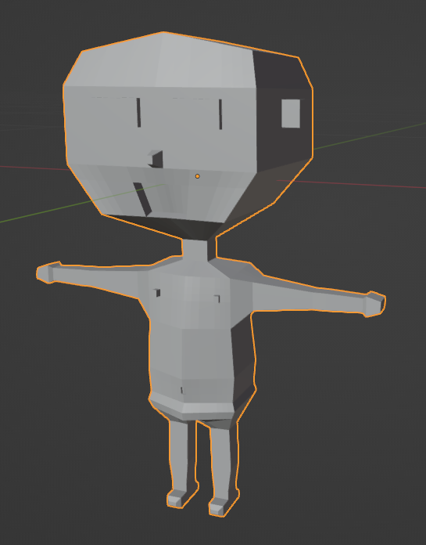

Finished the modeling, I made the UV mapping to later be used on Substance Painter.

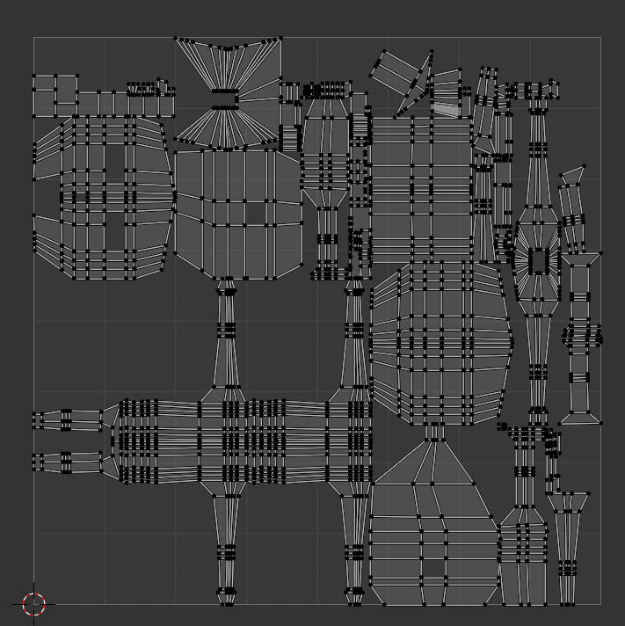

Finally, I started texturing on Substance Painter and baked the textures, so that I could use them on Unity and create a material for the character himself.

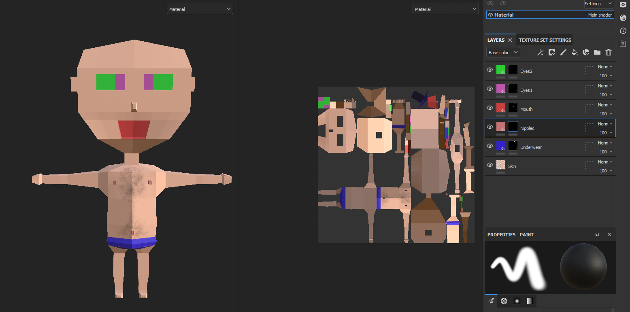

This approach was later discarded – I ended up realizing that it would be better for my case to assign multiple materials to a mesh on Unity, instead of using other software to create and bake all the textures and then create only one material for a mesh.

Since a big component of this game is the constant neon-glowing visuals, it was important for me that each part of each mesh would be distinguishable and have the glow effect at the same time, which was not happening if I baked the textures – the meshes on the scene that only had one material (and applied a material with glowing effect, using a shader), with the post-processing enabled, was making the material based on textures not visible at all!

Another thing that happened was that, even if I made a shader on Blender and then baked the textures to create the material on Unity, the result was underwhelming. Below there is an example of how the resulting texture after baking an object with a glowing effect.

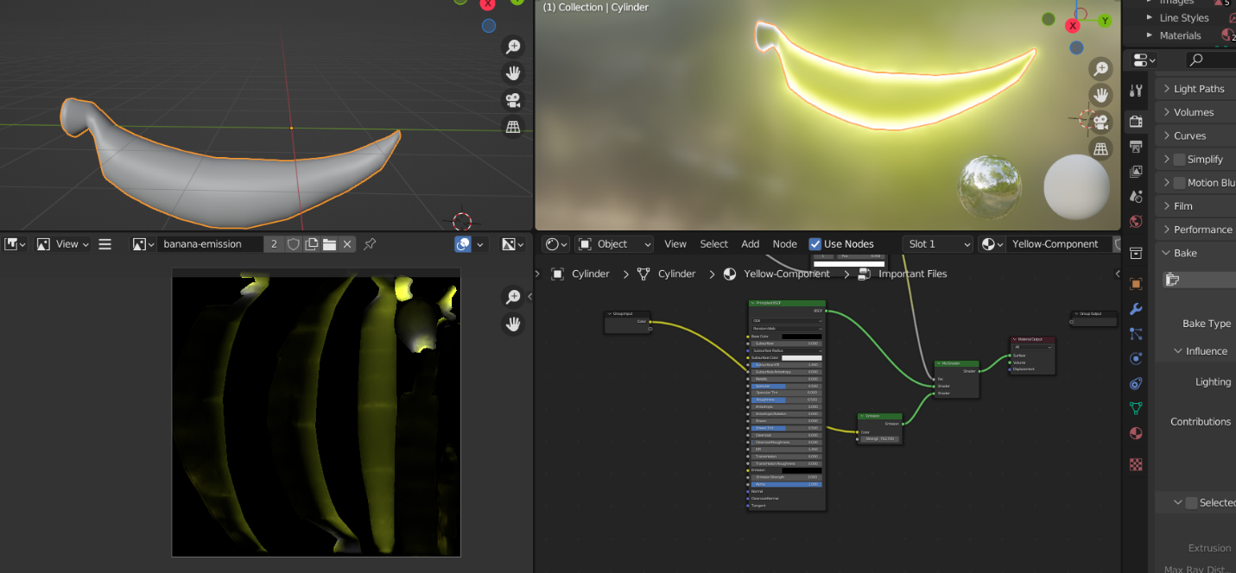

Collectibles

* Banana Gummy

To make the banana shape, I first started with a cylinder, and then I added loop cuts and scaled some edges - all this while the proportional editing: smooth was enabled. To make the corners, I used the not-so-fancy technique of making an extrude and scaling it. I then made correspondence between each one of the two components of this banana mesh and a material slot; to help me select these face groups, I enabled the Toggle X-Ray.

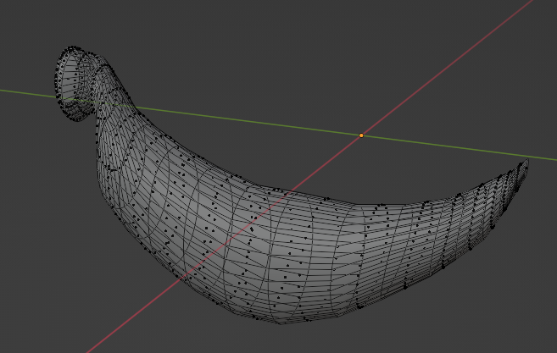

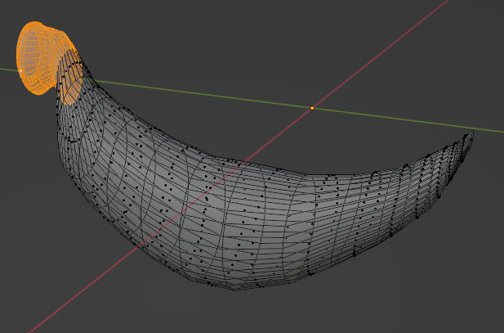

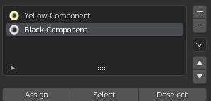

* Red Gummy

In this case, I used again a cylinder as a base mesh and scaled it to make it look more flat. After that, I enabled the Auto-mirror add-on and recurred to the Inset Faces Blender functionality at the base of the cylinder, followed by an extrude to the newly created face. In the end, I made a bevel to give it a more rounder appearance. To distinguished parts of this model were assigned a new material slot – one for the red component and another for the white component (top and base parts).

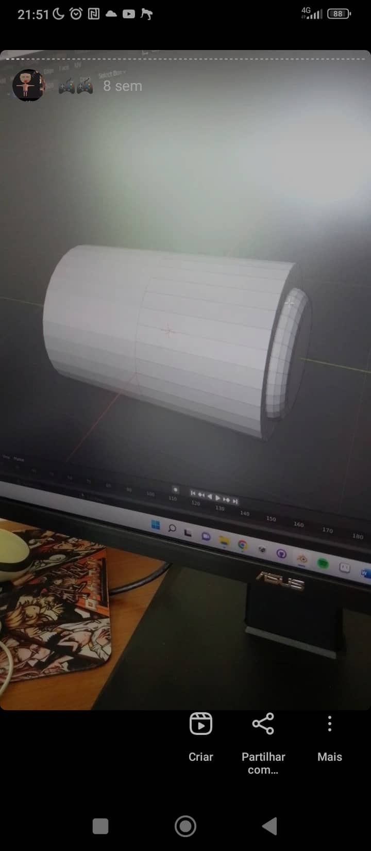

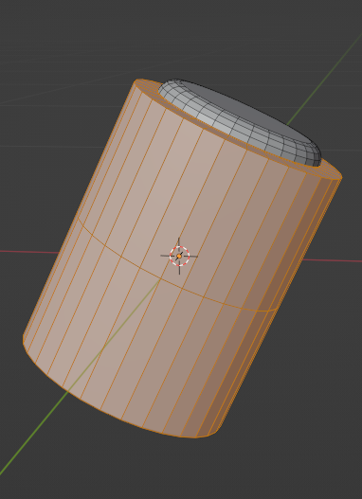

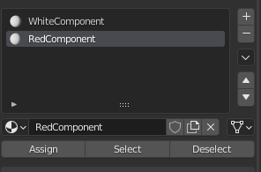

* Bear Gummy

Almost sure it was the collectible that gave me more hard work, although most of it is successions of loop cuts, extrudes, and scales, with bevels to the ears edges, feet, and lateral edges as well. A lot of edges were also edited by hand. It was also a great help to use the Subdivision Surface modifier before modeling this mesh, to help make the most detailed parts, such as the face. In the end, the Decimate modifier was applied to reduce the number of total faces.

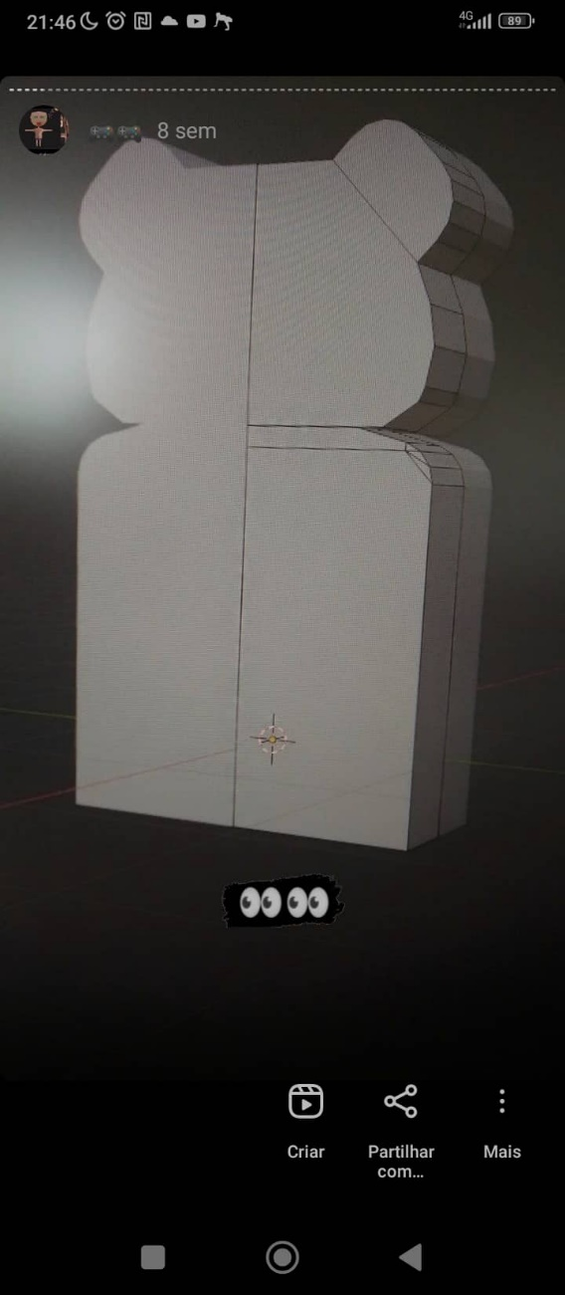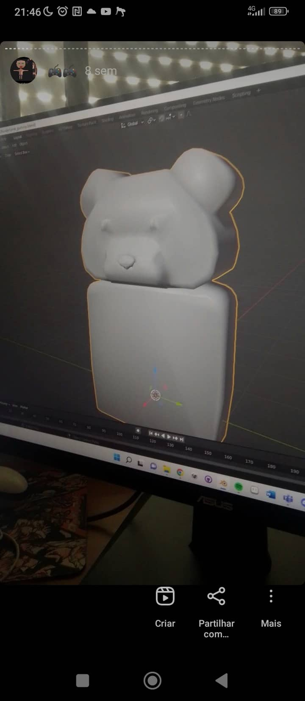

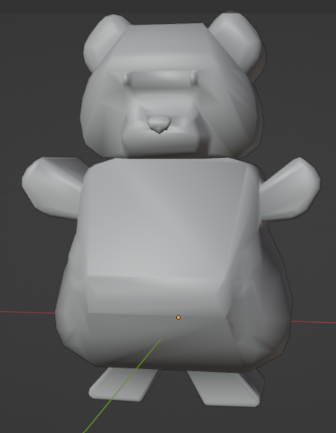

* Pink Gummy

For this model, I recurred to a sphere base mesh at the beginning of the process. I turned on the option Toggle X-Ray to select entire (round) sections of this mesh and scaled them, while the proportional editing mode: smooth was enabled as well, and scaled up at the bottom and scaled down at the top.

In the end, I assigned two different face groups to a material slot each – the top component would have a pink-coloured material and the bottom one a white-coloured material.

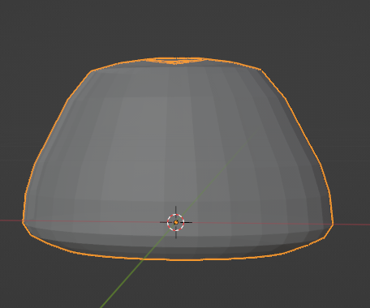

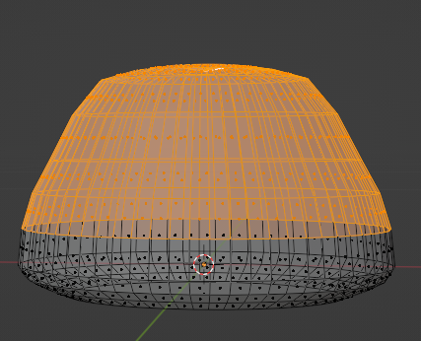

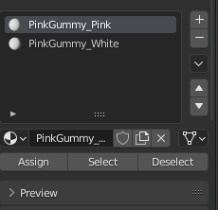

* Spiral Gummy

To make this mesh, I used a plane that was firstly scaled on the Y axis. Then, I made a bunch of loop cuts and turned on the proportional editing mode: smooth so that, while rotating the first vertice at the top left of the plane, and while controlling the proportional editing range by wheel scrolling, I could start to have a spiral shape. Finally, I applied a Solidify modifier to give it some depth.

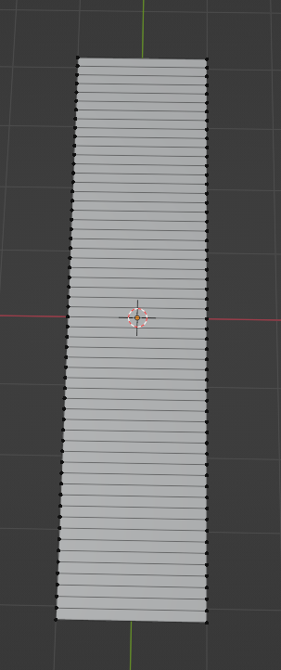 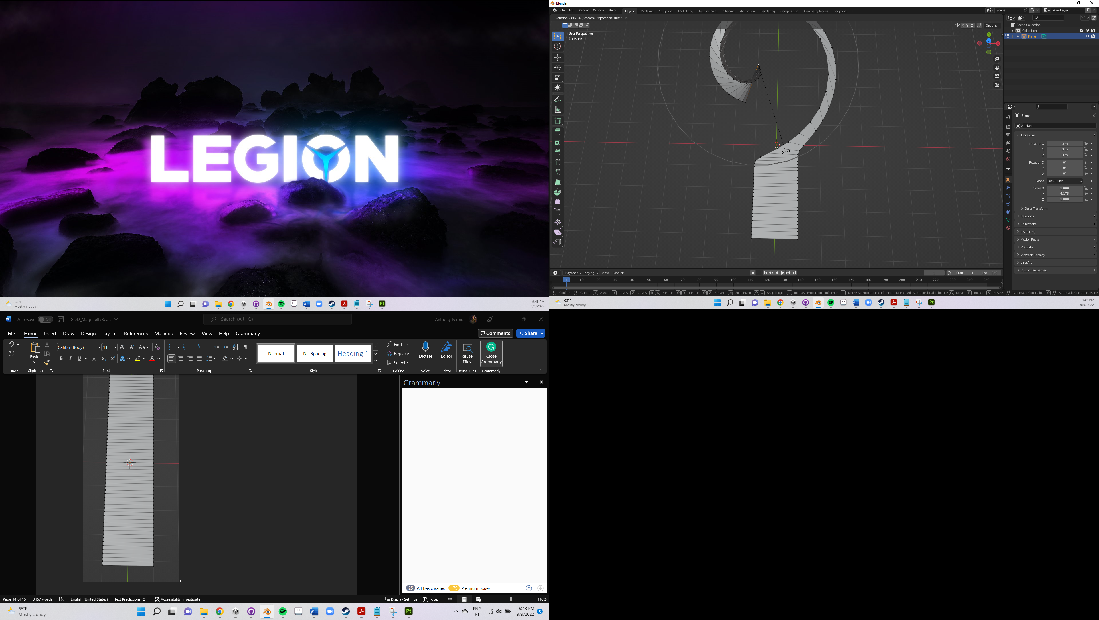

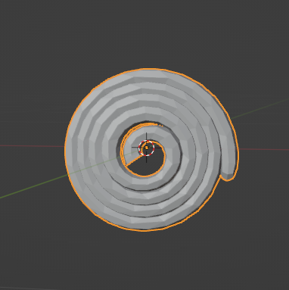

Checkpoint (Peach with a vulva)

To model this one, I first started with an ico sphere. I remember I did the same for other models as well, like the breast, the penis, the pregnancy test, even when I remade Nanail’s model. And the reason was to have more freedom to use the Subdivision Surface modifier (without applying it, only in the end) to then give more details and make the meshes look more polished. But this was just later in this case.

Carrying on (on, on, on… CARRY ON CARRY ON!!), I applied the auto-mirror add-on to the X-axis.

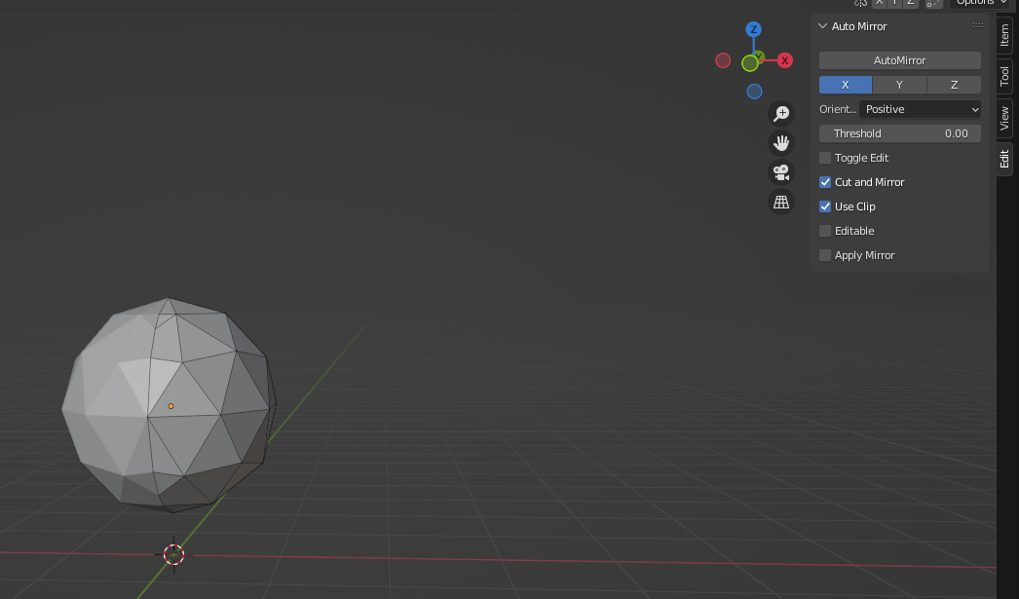

After that, I started to move the side faces and vertices on the top to make the shape tubbier, until it looks like a heart.

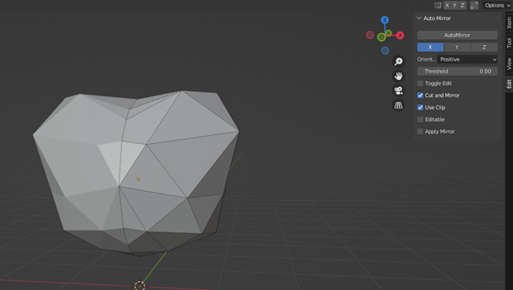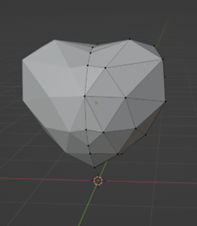

I kept going by enabling the proportional editing mode: sphere to start giving a even more rounder appearance while moving the remained faces at the top.

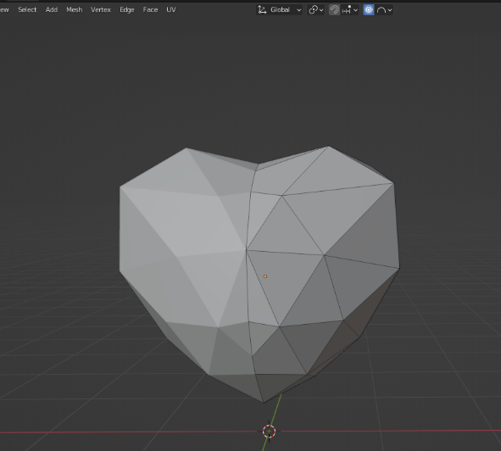

Subsequently, I added (FINALLY) the subdivision surface modifier to make the surface more polished, by increasing the number of polygons.

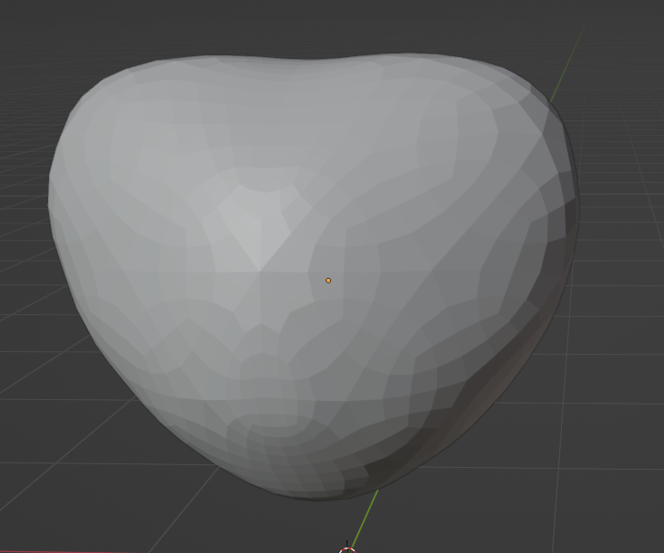

I then removed, remade and moved some vertices to make it look like on the polished mesh that the peach had cheeks (just like in real life, you know, peaches have an exterior hole that divides them in two, it almost seems the rear cheeks).

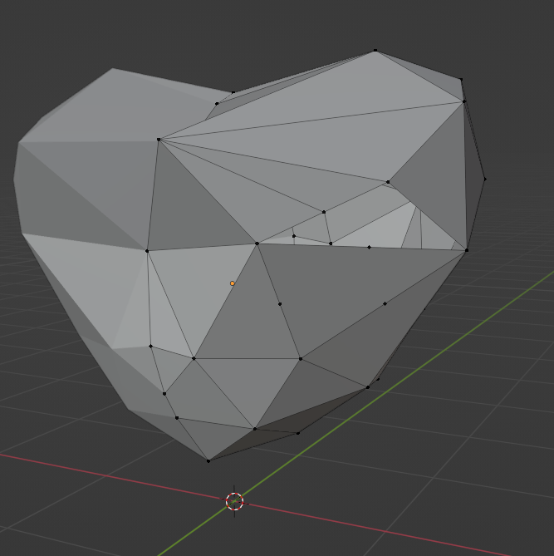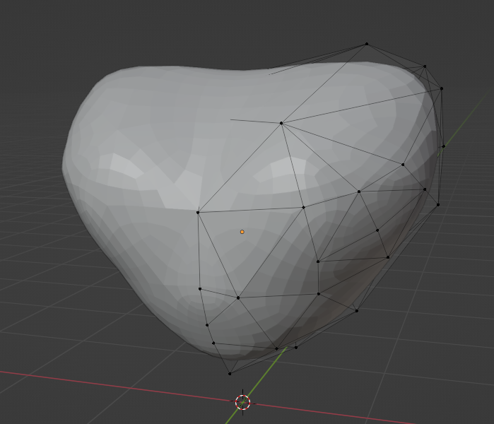

Now it was time to slice the model in two and start making the vulva. So, I turned on the Toggle X-Ray, selected half of the mesh and chose the option Separate By Selection.

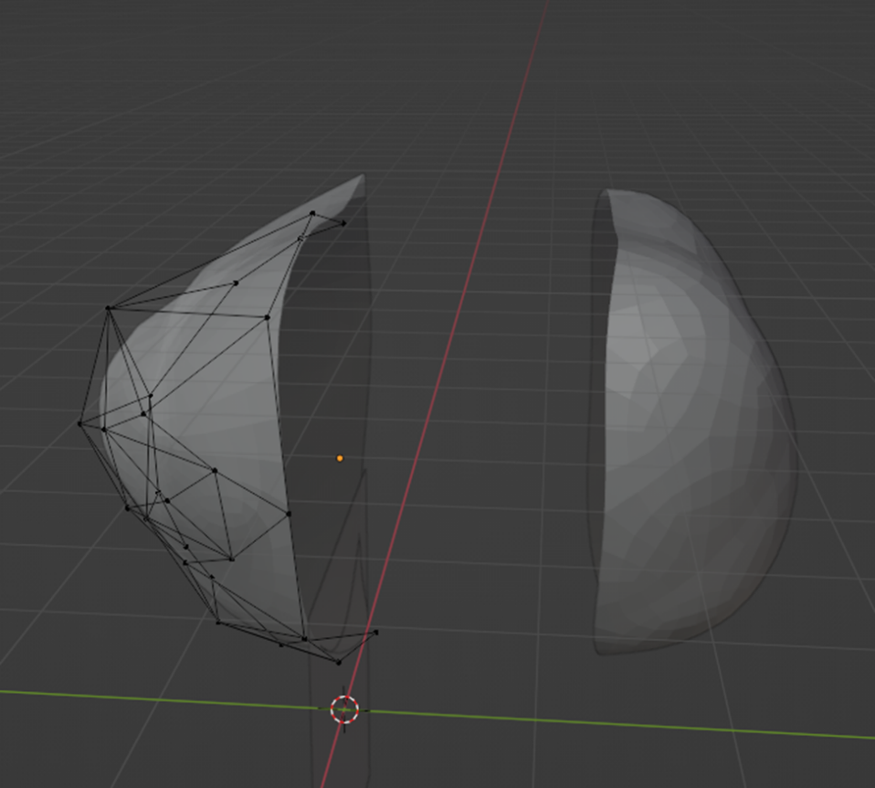

After that, I made an extrude followed by a scale on the opened vertices, to start closing the mesh again. In the end, I selected all the remained vertices and filled them. To help me modeling the vulva, I started adding loop cuts and remading some faces to give a more appropriate shape to the remaining mesh.

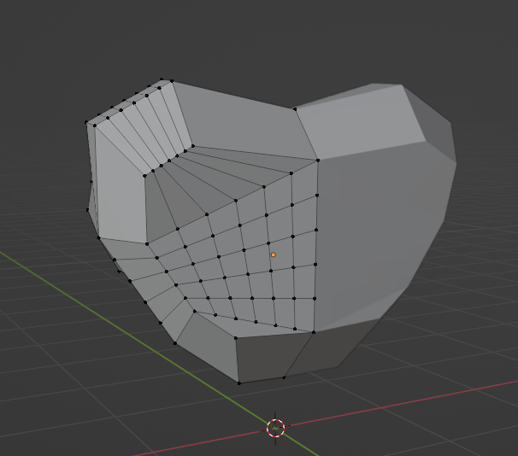

To make the vulva itself, I made some multiple extrudes while the subdivision surface modifier was still enabled. It was a good practice for me to sometimes edit this mesh (and even others) when I turned of the modifier, and then turn it on to check what it will look like, and if the result is good enough to keep going, or if it stil needs something to be done, to be refined anyway.

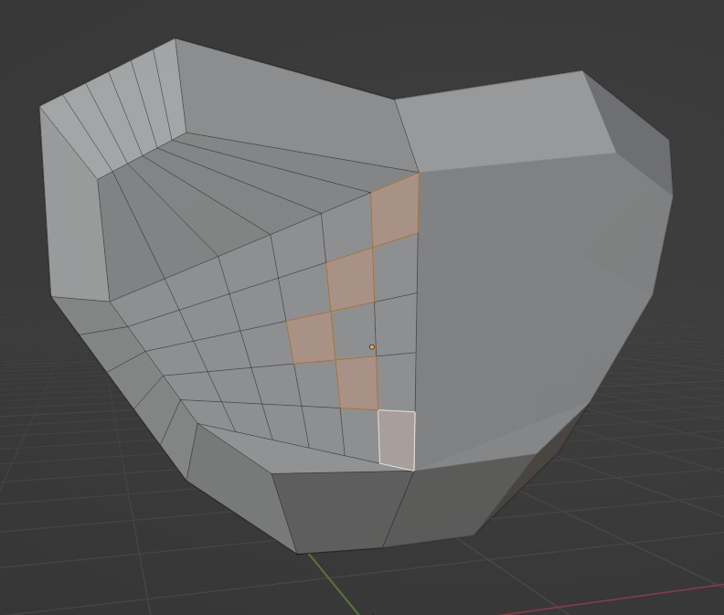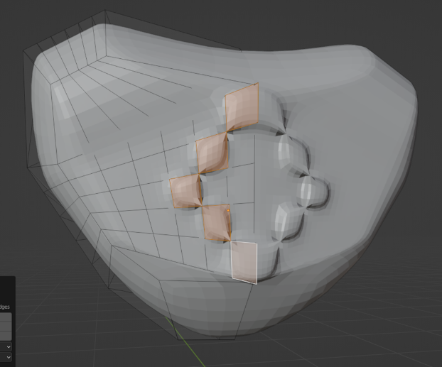

For instance, to make the clitoris region, I ended up using the merge vertices at center functionality, vertices where the extrude was previously applied.

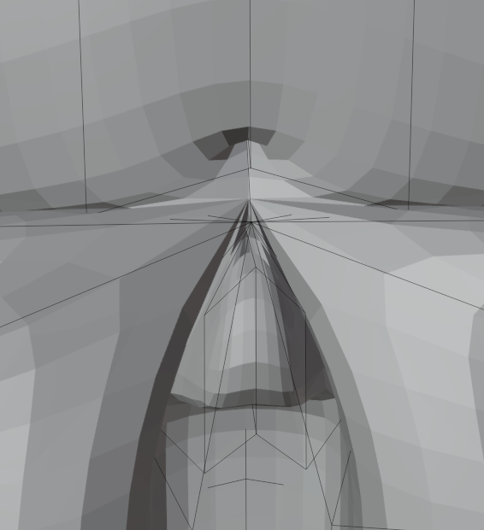

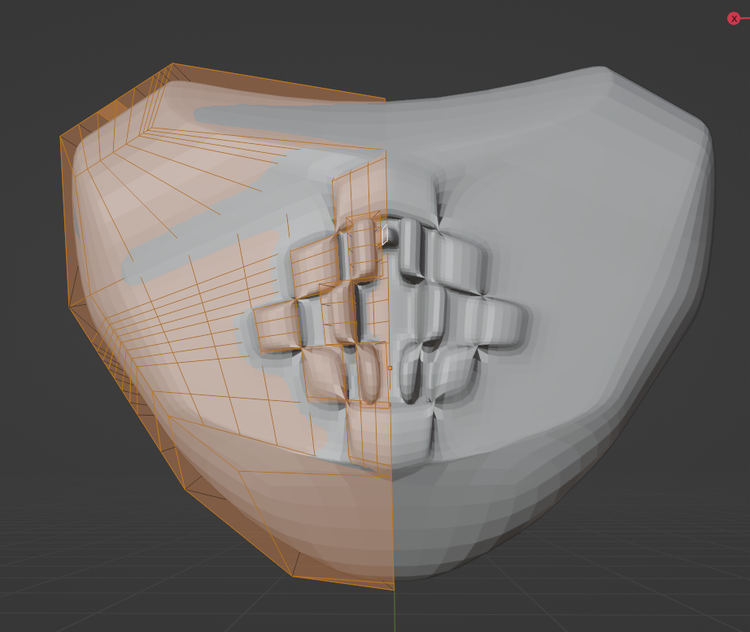

The remaining component of this model was making the peach leaves. For that, I started with a sphere, scaled it to turn it more flat, and moved the top and bottom parts of it while enabled the proportional editing: smooth; this was to be able to do the sharpier parts.

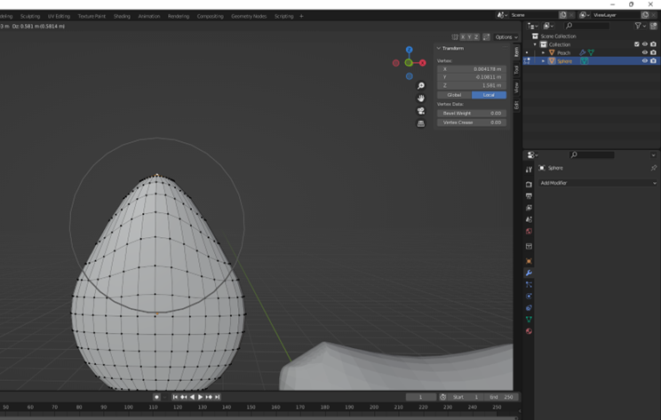 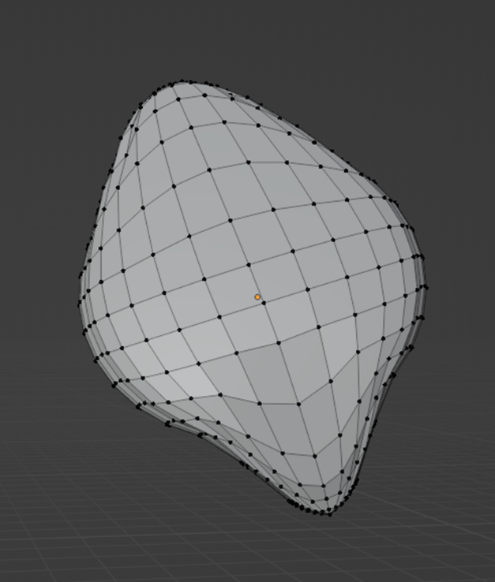

The final result was the following. After concluding the modeling, a decimate modifier was applied to all the mesh and each different component (different group of vertices/faces that would have a specific colour) was assigned to a new material slot.

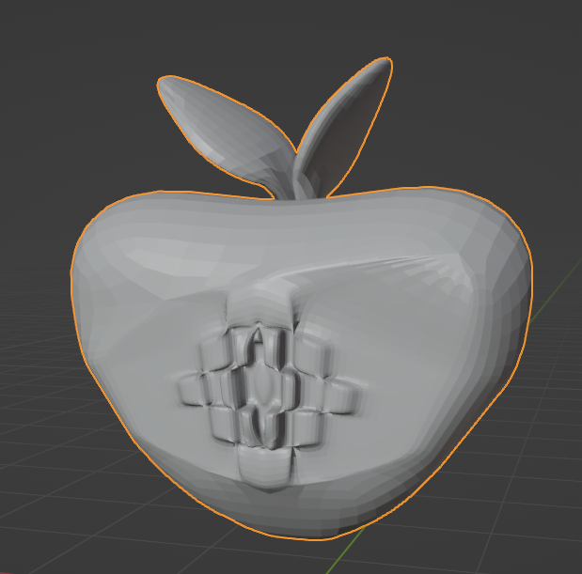 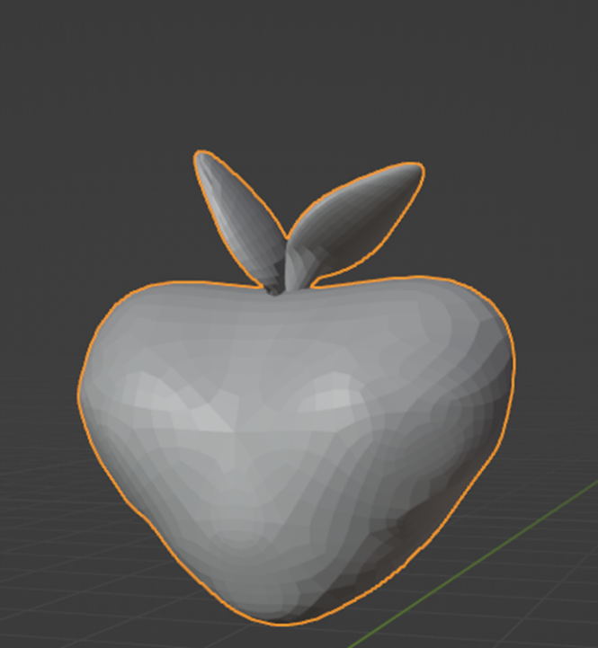

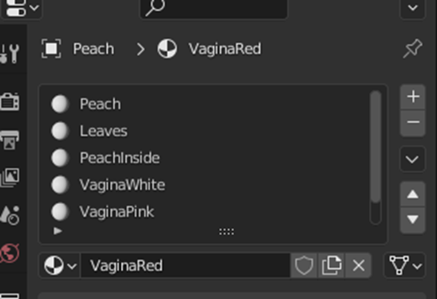

Obstacles

As you may already know, there were two sets of obstacles: the so-called walls and the ones more likely related to the story.

Walls

* Grid

So, I started off with a cylinder and turned on the auto-mirrer add-on, scaled it, and made some successive inset faces to have a more robust wireframe shape on the top and bottom faces of this cylinder.

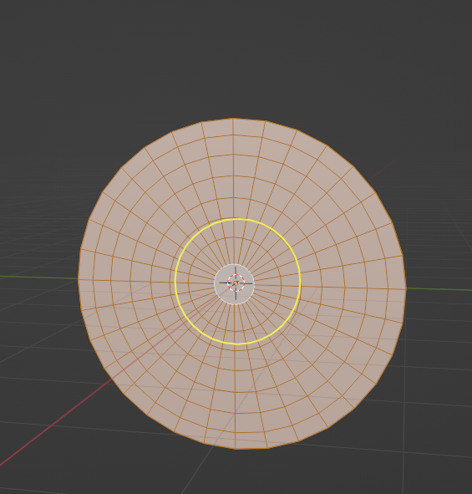

Then, I removed all the faces, remaining only the vertices and edges – literally, the wireframe itself.

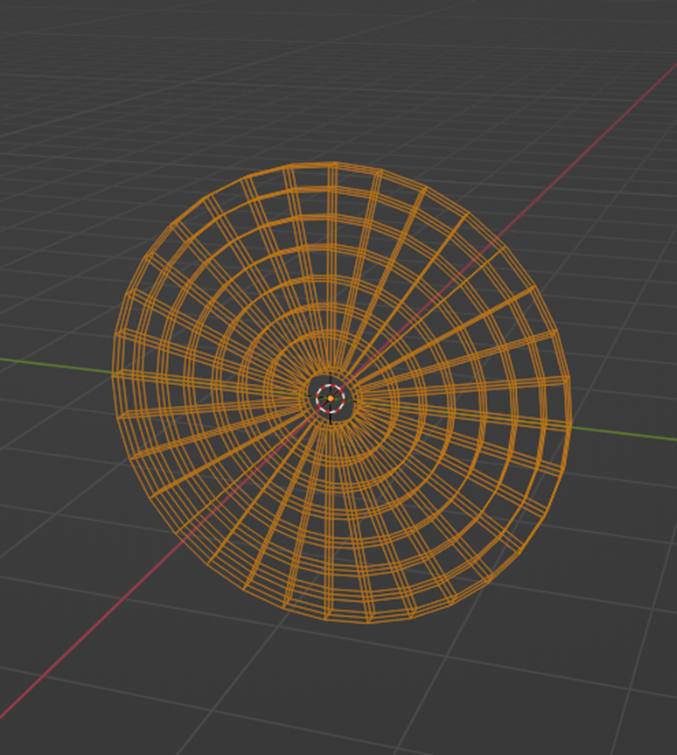

Consequently, I converted the mesh to a curve and, under the Curve Object Data properties, I applied round bevel with a little bit of depth, so that all the edges turn just like small sylinders (a mesh itself).

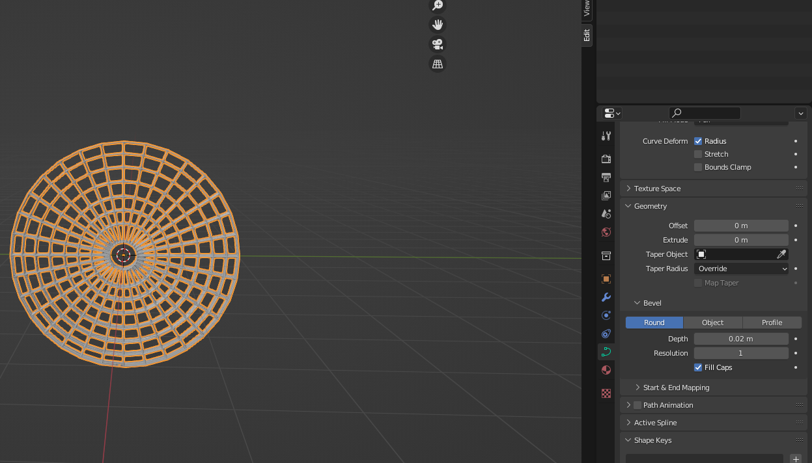 

In the end, I converted this curve to a mesh again.

For the other walls grid-like, the process was similar – getting a base skeleton with only the vertices and edges, converting to a curve and then apply some depth. It was the process of making the wireframe that was different.

* Cross

For this one, I started with a circle mesh. I removed three quarters of the vertices, and then made two extrudes – one to each vertex at the ends. The objective was to close this shape and create a center pivot, by overlapping these two recently-made vertices and then merge them by distance.

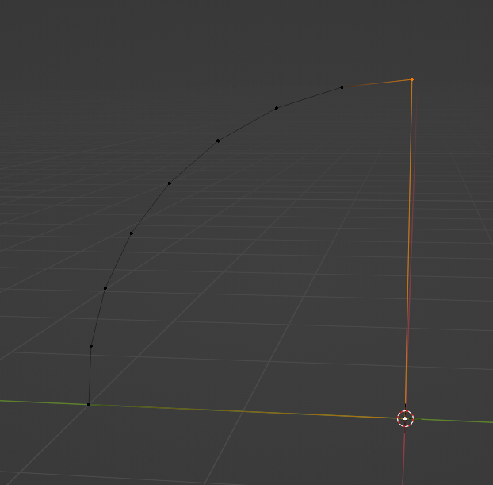

Next, I applied the mirror modifier for both Y and Z axis, so that I could have 4 shapes like this, one for each quadrant.

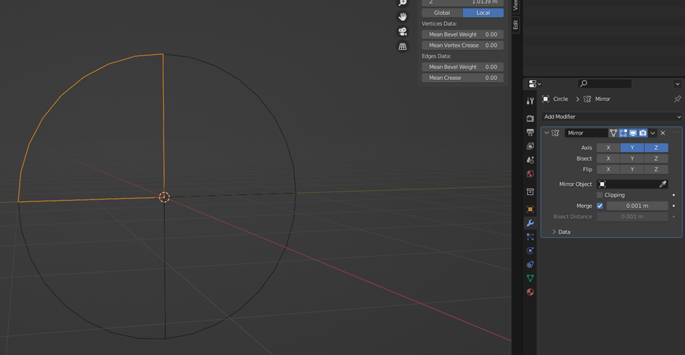 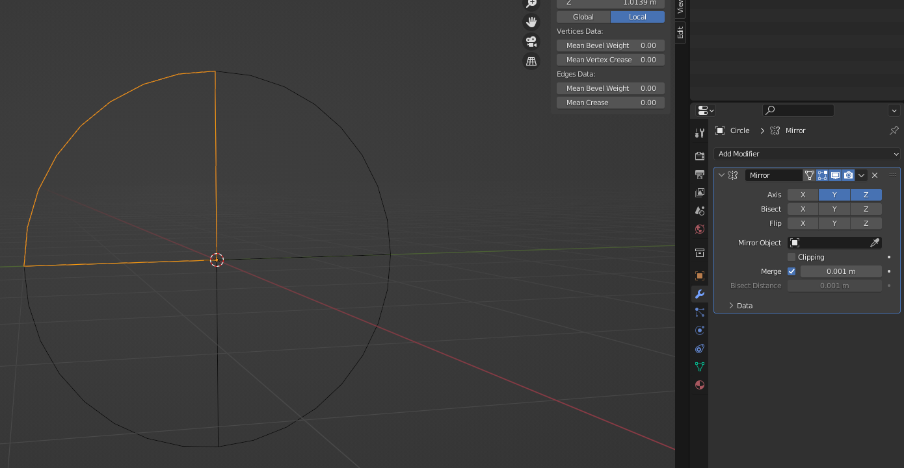

I finally converted to a curve and added some bevel round depth, which ended with this result.

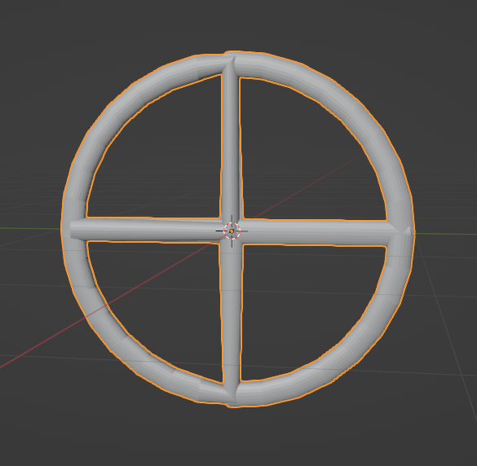

* Wheel

For this one, I used a circle too. First, I removed various vertices, only remaining the following ones.

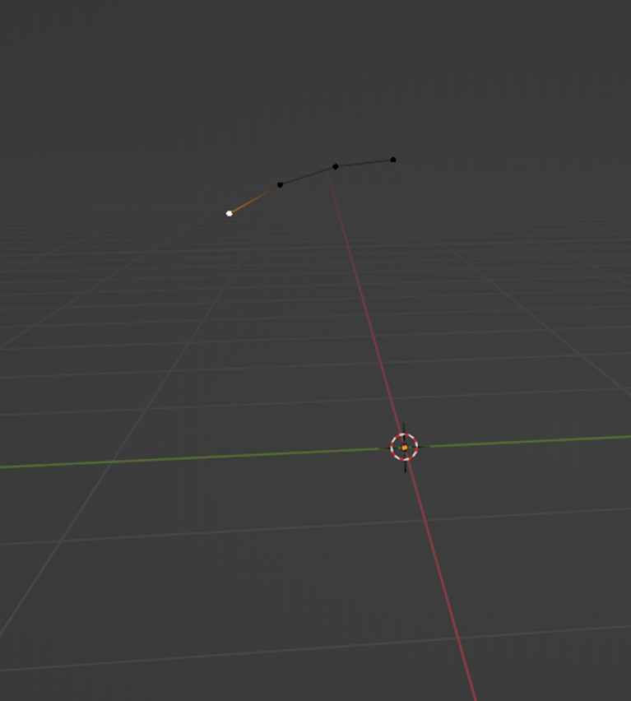

I then created again a center pivot vertice, recurring to two extrudes, and then when the two vertices were placed at the same position, I merged them.

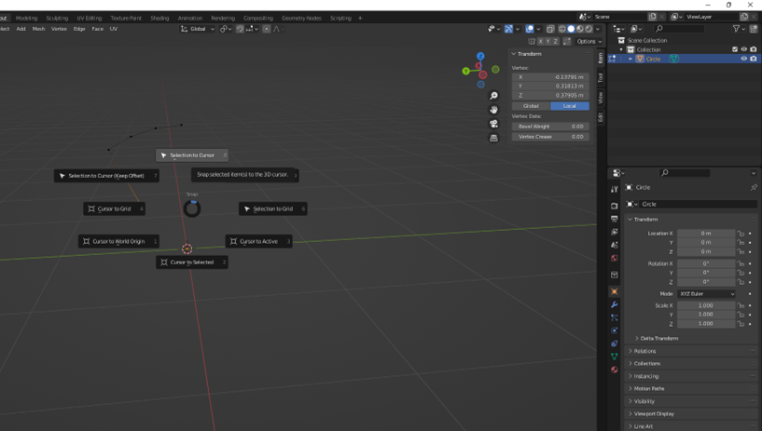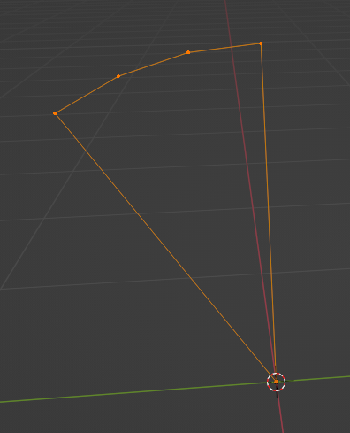

Ok, now I needed to replicate this shape, but how? The first thought that came to my mind was “I cannot use the mirror modifier, I need more than 4 shapes! And I don’t want to make successive mirrors and need to translate the overall mesh to a correct place and so on…”. So I used the Spin tool on edit mode (by selecting the edge at the end).

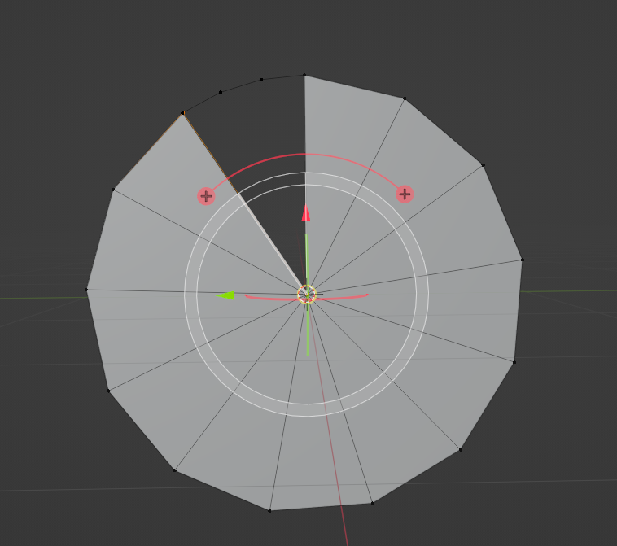

After this, I eliminated the faces and subdivided the mesh so that each slice would have the same number of vertices (did you notice that each new shape is a triangle? I did not want that, I wanted a rounder appearance, just like the first one, so that I could place these obstacles on my slides that have a cylinder-shape – if I used only triangles, I could have problems when I would apply the collider in Unity, that’s what I thought).

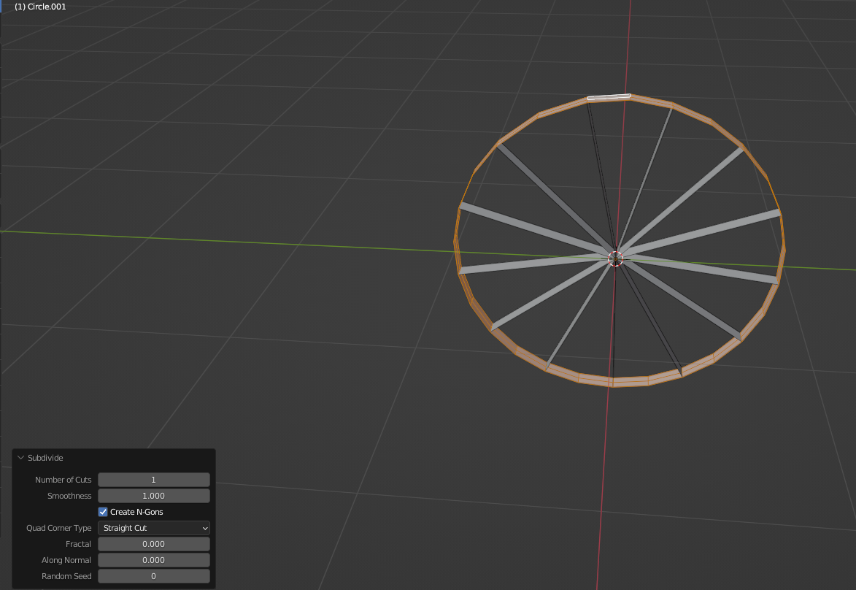

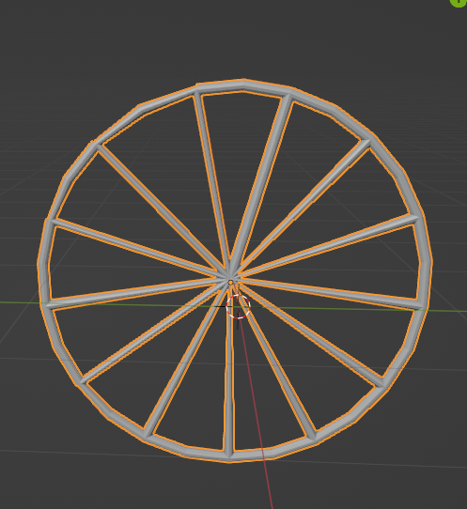

* Stylish grid

This grid was just an experience that I actually fell in love with the outcome. I had the wheel grid, selected the interior vertices with the Toggle X-Ray turned on, and rotated them with the proportional editing mode: smooth enabled as well.

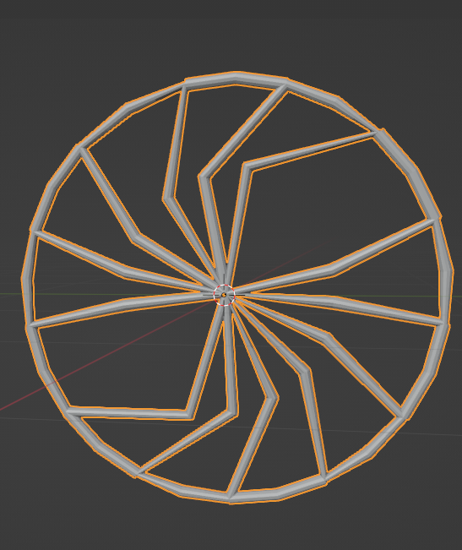

* Wall slice

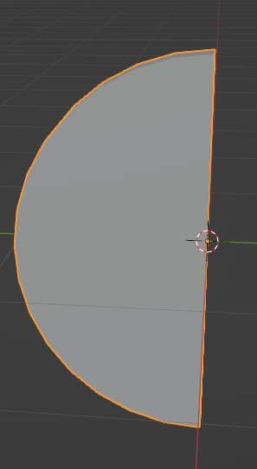

* Narrative related
* Breast

I started with an icosphere and selected the subdivision surface modifier, without applying it yet. I then made multiple extrudes and scales to design the breast details. To be able to do this I also needed to make some loop cuts.

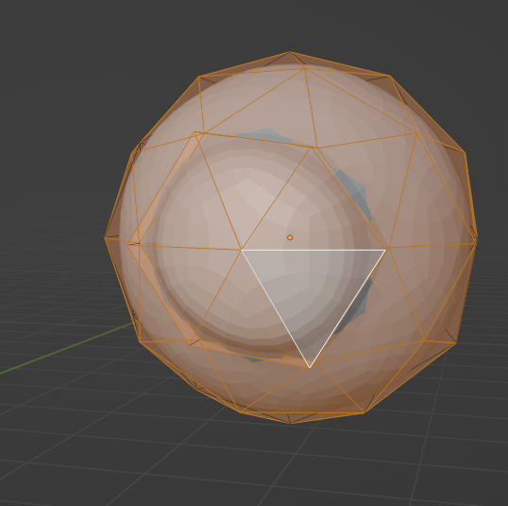 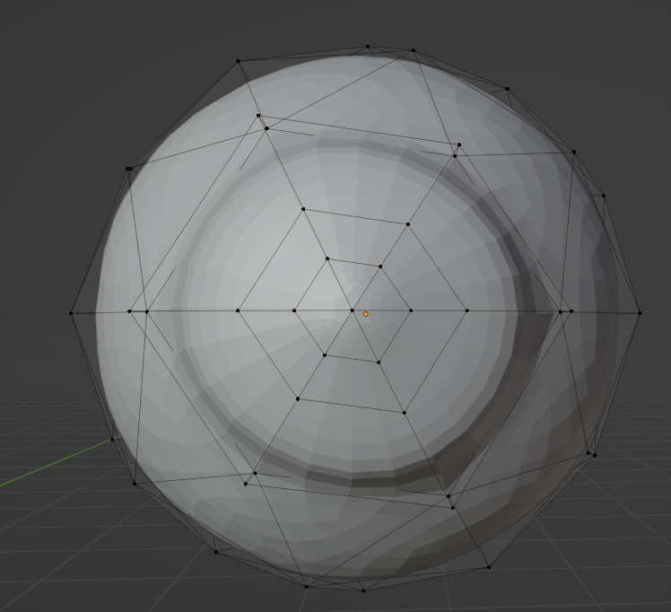

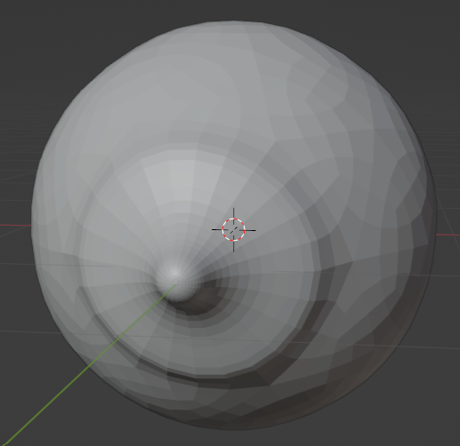

In the end, I applied the so famous subdivision surface modifier, followed by a decimate one.

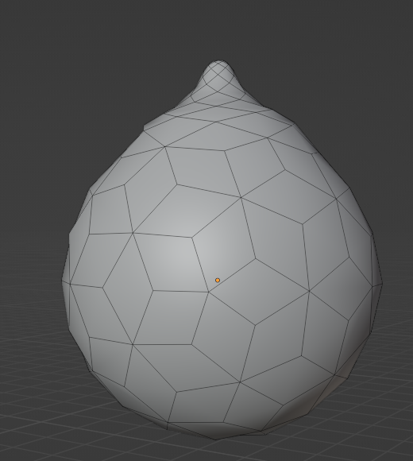

* Penis

I can clearly divide the process of development of this model in three parts – the testicles, the penis itself, and the pubes.

For the testicles, that’s easy – I used two icospheres and then joined them.

For the penis trunk, I added an ico-sphere, selected an area more located at the top of this mesh after enabling the X-Ray, and then I moved upwards. I first tried with only a cylinder, but the result was awful.

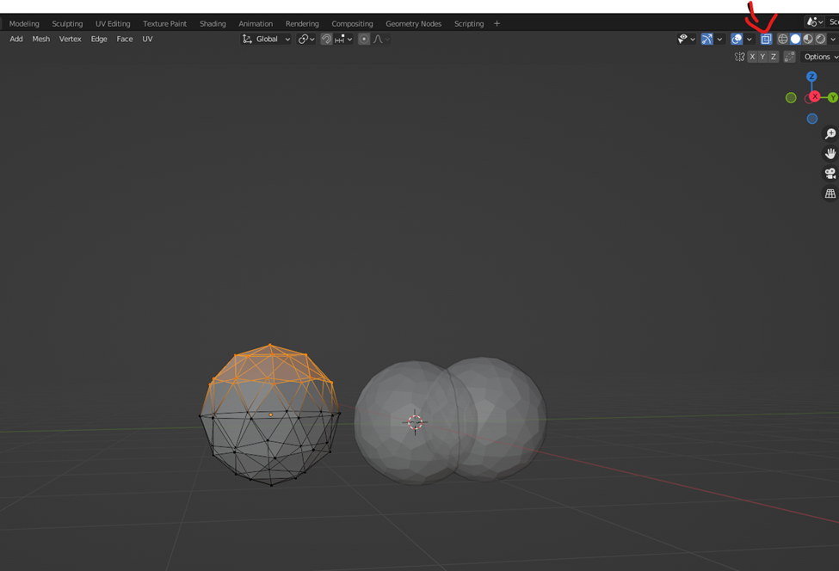

For the glans, I also created an icosphere (I think I just had a crush on them, so cute), I tried to give it a more sharp shape at the top and rounder one at the bottom while using the proportional editing mode enabled, and then I started to move some vertices at the top by hand, and to make extrudes. The goal was to make the urethra inlet.

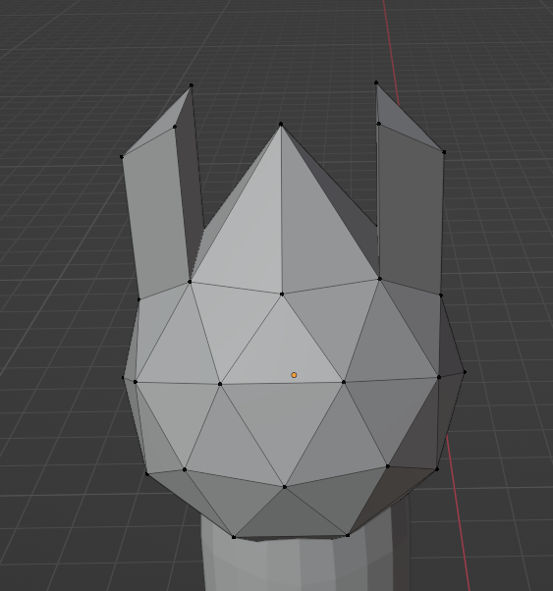

Finally, I merged the vertices at the center, moved upwards some edges and scaled the bottom part of the glans. To make it look more rounded, I even turned on the proportional editing mode: sphere and moved some faces a little bit.

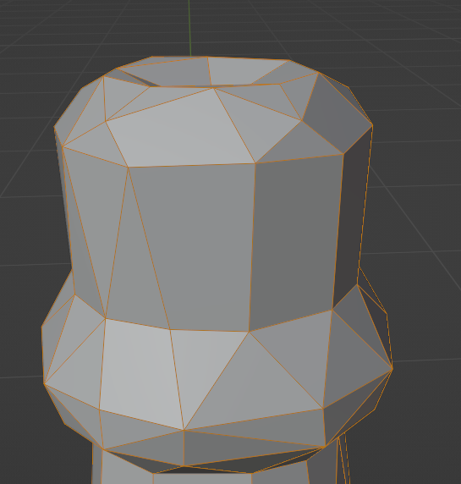

For the pubes, I installed an add-on called Add Curve: Extra Objects, and added a curly curve.

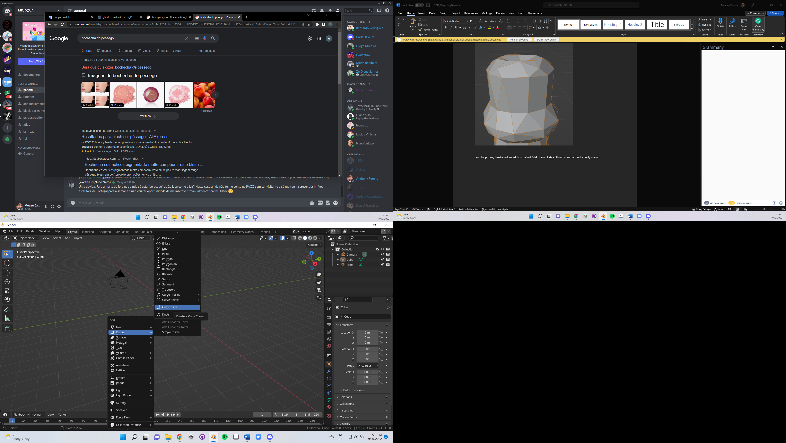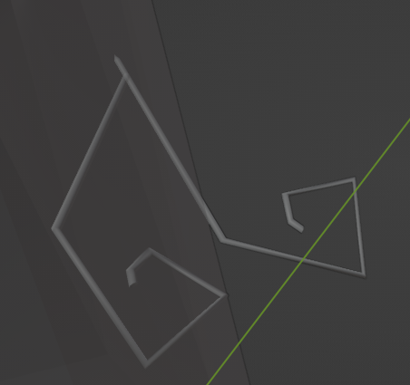

Next, I made some adjustments to its shape, gave it more depth by going to object data properties and giving some round bevel depth, and then converted to a mesh and applied the decimate modifier.

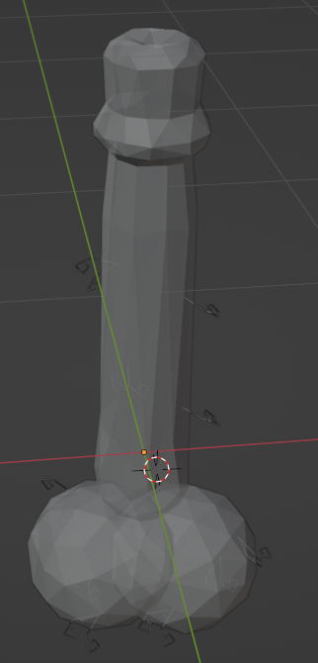

* Pregnancy Test

For this model, I used an icosphere as well. I began by scaling this mesh and then, with the proportional editing mode: smooth turned on, I moved part of it.

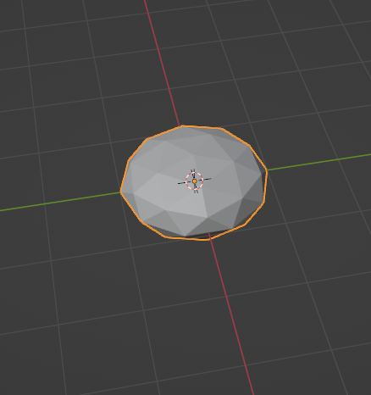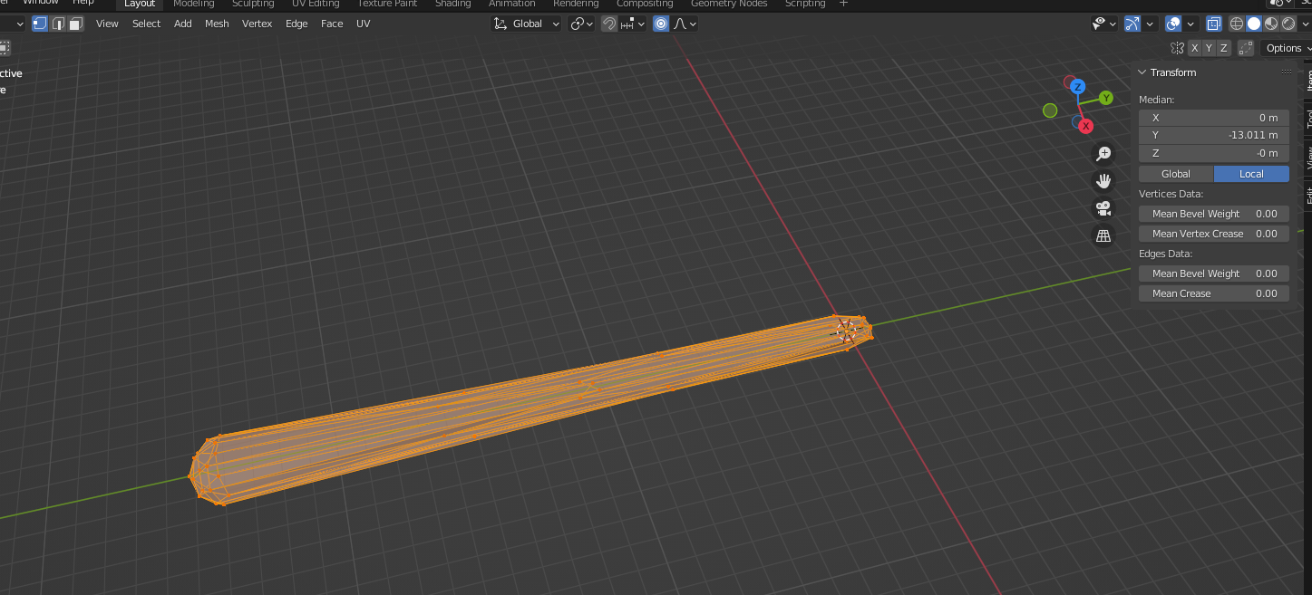

Next, I recurred to a subdivision surface modifier and on the surface where it’s displayed if the woman is pregnant or not, I used an extrude to make a pit.

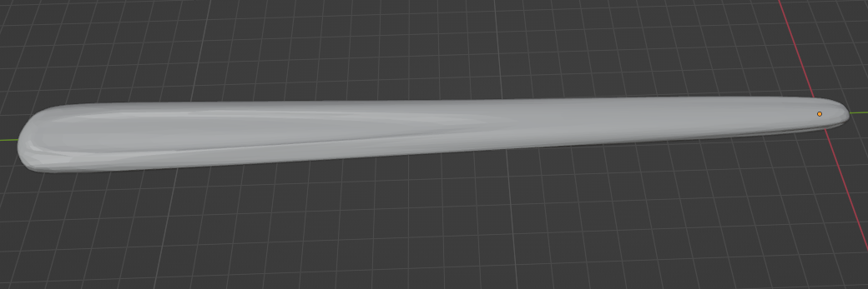

Then I started to work on the display itself. So, I used a text object, wrote the sentence and after this, I converted the text to a mesh and applied a solidify modifier, followed by a decimate modifier, to reduce the number of polygons.

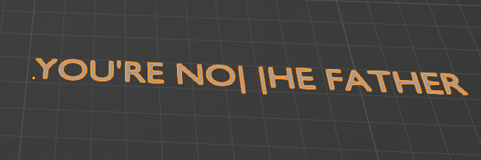

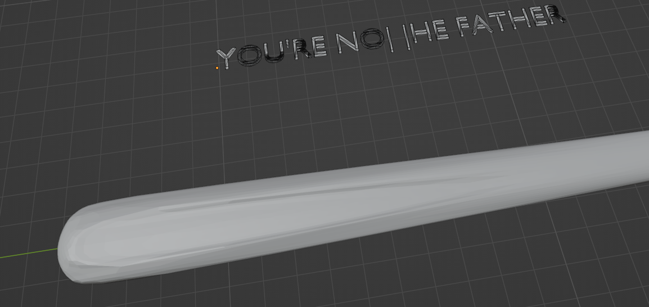

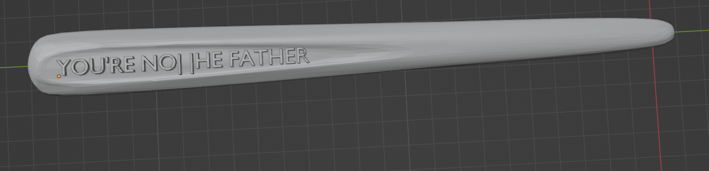

* Clock

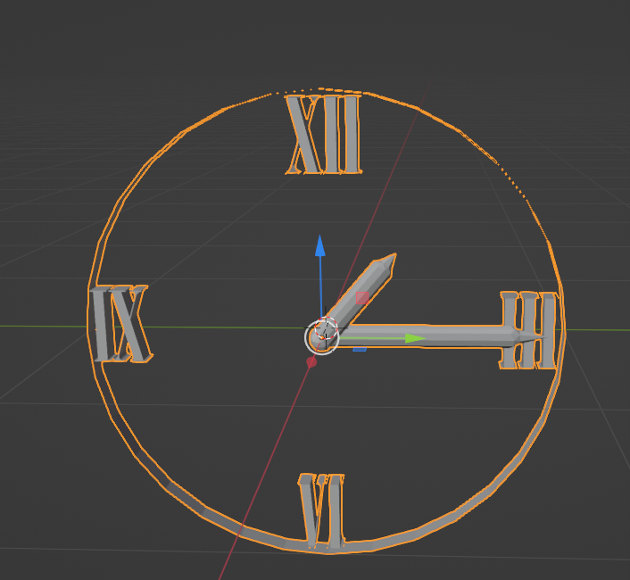

Slides (ground)

So, as I previously said, at the beginning I aimed to a complex slide. So, how could I make it in Blender? Using a curve, editing it, giving it some thickness by using a Bezier circle, and then convert to a mesh. Pretty simple overall. Also not to forget to apply a solidify modifier, so that in Unity there are no problems on displaying the rendered mesh.

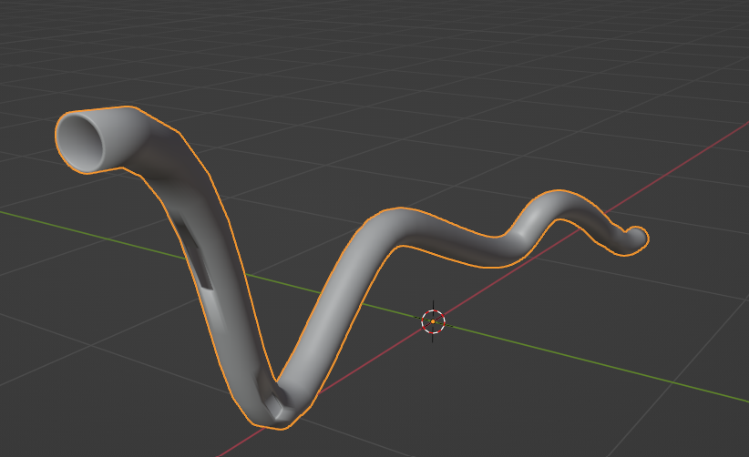

But, as I also told, I declined this method, and decided to only make horizontal slides – basically, using a cylinder.

Then, I started to think about a way that I could create the holes – and that’s how I tried using the geometry nodes. Furthermore, I added a cylinder, scaled it, removed the top and bottom circular faces, and tried it.

So, my goal was to delete randomly some parts of the mesh, based on a texture. That’s why I ended up using a magic texture and a color ramp node, so that I could measure the quantity of originated holes.

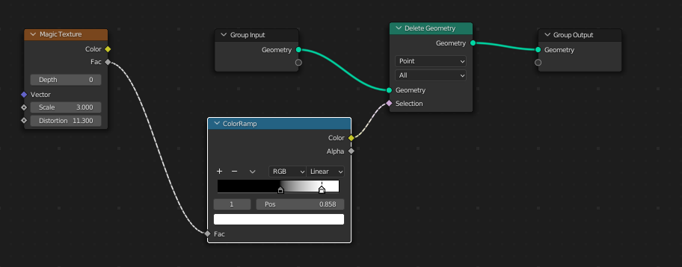

After this, I applied both a solidify modifier and a subdivision surface one, to make the holes turn out rounder.

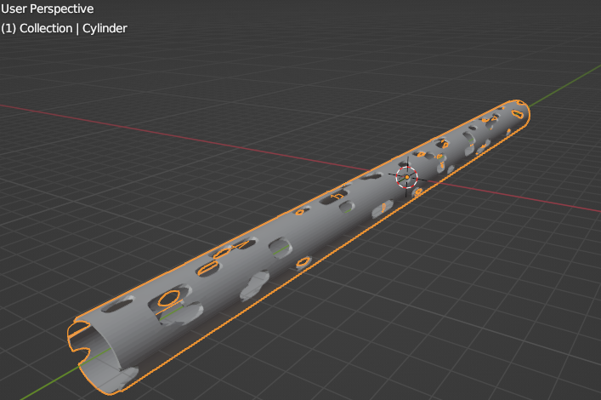

But then, when I tested this slide in Unity, I did not like it – the round holes could mislead the player, they could confuse it about where exactly the collider ends; it would be better to use square-based holes instead. And also, I did not feel I had a lot of control about where the holes should be generated more, the holes are generated equaly throughout the mesh itself. How could I place my ovjects inside the slide if he has too much holes? It’s better to make the holes by hand, so that I can control exactly how much density I want for each slice of slide. And that’s what I did.

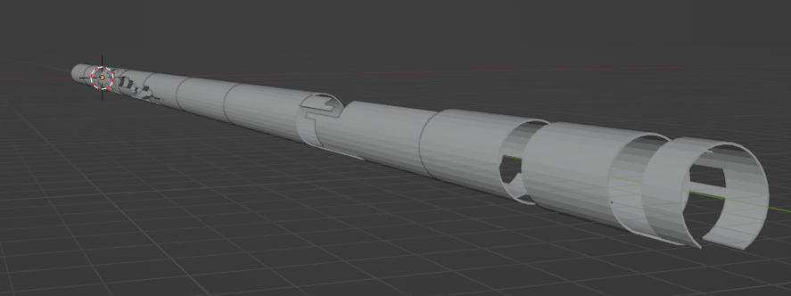

So, I ended up making a bunch of cylinders, removing the circle faces, adding a lot of loop cuts, removing the faces that I wanted to to make the holes by hand, and then applied a solidify modifier.

After this, I UV-mapped each slide. I selected the cube projection option and then made a smart UV project. This was triumphal to make the slide shader work correctly and make the effect that I wanted to.

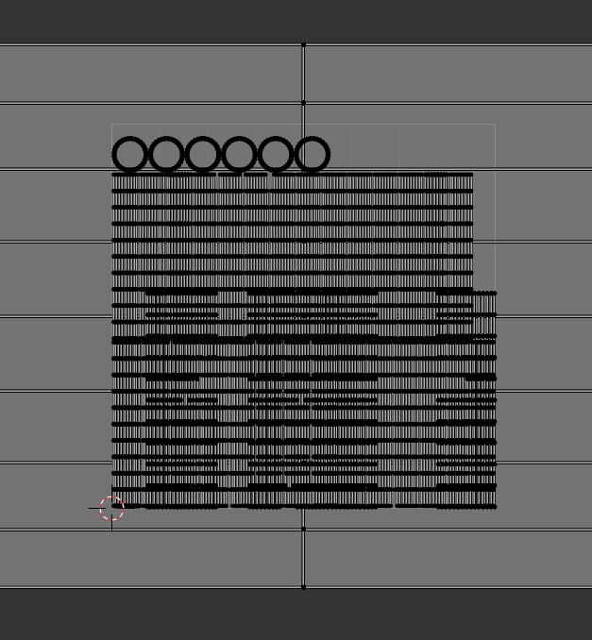

Nanail, final version

To make this version come true, I first enabled the auto-mirror and then used and abused of the Skin modifier. I started with a plane, merged all the vertices at center, so that I only had one, and with this modifier, I only needed to extrude the vertices and then scale them. The process of modeling is somehow similar to the used to make the first one – extrude and scale and so on – but this modifier was my saviour, I really liked it.

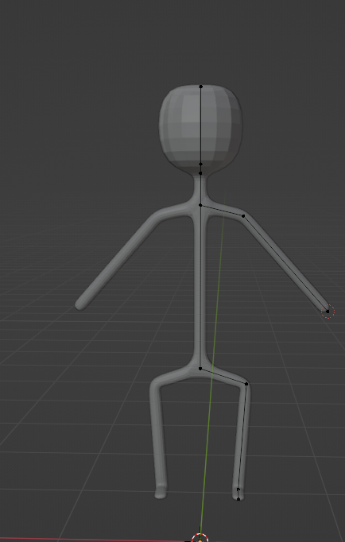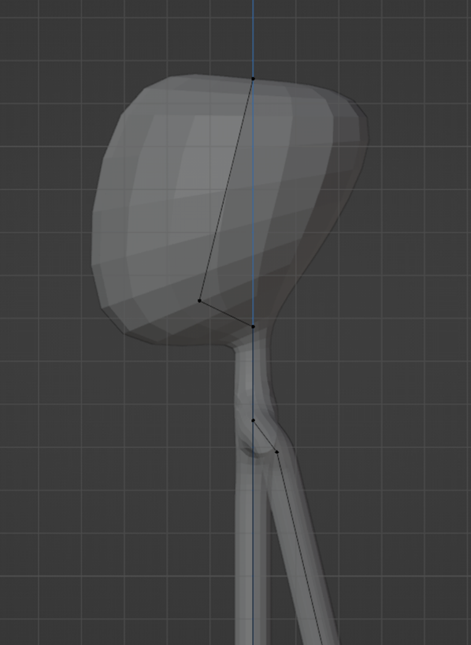

One curious thing that I discovered was that this modifier automatically merges the space between different vertices if you scale enough a specific vertice. I also needed to apply two subdivision surface modifiers during the development of this model.

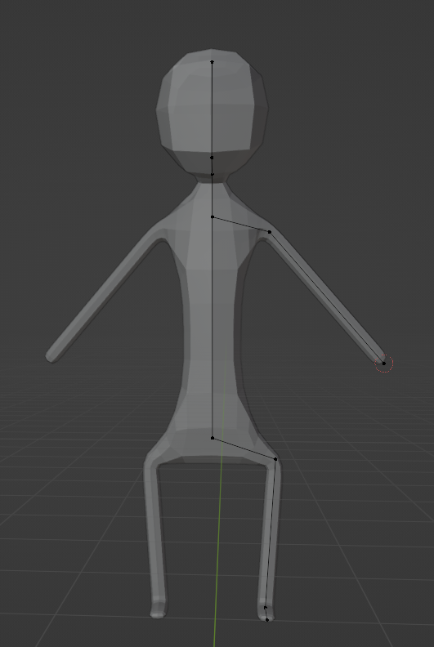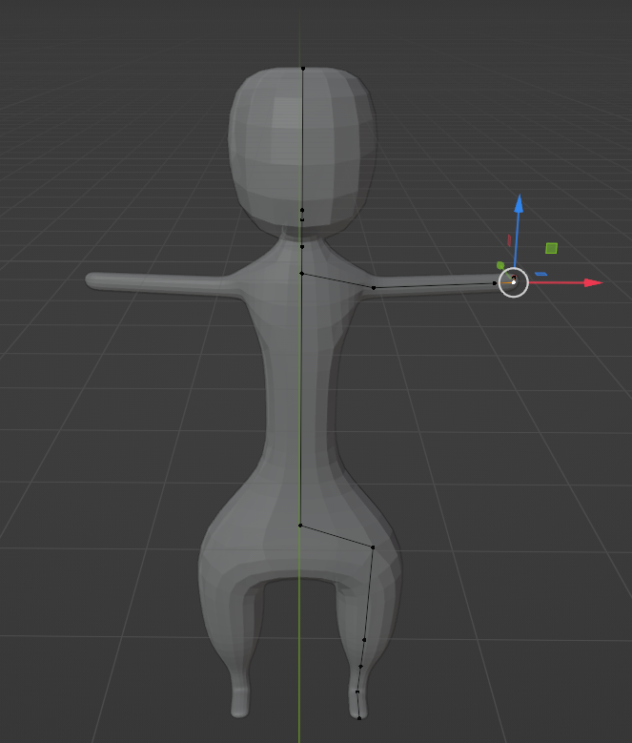

Sometimes I needed to subdivide an edge to create a new vertice (without the need to extrude one).

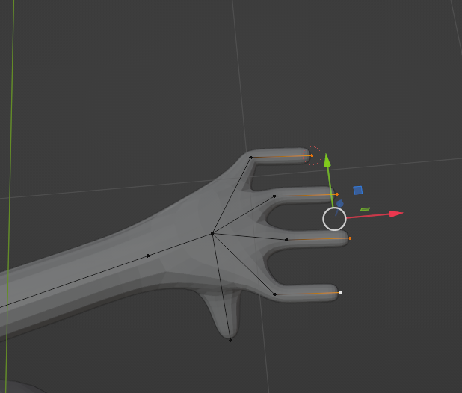

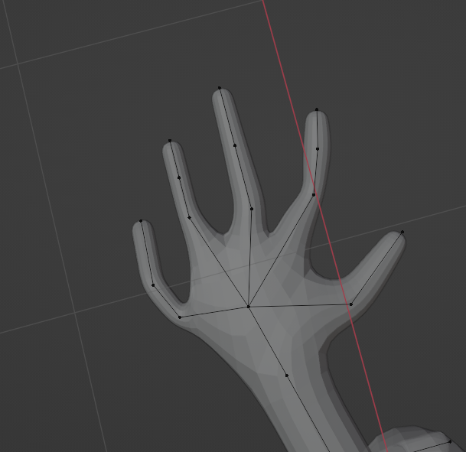

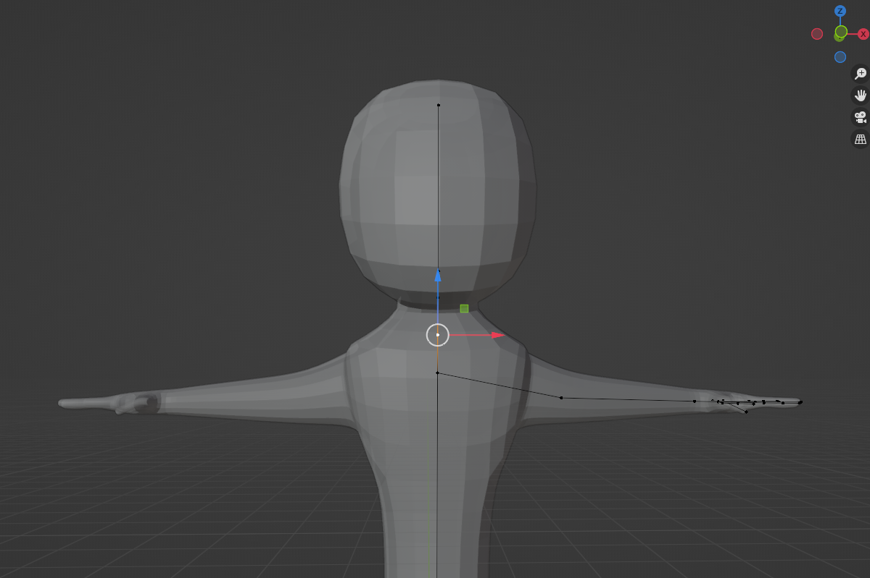

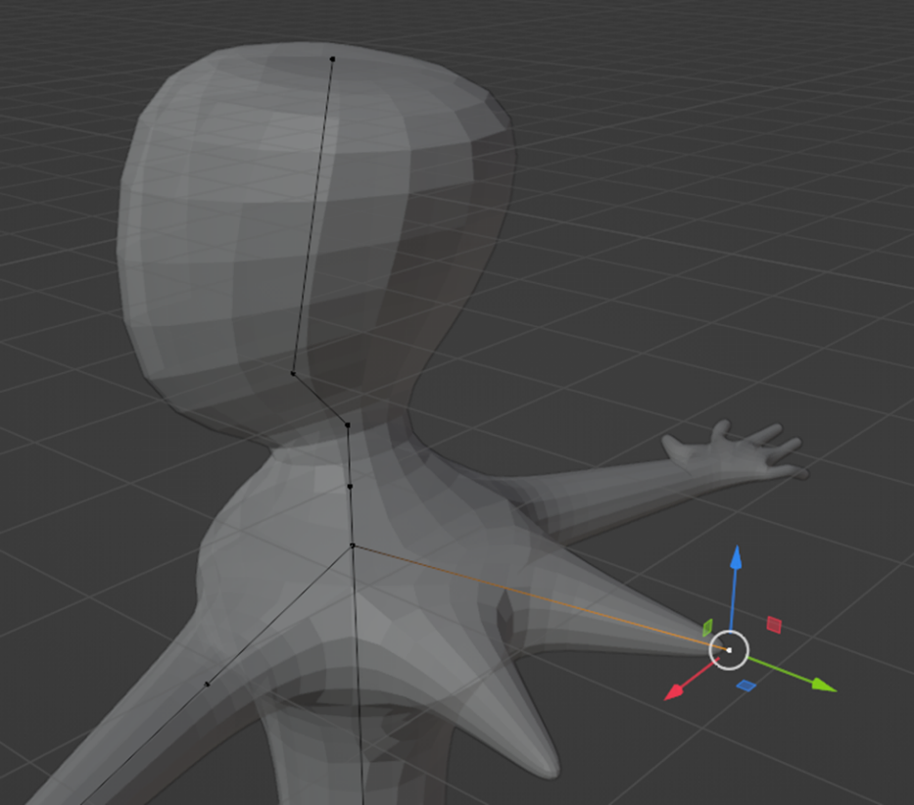

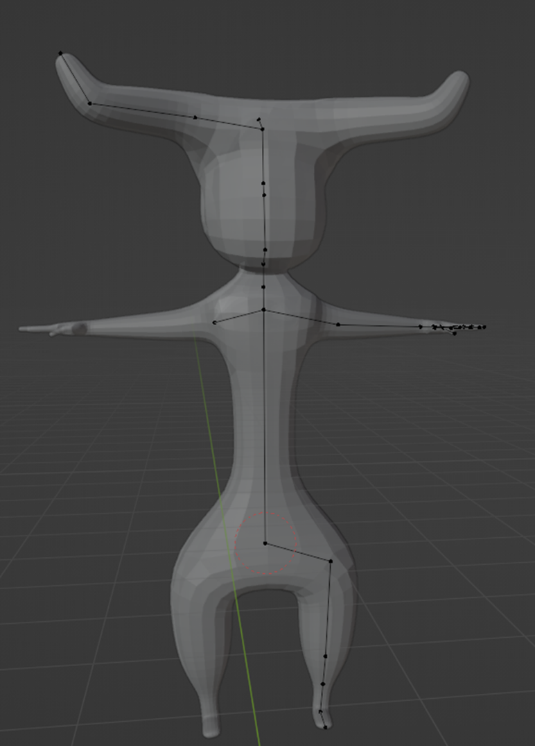

Ok, now about the small details, starting with the face. I first thought about using different meshes and placing them in front of the base mesh, and that’s what I did: I created two eyes using two spheres and two eyebrows using a scaled plane with a solidify modifier, followed by a bevel one.

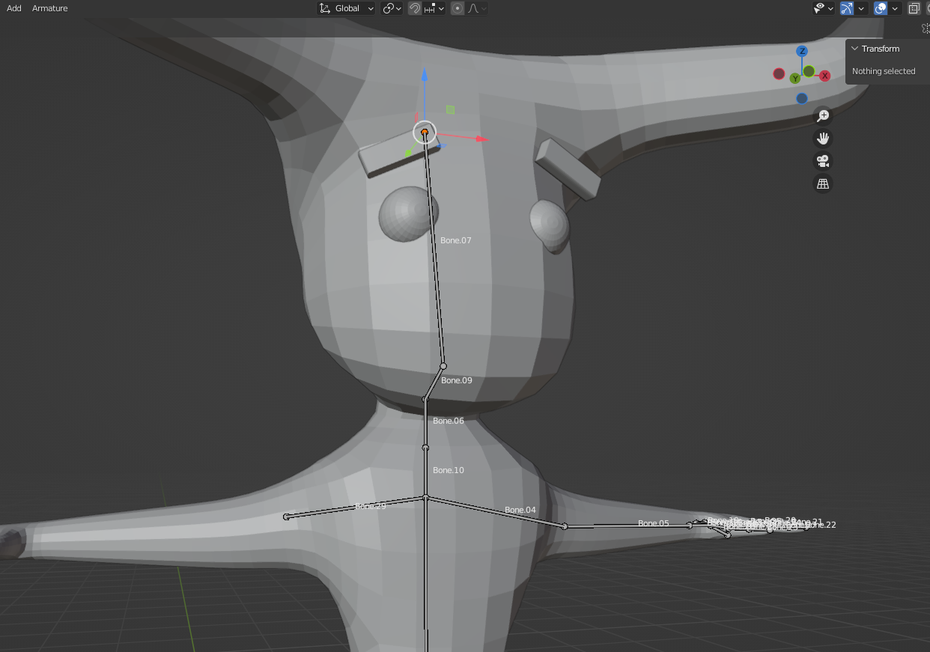

Other faced parts, such as the mouth, the ears, or even the nipples and the belly button, were created using an extrude and scaling. For the nose, I applied a bevel to the vertice, so that I could have a face to extrude, and then extruded it. Some details, such as the pants elastic, where made by extruding along normals.

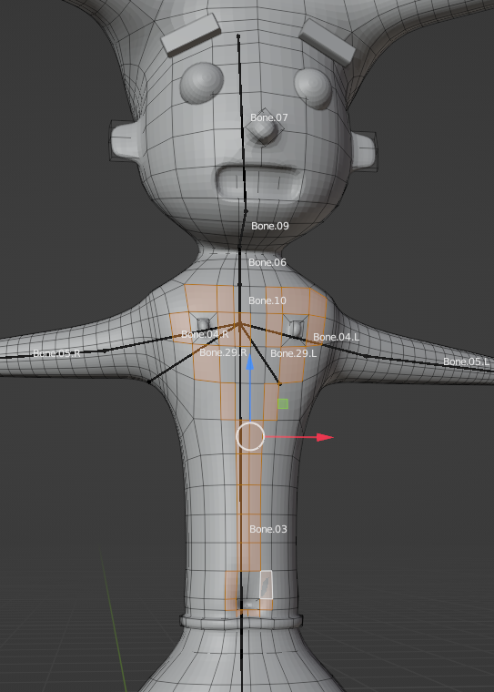

The overall model seemed done. So it was time to start making the body hair. For that, I created particle systems, starting with two – one for the torso hair and another one for the armpits hair. I then assigned to each particle system a vertex group/a group of faces that were previously selected. 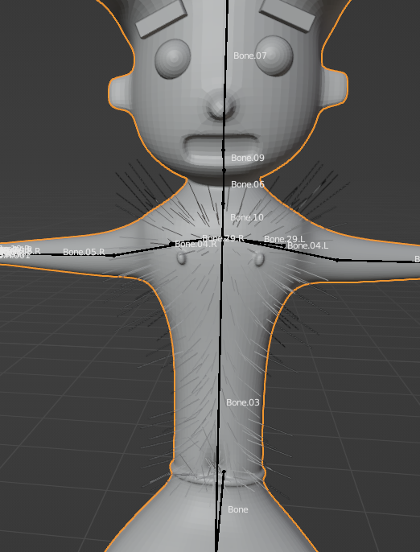

I then converted the particle systems to a mesh, and I noticed that there were no faces involved, just edges! No way this would be visible in-game. So I decided to convert the mesh to a curve, and under the object data properties, on the section Bevel object, I assigned a previously created Bezier circle with such a smaller radius.

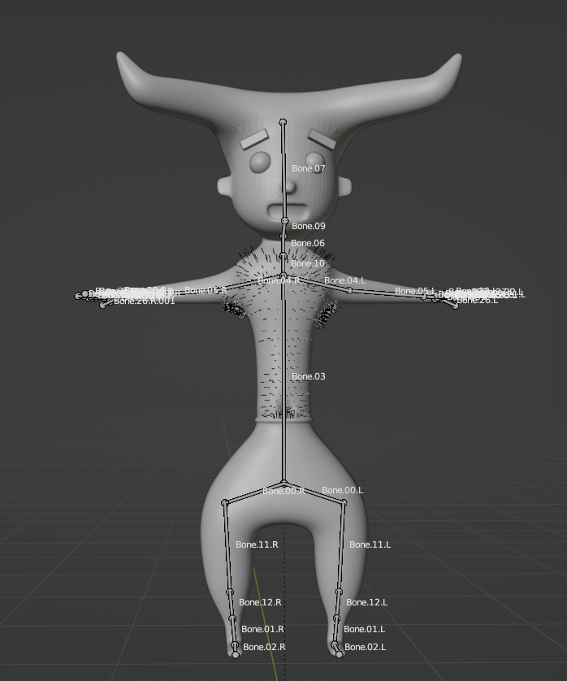

After this, I applied a decimate modifier to all the hair meshes.

Later, after trying rigging the character, again and again, I concluded it was better to model again this character. Why? I did not like the outcome. The face was childlike (I know, it almost looked like a 4-year-old boy drawing), and because of multiple separated meshes that I needed to be reparented to the main mesh, I had too many problems making the rigging and the animations work. So, I had previously a backup file with the starting mesh and made the details only using loop cuts, extrudes (some of them along normals), and scales.

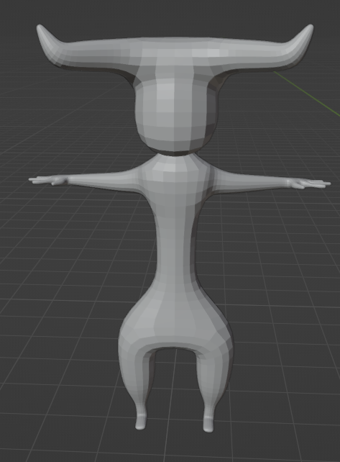

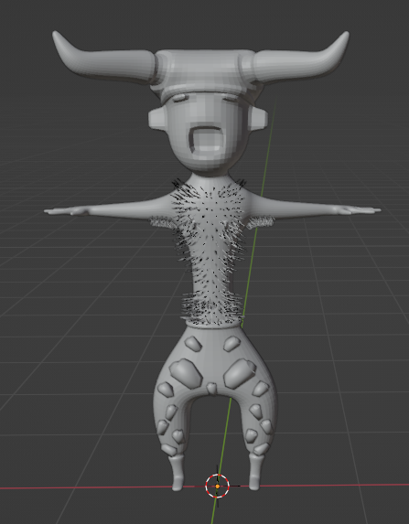

I established to not model the nose because I thought it was better looking like this. And although I wanted to only rely on extrudes, I decorated the pants with some beans, a previous mesh that I made.

Bean

This was one of the first models that I created for this game. I first started with a curve, edited it, and closed it. Then, I converted it to a mesh and extruded the edges (that at the time were the only existing thing). After having a base mesh, and to close this mesh, I started making extrudes and scales. I also edited some edges and vertices by hand and used the subdivision surface modifier. In the end, I decimated the mesh.

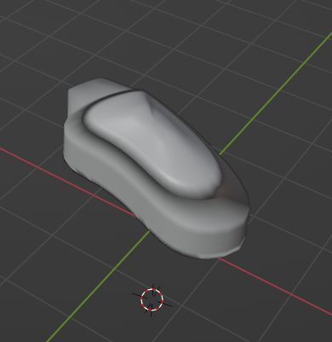

Stress Level Bar

The stress level bar is a mix of three models – a scaled cube that had a bevel modifier applied, a bean, and a scaled cylinder, to connect both previous meshes.

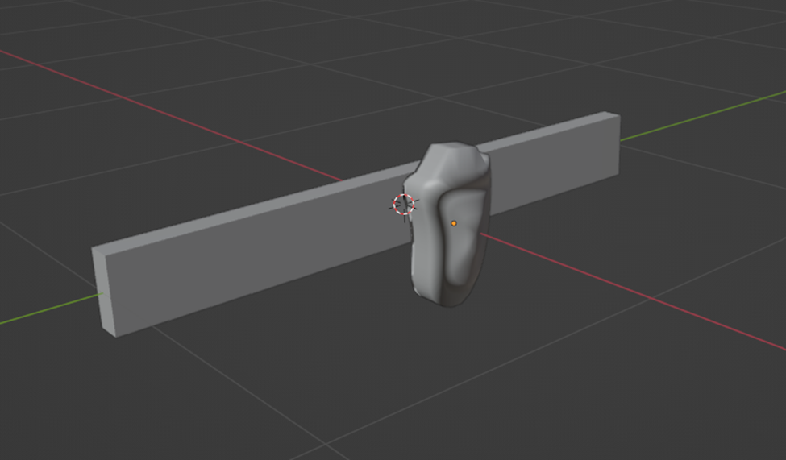

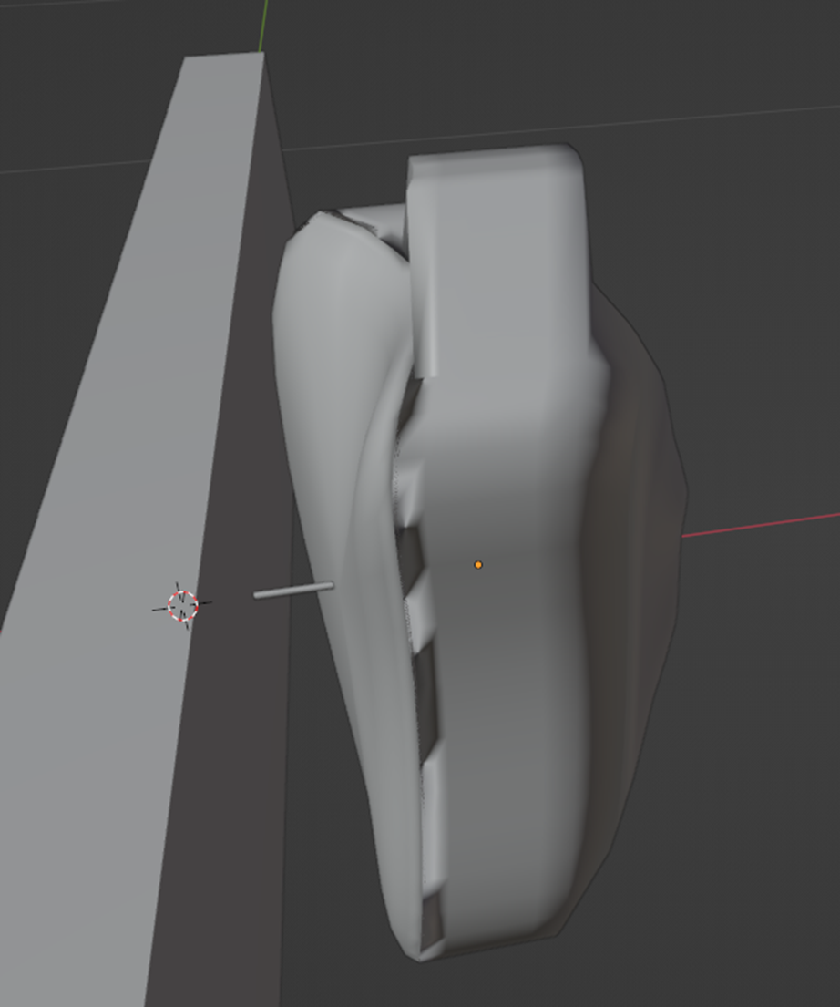

Background

* Animation
* Collectibles

Each collectible had two animations that were created by me: a default animation and a dissolve animation. Their default animation is them rotating on a loop, and then when they collide with the character, a transition happens between the default and the dissolve animations thanks to a trigger. This last animation consists of changing a parameter defined by my created dissolve shader – the cutoff height. This number goes to negative values so that the mesh incrementally disappears.

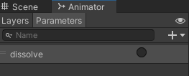

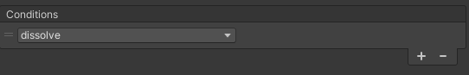

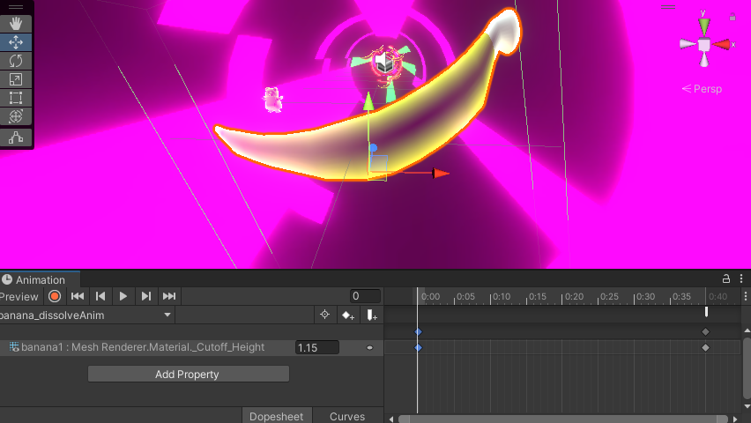

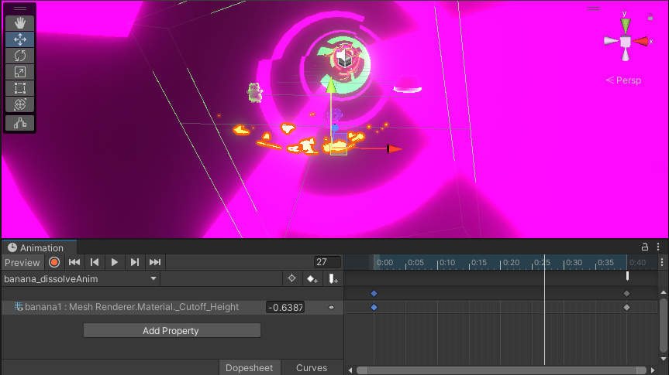

When the animation ends, the gameObject is disabled.

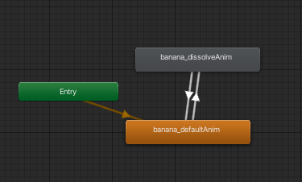

For the default animation to be a perfect loop, so that it does not start or end with a different speed, both tangents were set to linear.

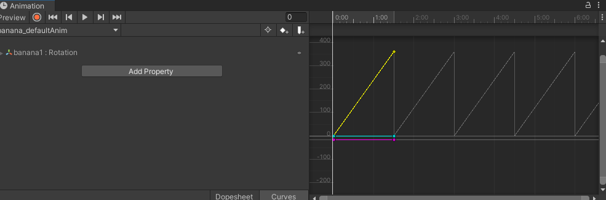

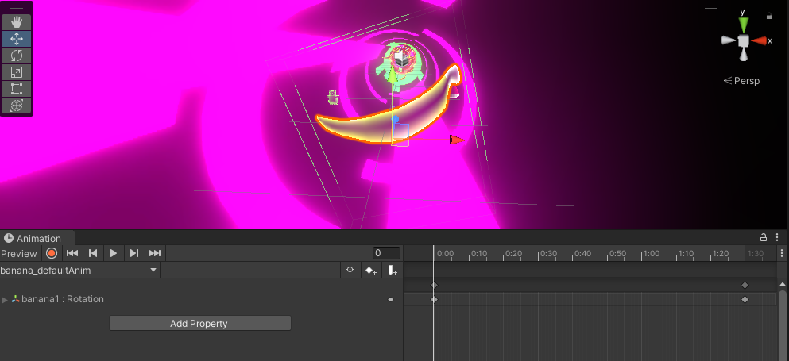

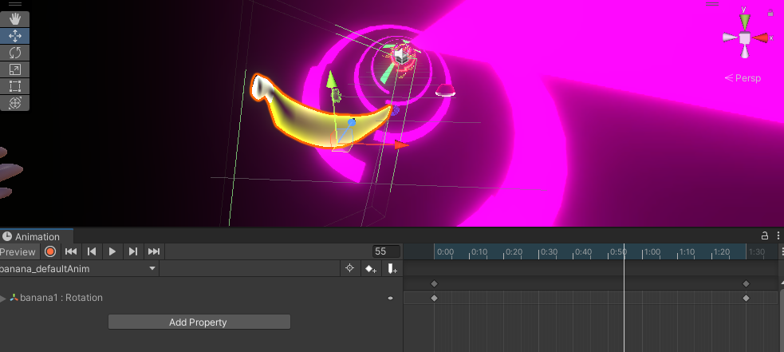

* Obstacles
* Walls

The only wall that can have an animation is the cross wall, just to add a challenge to the player and check if he can pass through a hole. It only has a default animation, the wall rotating.

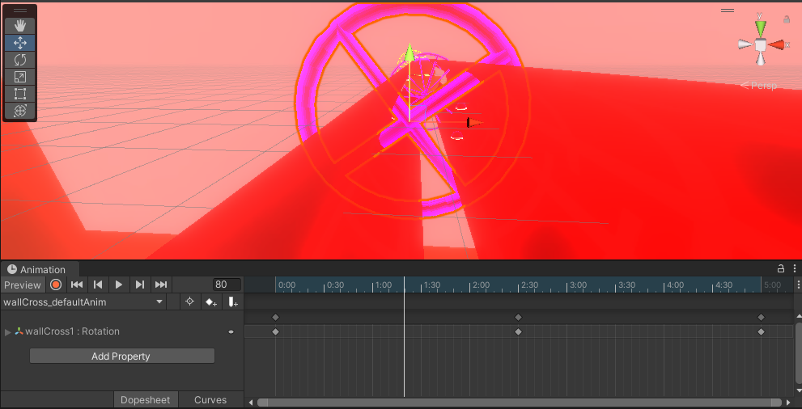

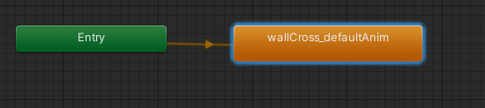

After checking that the cross animation was too fast, the animation speed was changed to a smaller value.

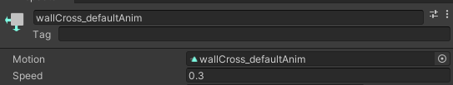

* Narrative related
* Pregnancy test

The pregnancy test object can have one of three default animations: a rotation (almost just like it was shaking to one side and then to the other), a translation, and then a custom one, using both rotation and translation. This last one is an animation with such a faster time rate.

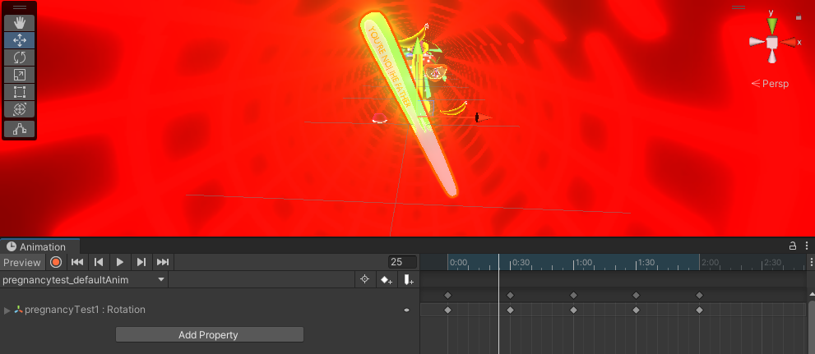

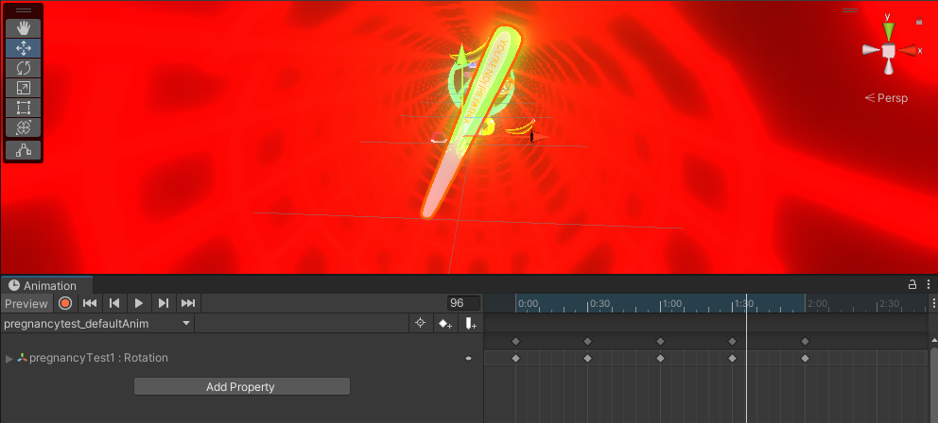

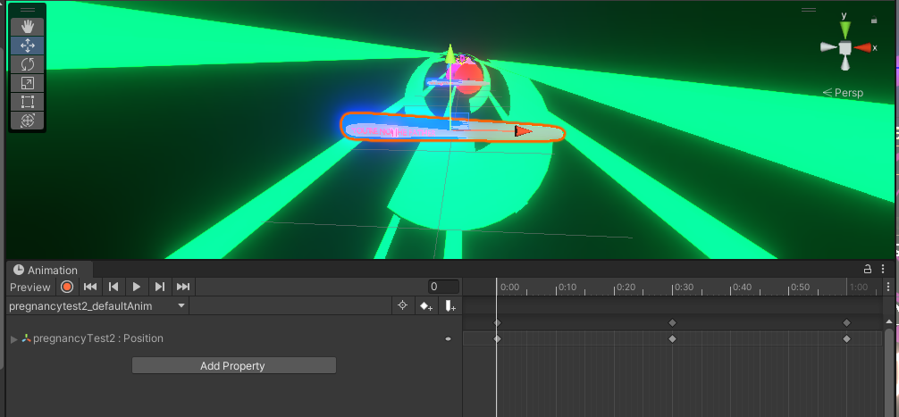

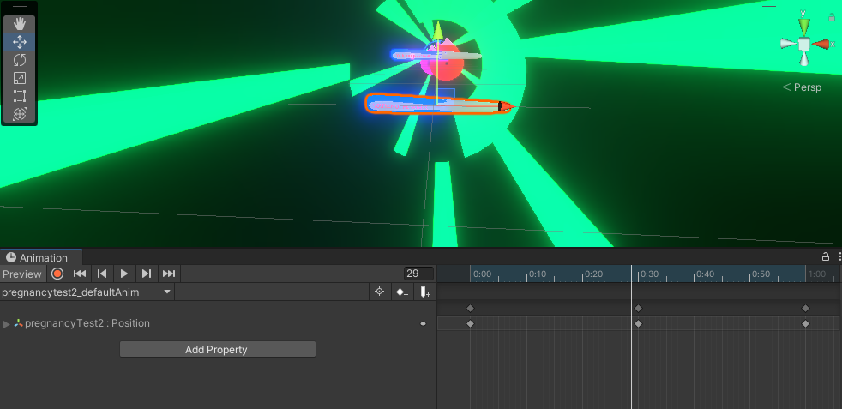

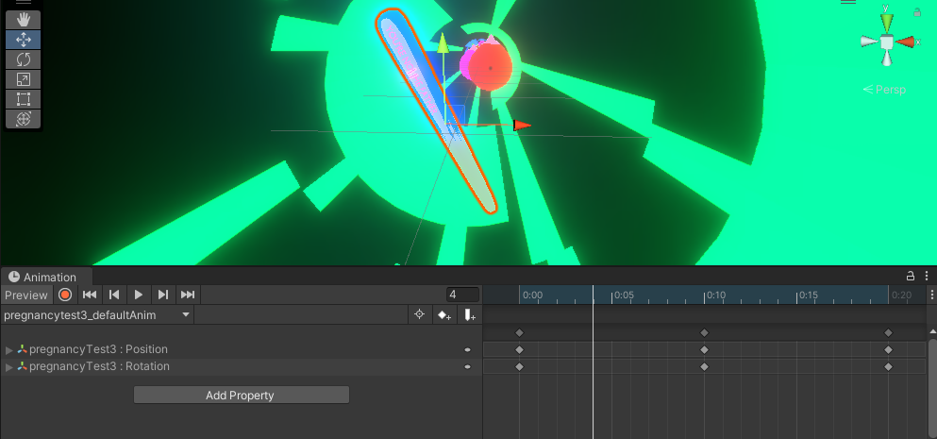

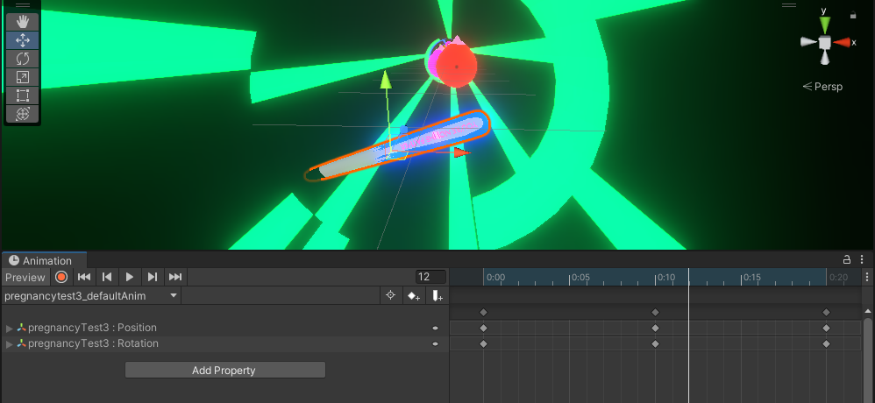

For the animations that were only concerned about only the rotation or only the position, the tangents were assigned to linear as well.

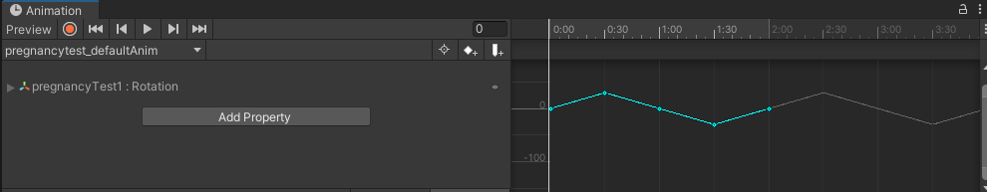

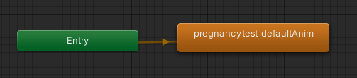

* Penis

Penis objects can also have considerable default animations – depending on the starting position and the rotation direction.

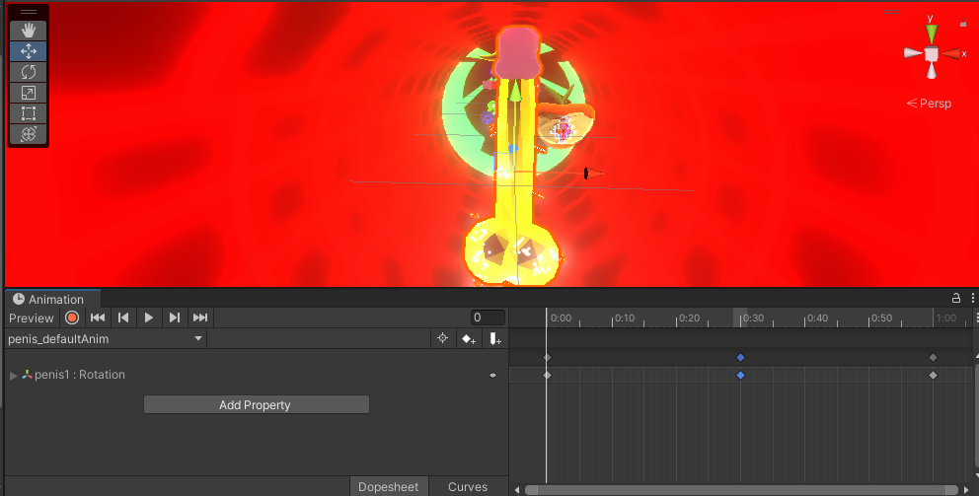

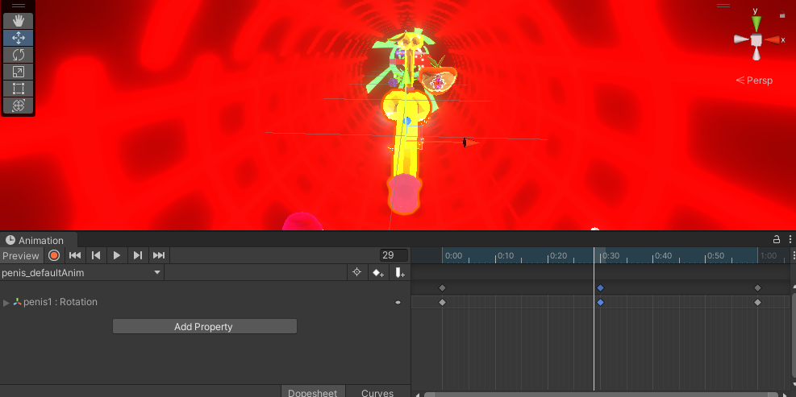

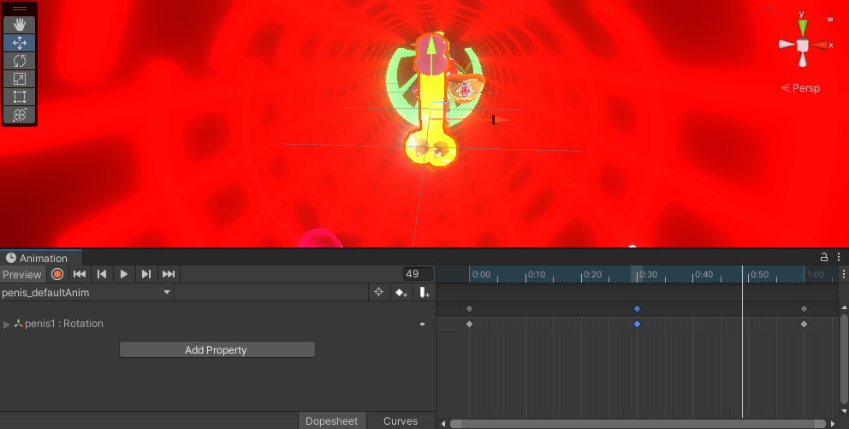

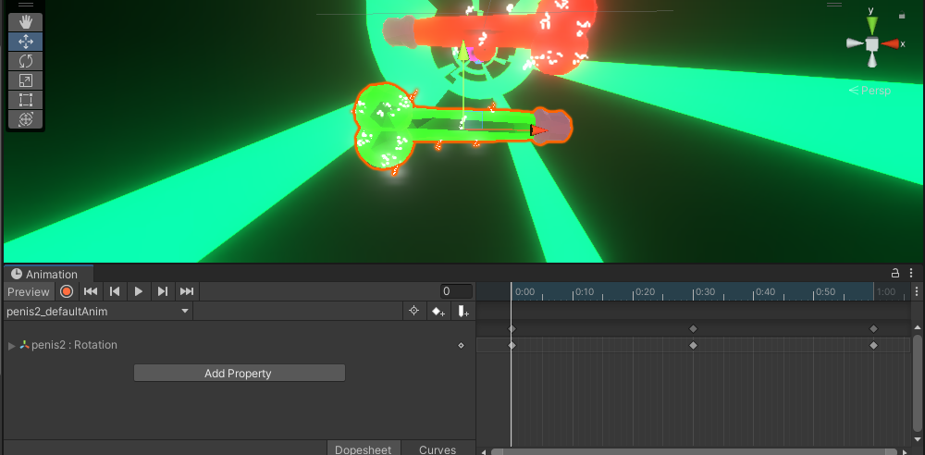

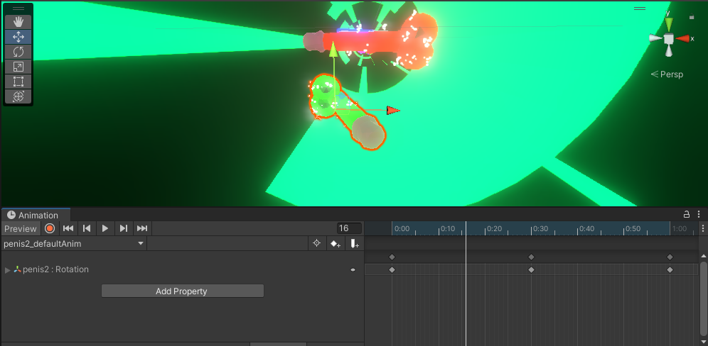

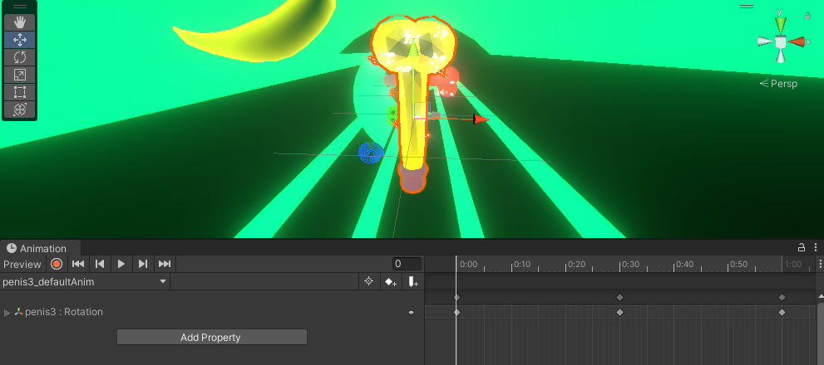

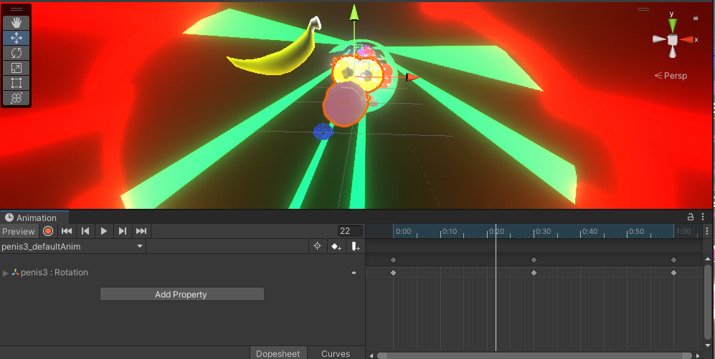

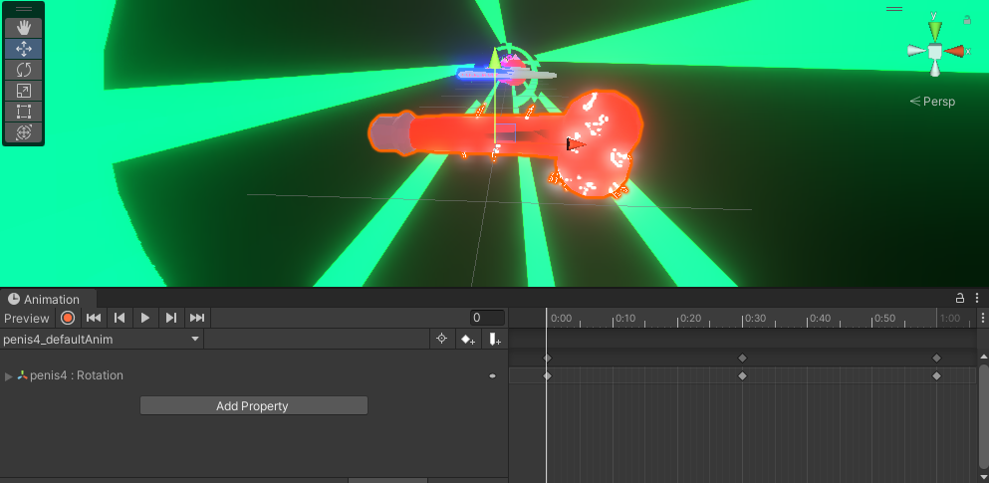

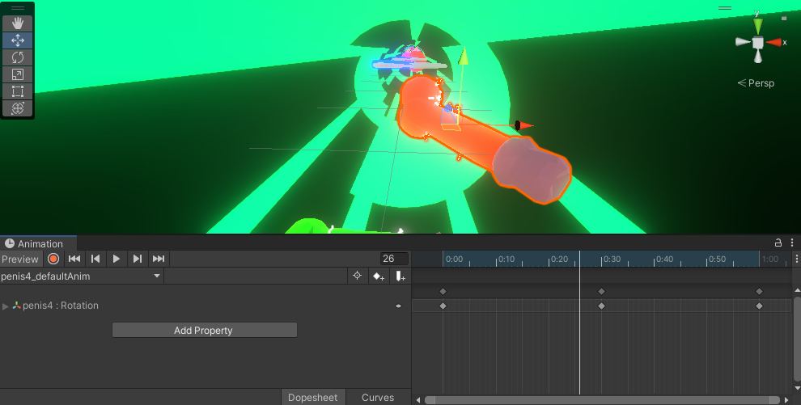

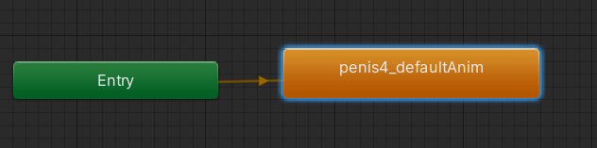

* Breast

To make the breast animation, I initially wanted something that would shake the model like jelly. And so I started searching about soft bodies and how to make them. I discovered that, in Unity, it’s easier to make soft bodies in 2D environments, using bones, moving them, and linking them using spring joints. So I decided to give it a try, using bones in a 3D environment, using the same methodology.

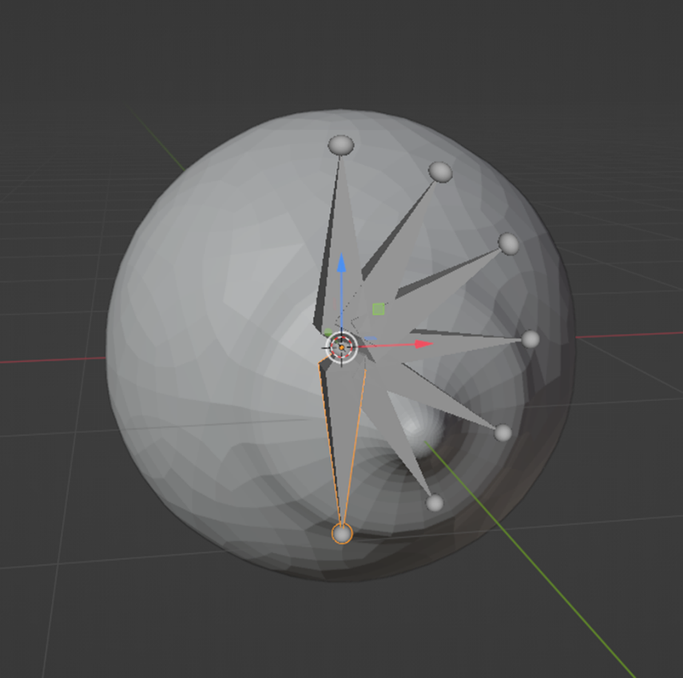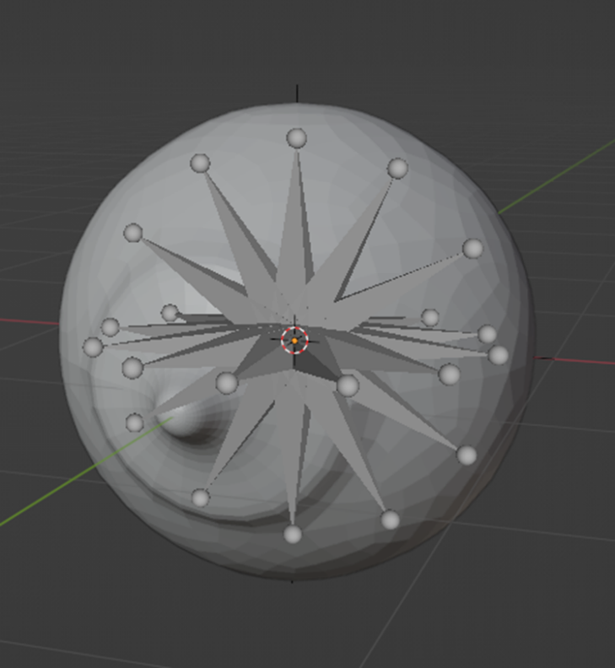

However, when I tried this in Unity, I did not like it – to move and link all the bones by hand. It should have a better way of doing this. That’s what I thought.

Then, I started looking for ways of instead of doing soft bodies in Unity, doing this in Blender. And bingo! I found it.

In Blender, I added a plane and, under the physics tab, I added a collision. Then, I added to the breast model a soft body, and gave it some Z-axis height. After this, I played with the values related to the Edges section.

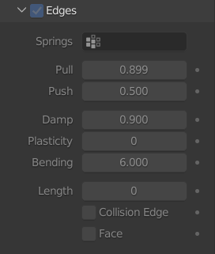

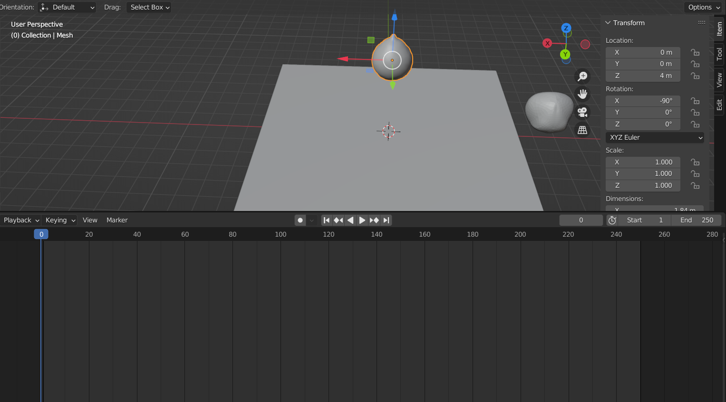

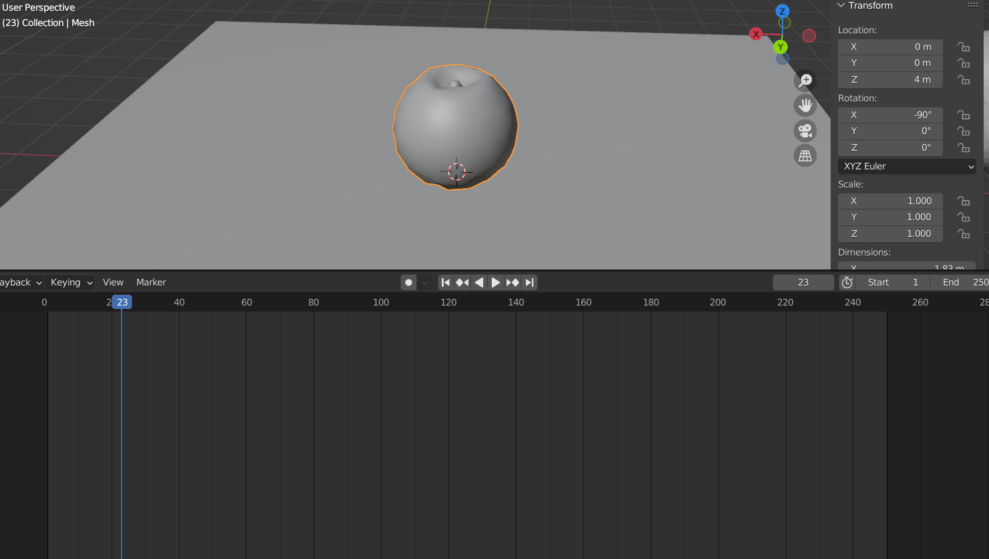

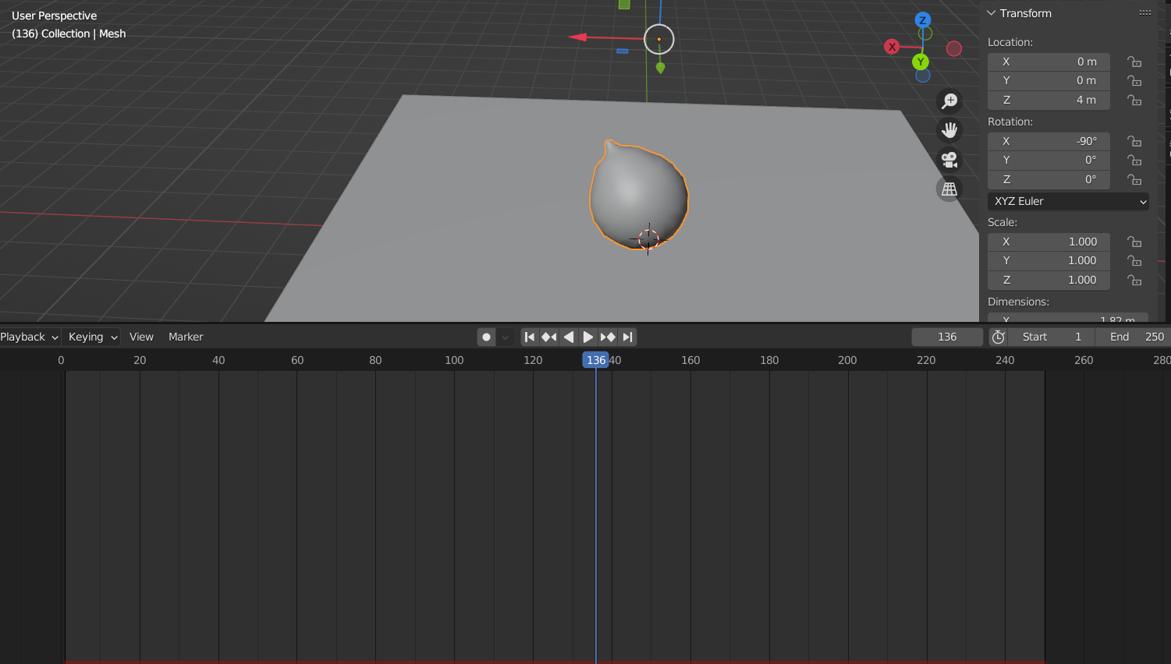

Then, I exported the model as an Alembic file and used it in Unity. The animation was able to play, recurring to timelines.

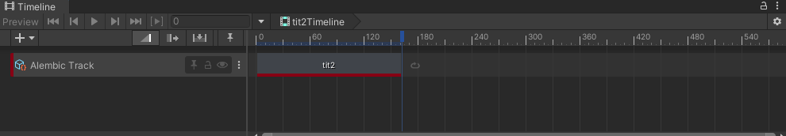

All this work… I even tried enabling the option Goal in Blender and playing with its values, so that it could bounce multiple times.



But the overall result in Unity was barely noticeable. And after making the same procedure over and over again and it was never convincing, I decided to drop it :’(.

I simplified the animation – and just picked the initial mesh, and in Unity changed the scale values.

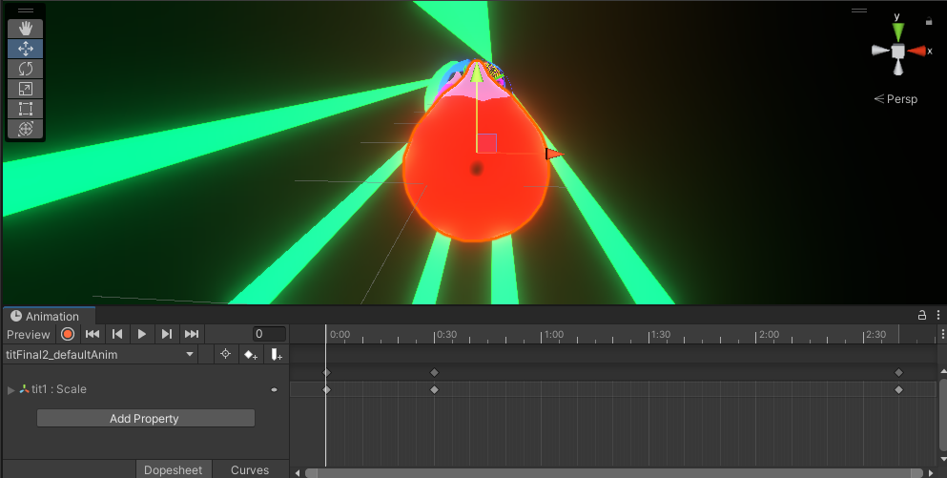

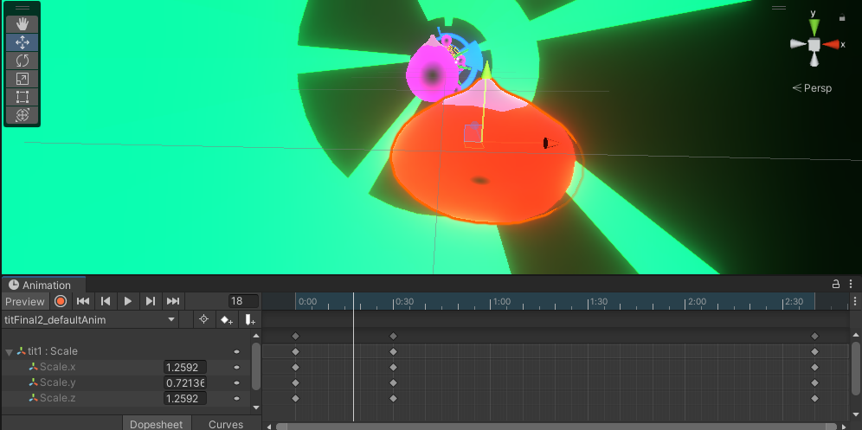

To finish this section, I wanted to assure you that not all breasts are animated – the smaller ones are not.

* Nanail, the character

Before jumping into the character animations, I first needed to make the rigging. And you know what? The skin modifier allowed to create automatically an armature! Such a life savior, I thought.

On the other hand, when I exported it to Unity, and applied the humanoid rig option, it never accepted it – there were always problems with the bones assignment! My first thought was “start dissolving some bones” and to learn a little about anatomy – but it did not help much! With this armature, my character, instead of running as it should be, he was jumping still! It remembered the Gingerbread Man from Shrek. Awful.

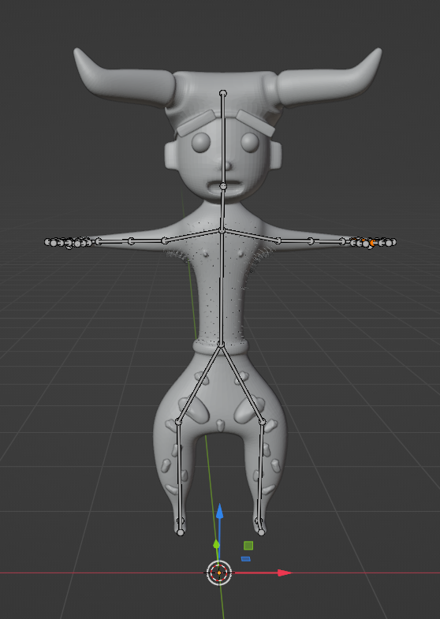

I even thought about making my armature all by myself, and I even did it, but it did not work either.

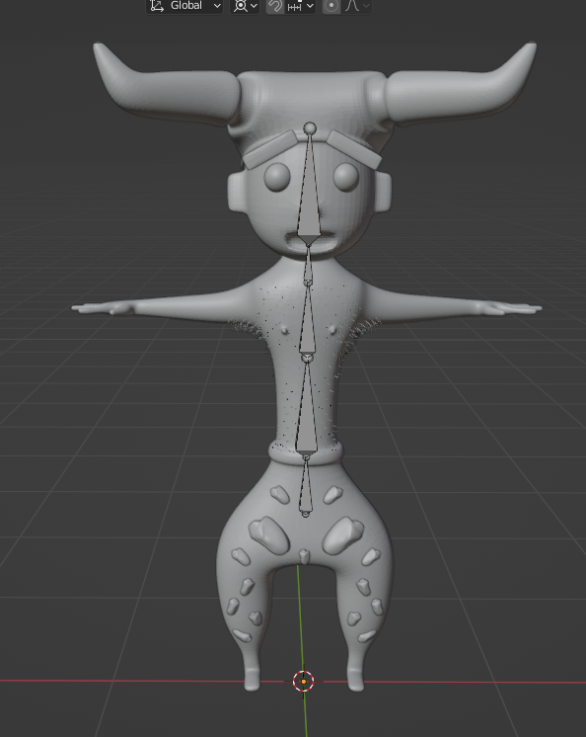

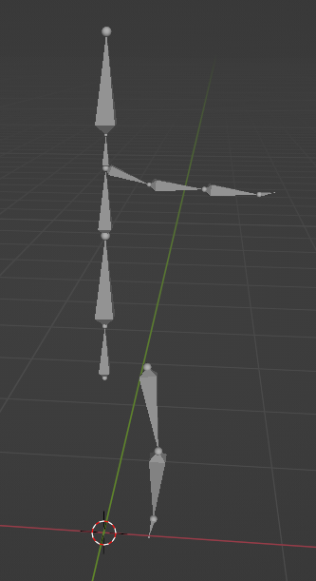

So, I retried a few times to make the rig, starting with the output that the skin modifier already was giving to me. And ended with a pretty satisfactory result. The bones that were not connected had the legit parenting and so on.

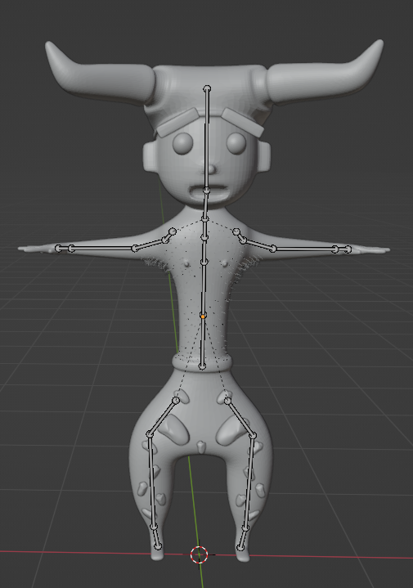

But again, not working! And do you remember when I told you that the joined meshes, even though they were reparented to bones from the armature, were not moving well in Unity as well? I SAID ENOUGH!

And I restarted the character modeling at this step.

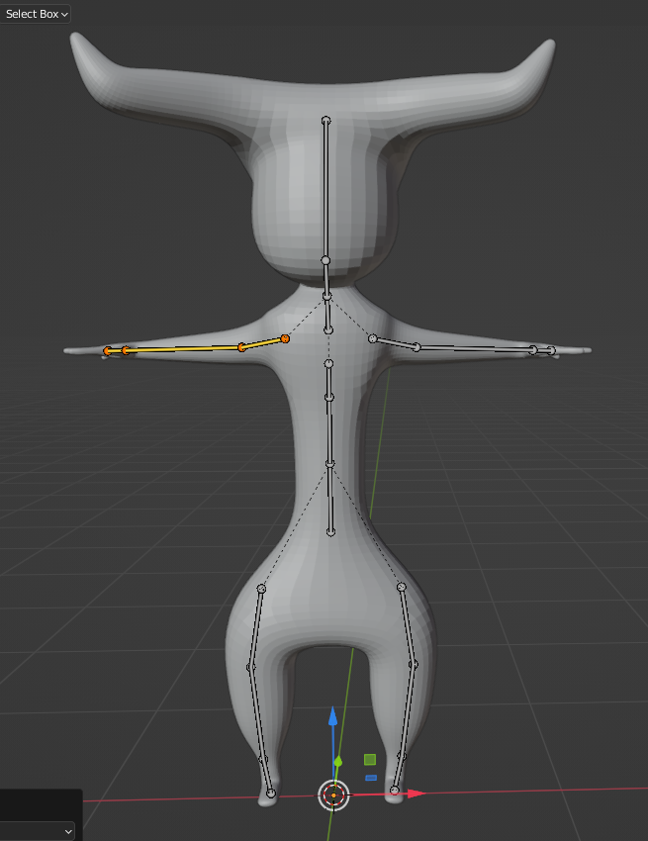

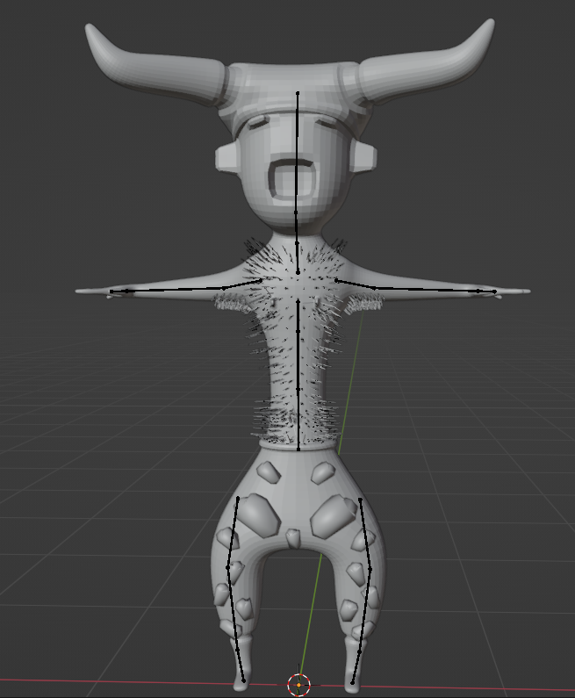

This time, the rig worked better in Unity – the running animation was working – but the mesh was distorted, mostly the area where should be the knees, and the hands; they looked like Spider-Man’s hands. So, I learned that Mixamo could make my rig automatically thanks to their algorithm, and that’s what I did. Problem solved! I uploaded my character, assigned the main parts of the body to it, and then, after the rig was made, I selected a running animation to use on my game.

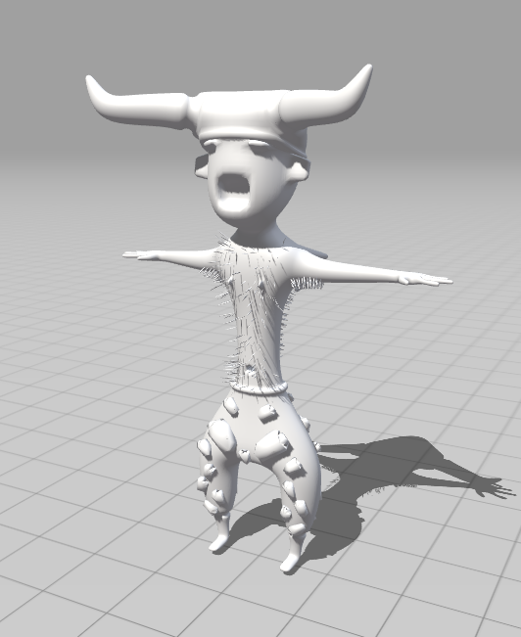 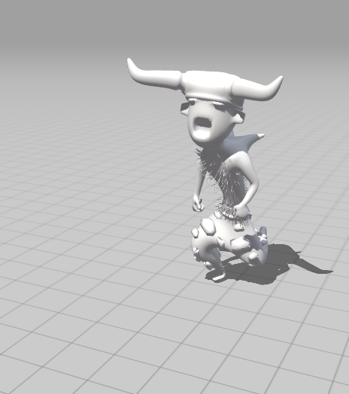

In reality, I wanted to make my own animations – I thought about using Plask, which was a tool used in one of the practical classes in the Modeling and Animation curricular unit; I needed to record a video where I was making the animation movements, and then upload to this online resource. But, because of lack of time, I focused on the humanoid animations that were available in Mixamo.

My character has a total of three animations – running, which is the default one, dashing when the user dashes when clicking the arrow up, and then the dying one, when the stress level goes out of range, based on the stress level bar. All these three animations were imported from Mixamo by using the retarget method learned during the Modeling and Animation curricular unit.

I had a problem when looking for a good dash animation to use for my game – all the dashing animations did not have an “in place” option! What should I do?

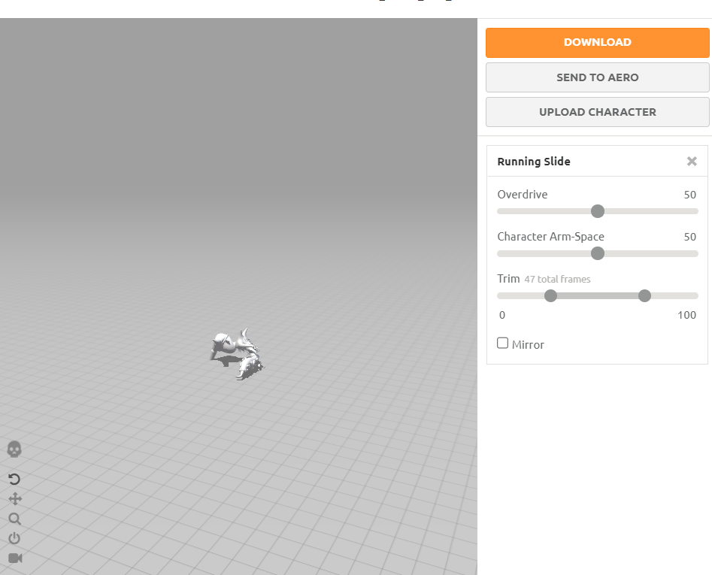

Well, I found a Blender add-on (which I needed to purchase) called In Placer; what it does is, when you open the model from Mixamo with the animation, and you enable this functionality, it converts this animation so that it works, but stays in place. Before purchasing the add-on, I tried to remove some keyframes and edit the animation in Blender all by myself, but it was too confusing for me, and I did not have much time to do all that work. Work smarter, not harder!

Returning to the overall character’s animations – three of them, the default one being the running; the transition to the dash animation happened thanks to a trigger called “dash” and the transition between one of the transitions and the death animation was made recurring to another trigger. After finishing the death animation, an animation event was added to trigger the default animation.

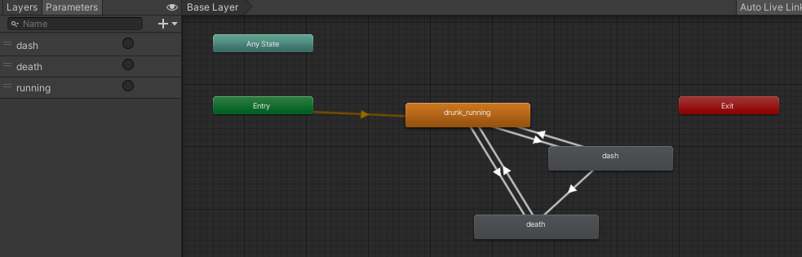

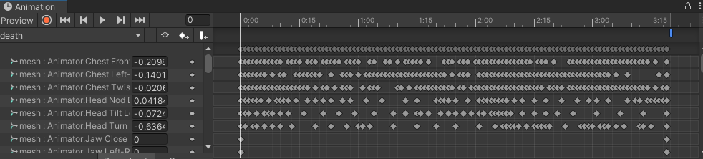

I thought about adding another animation for when the character falls through a hole (which is not considered dying), but I did not add it for two reasons – I liked the aesthetic vibe that, even when falling, he was still running, just like he did not notice that his environment had changed; this reminded me, for instance, Sonic Heroes, a PS2 game where, when the user goes out of the level itself, you can still play your character whatever you want to for some seconds. The other reason was that I did not want to exaggerate on using external resources – that were not made by me. It’s better to be worse but it was done by me while trying to learn than to be better but it was done by someone else. That’s what I thought.

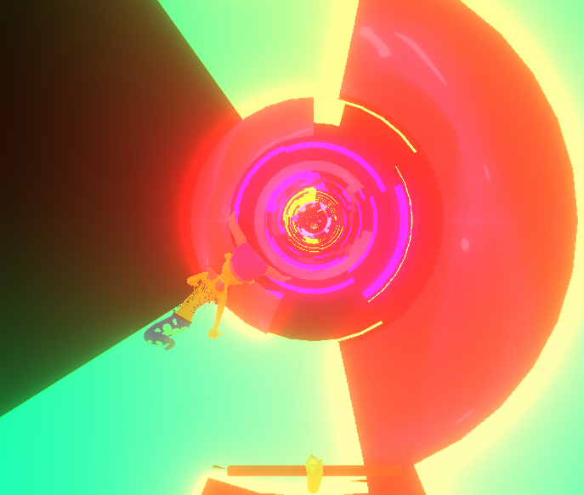

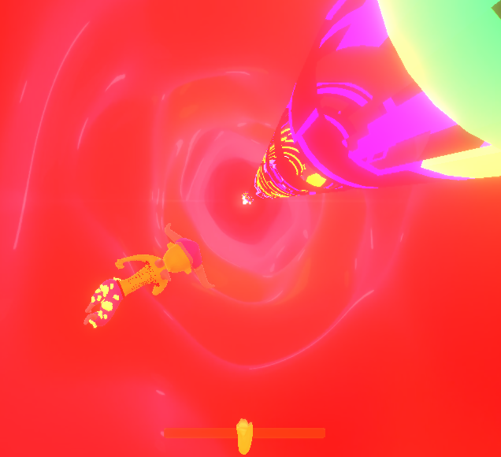

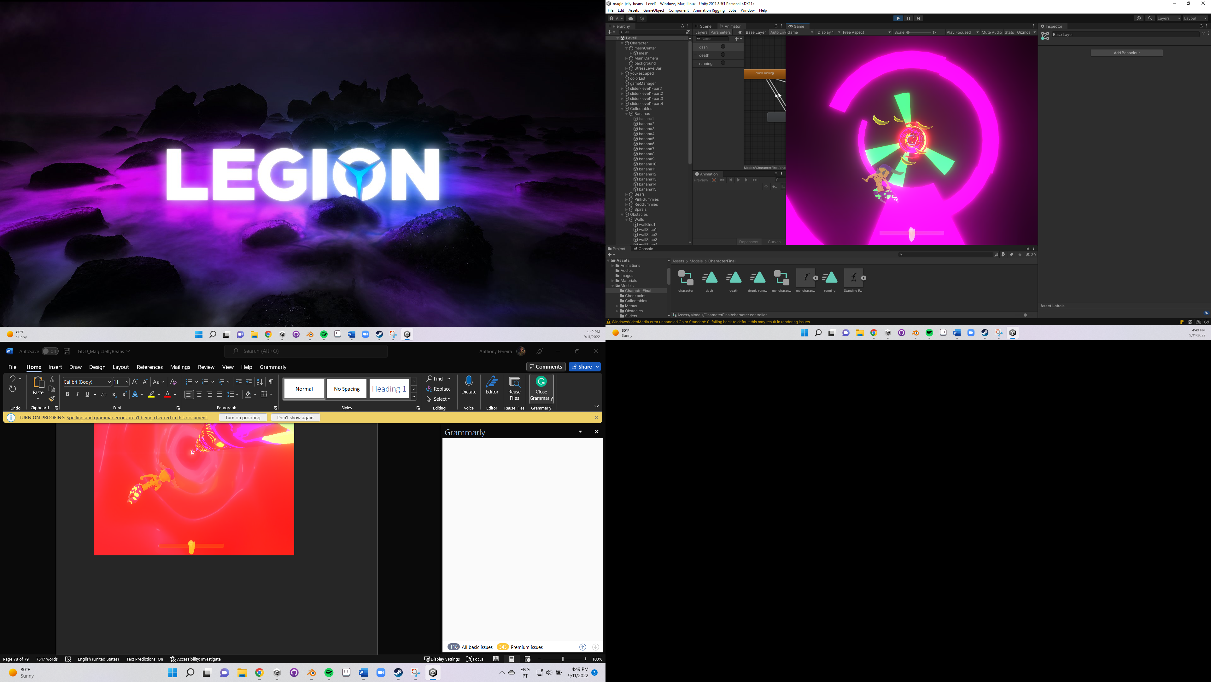

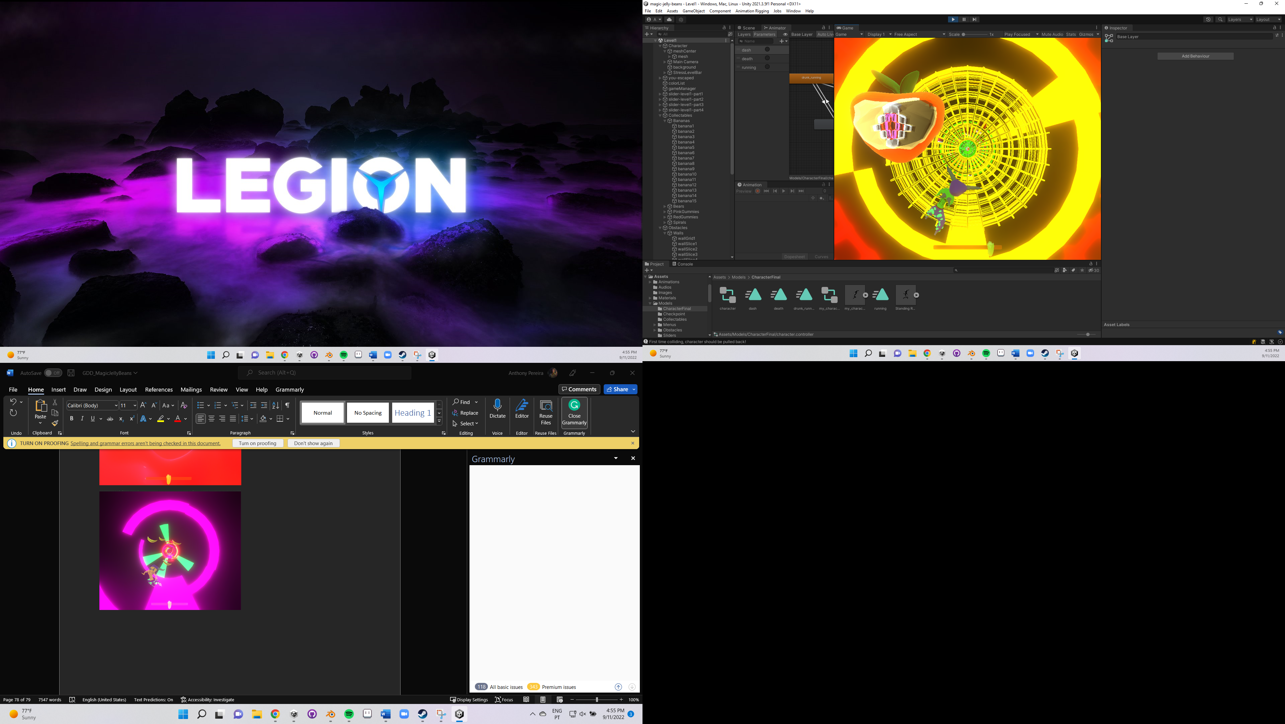

Intro

To make the intro to my game, I wanted to make some small sentences that could resume the overall story and animate them so that they are shaking like jelly. Do you recognize what I’m saying? Yes! Soft bodies! I used the breast methodology that I dropped to make this introduction.

But first, I needed a font. Which should I pick? I was pursuing a childish-sweet font, handwritten, that I could play with. I searched a little on the Internet for free fonts, but I did not like the ones that I found. I wanted a nice-looking handwritten “g”! And then I realized that my computer had a font called “Kristen ITC”. I just fell in love.

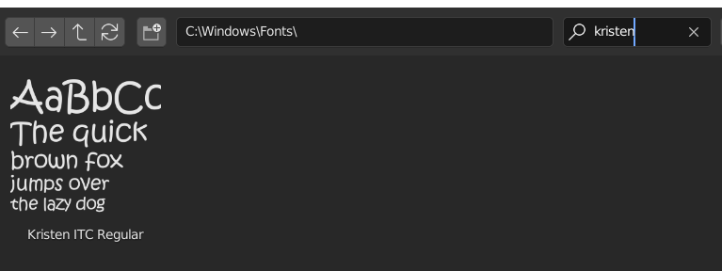

So, I picked this font and made a bunch of previously thought sentences, added a solidify modifier followed by a decimate one, and converted all the text to meshes.

Then, I played with the values related to the Goals and Edges sections, so that the text could better bounce, and exported the meshes into Alembic files.

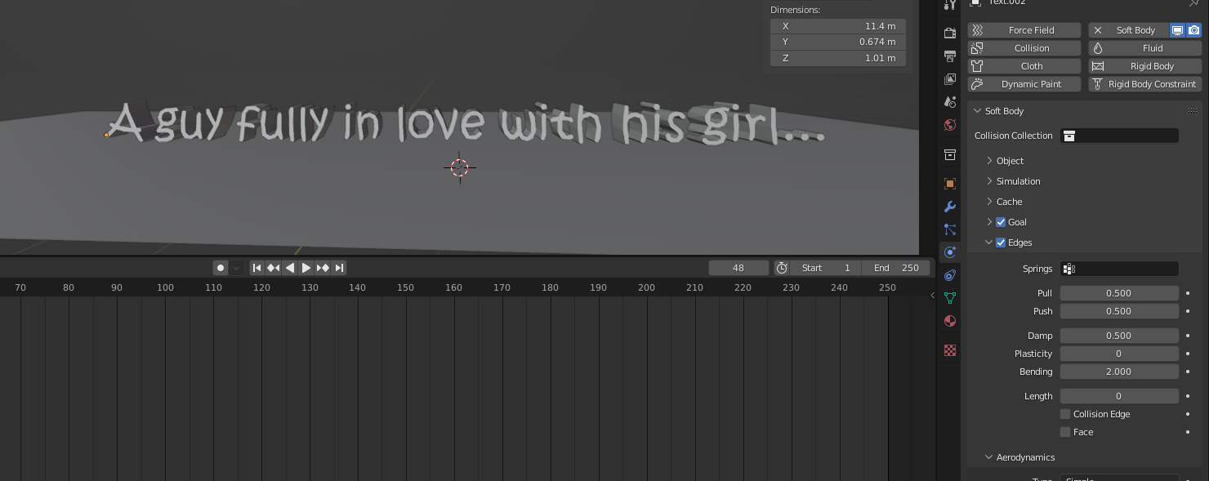

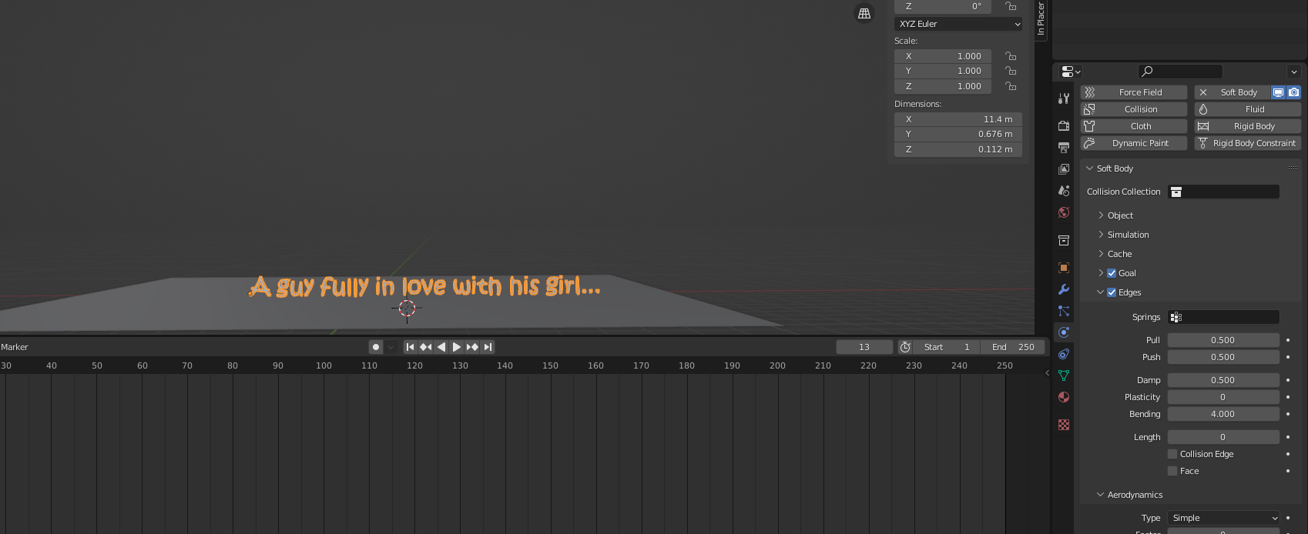

Background

Post-processing and shaders

For the glow to work in my project, I installed the package for enabling the Universal Render Pipeline (URP). I first turn on the post-processing on the camera, and then added a global volume with the bloom effect enabled.

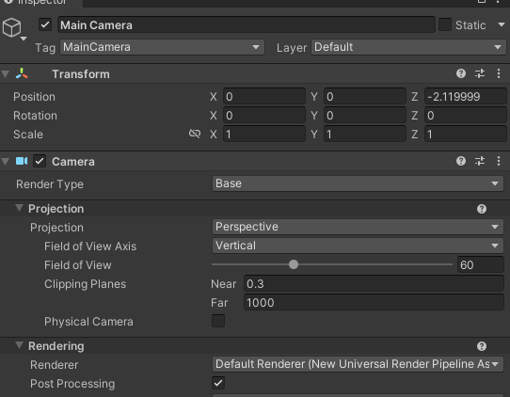

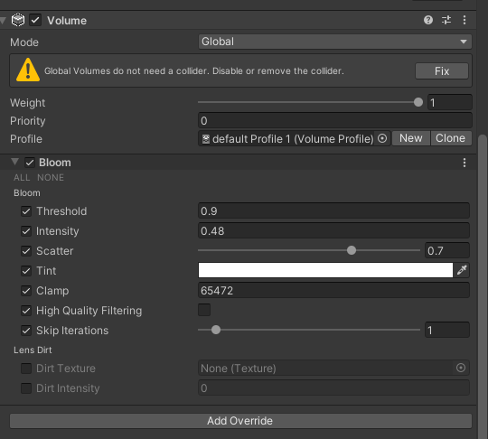

I made up three shaders using ShaderGraph: one with a glow effect, another one for the dissolve animation (needed for the collectibles after being collected) and another one for the slides. Let’s start with the glow effect.

* Glow Effect Shader

So why did I make a glow shader, if I could only create an ordinary Unity material and assign it with a colour with some intensity since HDR is supported? Well – the answer is simple. First, I desired to try ShaderGraph (a visual interface to make cool shaders without the need of directly working with vertex and fragment shaders by hand? Seems promising.). And I did not want a uniform glowing effect – my goal was to have more of a mix between a glow effect but with some black or darker components, not just a plenty glowing object. Imagine all the objects glowing immensely, you could not distinguish them! And the collectibles were probably one of the most important components of this game.

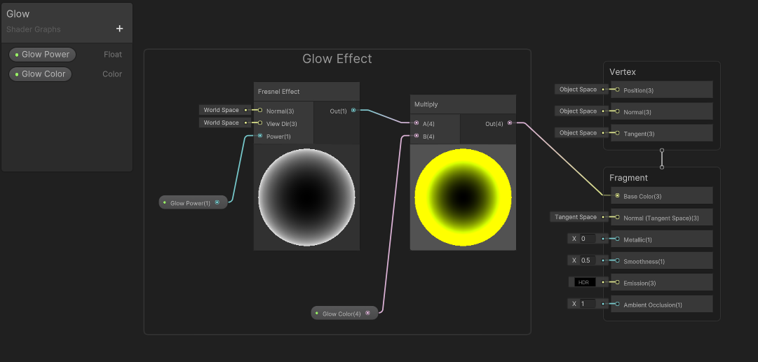

I declared two variables in other to edit these in the Inspector, glow power and glow colour – the glow power was used by the fresnel effect node, in which how much the glow power float value was bigger, bigger would be the dark area (and so, lower would be the glow intensity). I then used a multiply node to conjugate with the glow colour.

* Dissolve Shader

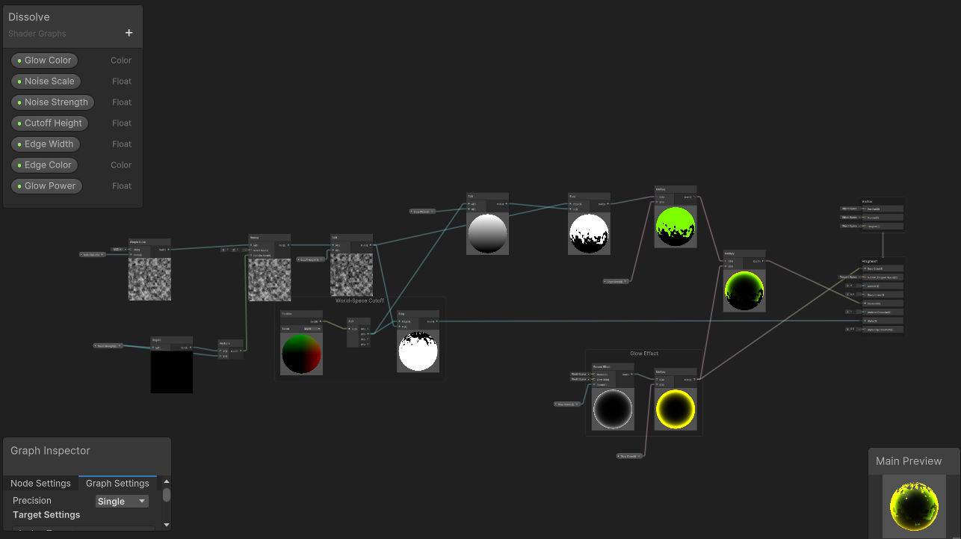

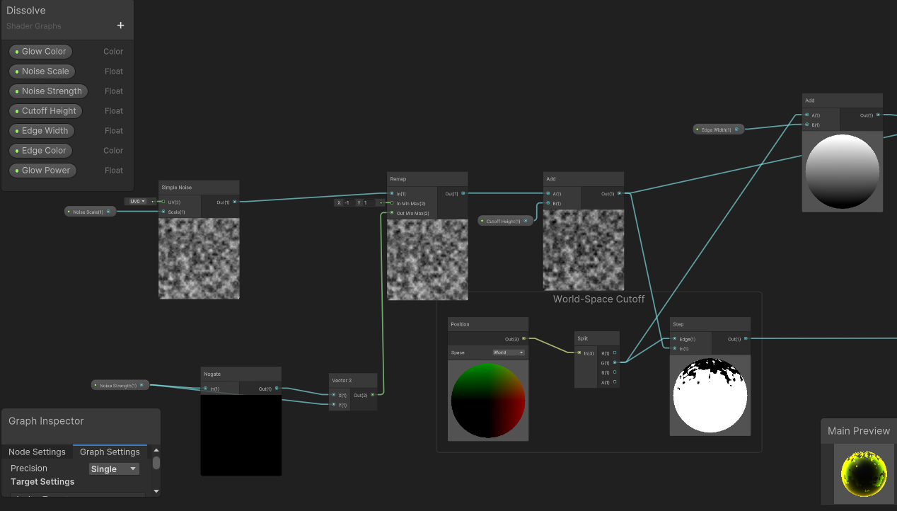

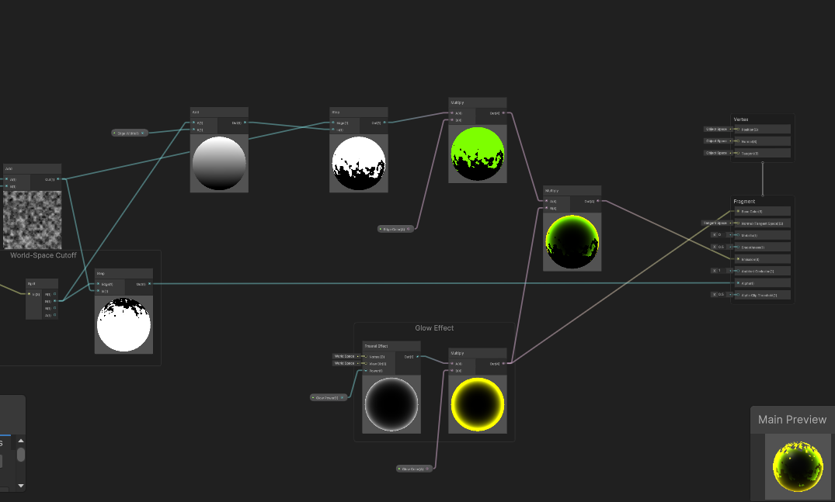

Do you remember the procedure that I described earlier about using a texture to, in Blender, create some slide holes? This was similar. I’m not going into too much detail on this one, because it’s a little bit tricky, but summing up, I used a simple noise that was conjugated with a cut-off height variable, the one responsible for the dissolve effect. Other variables were created, such as the noise scale and the noise strength, which were responsible for the texture scale (if it would make smaller details or not) and if the noise texture would be applied to all the objects or not, respectively. There’s also the edge with and the edge colour, wich their objectives are obvious – when the mesh is dissolving, there’s a line between the part of the mesh that is gone and the remaining mesh, which is the edge; this can have a specific colour and also depth.

Did you notice that the glow effect shader is also incorporated in the dissolve one? Yes, I needed to make this because I had some problems using both shaders at the same time on the same mesh. I tried to search about shader pass and that this could solve my problem, but since I had so little time and I remembered to fuse these two shaders, I ended up doing that. I still did not delete the glow shader, because I eventually used it to define all the obstacle materials (that did not need to be dissolved).

* Grid shader (for slides)

For the slides, I wanted, again, something related to glowing. But I thought “well, I wanted to use more wireframes!”. So why not both? I ended up making a shader that makes a square figure, this figure is then divided into numerous fractions defined by the Vector2 Tiling. These lines are then moved because of the Time node – the X was assigned to Time to make it move always in the same direction and the Y to a sinusoidal function to make it move both to the left and the right.

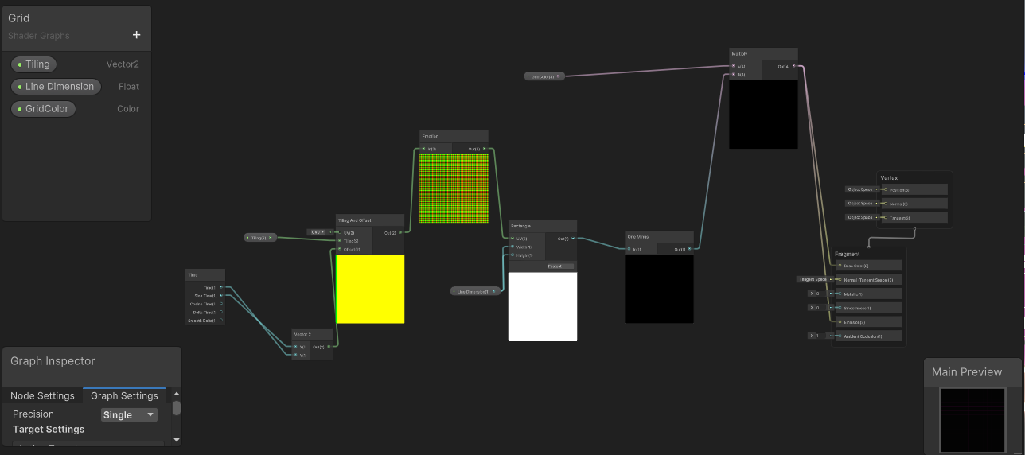

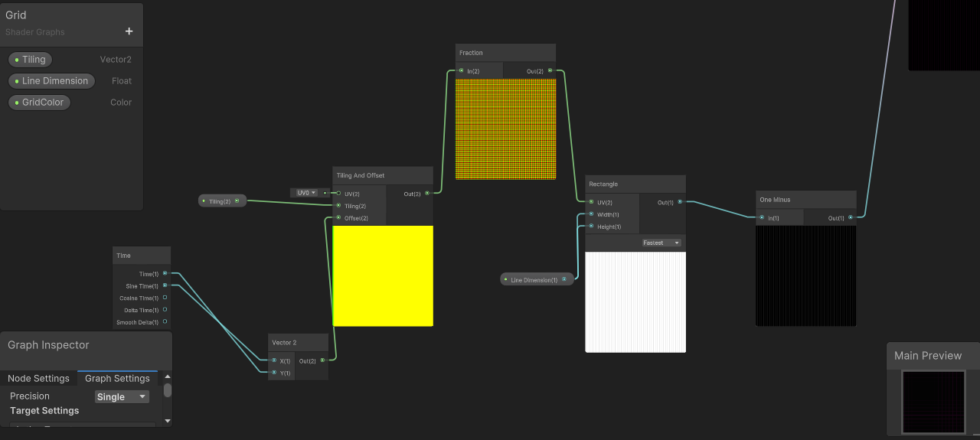

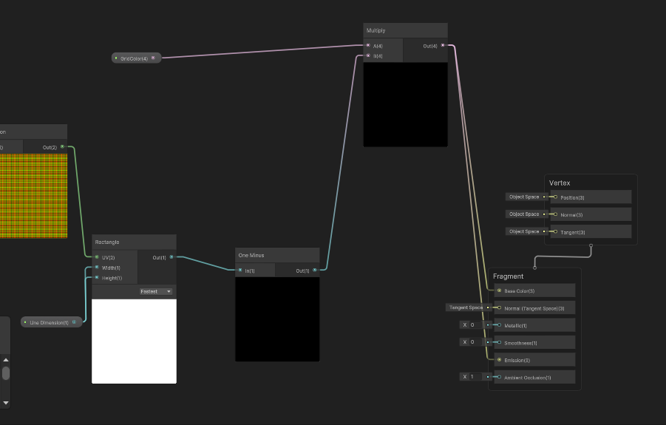

To reach this effect to the fullest, I discovered, as I already mentioned that by applying a cube projection to all the slides, the result was even funnier.

Audio

The audio was never a priority for me. I did not have previous knowledge about audio production, and although I’m always saying the same thing, it’s true – I DID NOT HAVE THE TIME TO LEARN SUCH A FRESH-NEW TOPIC WITH THIS DIMENSION! Also – I did not want to use some random free sounds on the Internet just to show the teachers that “yes, audio is also present in this game, now give me a good grade”. I wanted something mine. So I started brainstorming.

My goal was to elaborate on two background audios, one for the main menu, and the other for the level itself.

For the level, I wanted something more hilarious-like, a little bit repetitive and irritating so that it could trigger and deconcentrate the player, but also something accelerated that could give some fast-pacing and action. I recorded a melody with my voice and started editing it on Audacity. I started by accelerating it and changing the tone and depth, and then I made some adjustments and loops. After this, I added as a background only one free audio that I found on the Internet – called Techno Fights by Alejandro Maganã, and changed also its velocity as well.

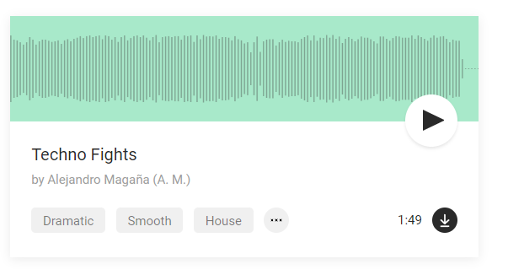

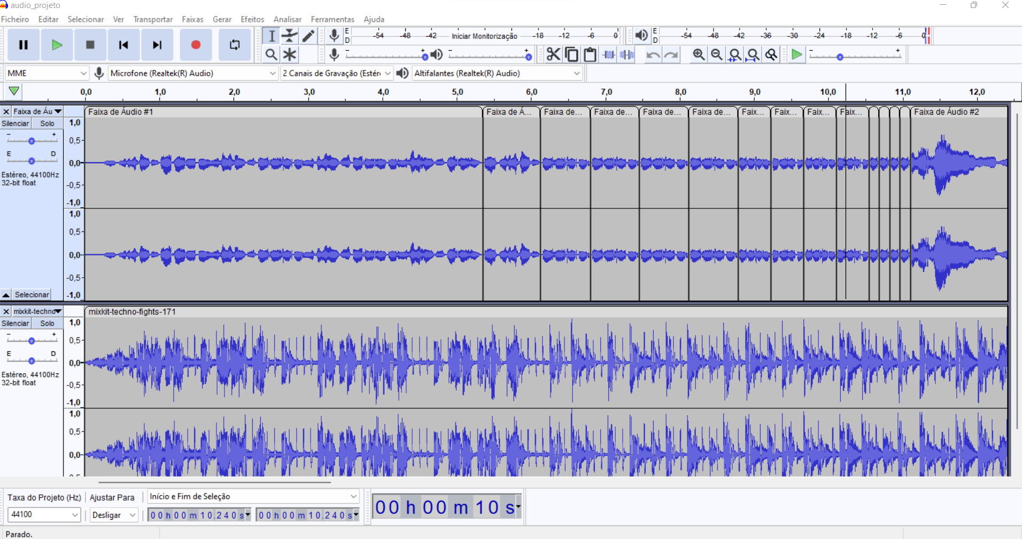

For the main menu background music, I wanted exactly the opposite – something calm, but somehow creepy. As to spoil the player that something is or can go wrong. Again, I recorded multiple audios at 2 AM while I could not sleep with my sweet lyrical voice. I then conjugated three different sounds: a main one, with a peaceful melody that seems like a lullaby (remember, the protagonist takes pills to go to sleep! It’s related and not a coincidence), followed by a regular background sound, just to add a bit of rhythm (because of the fast-paced game that the user will play). I also recorded a sound that I immensely slowed down to add the creepy-psychotic idea.

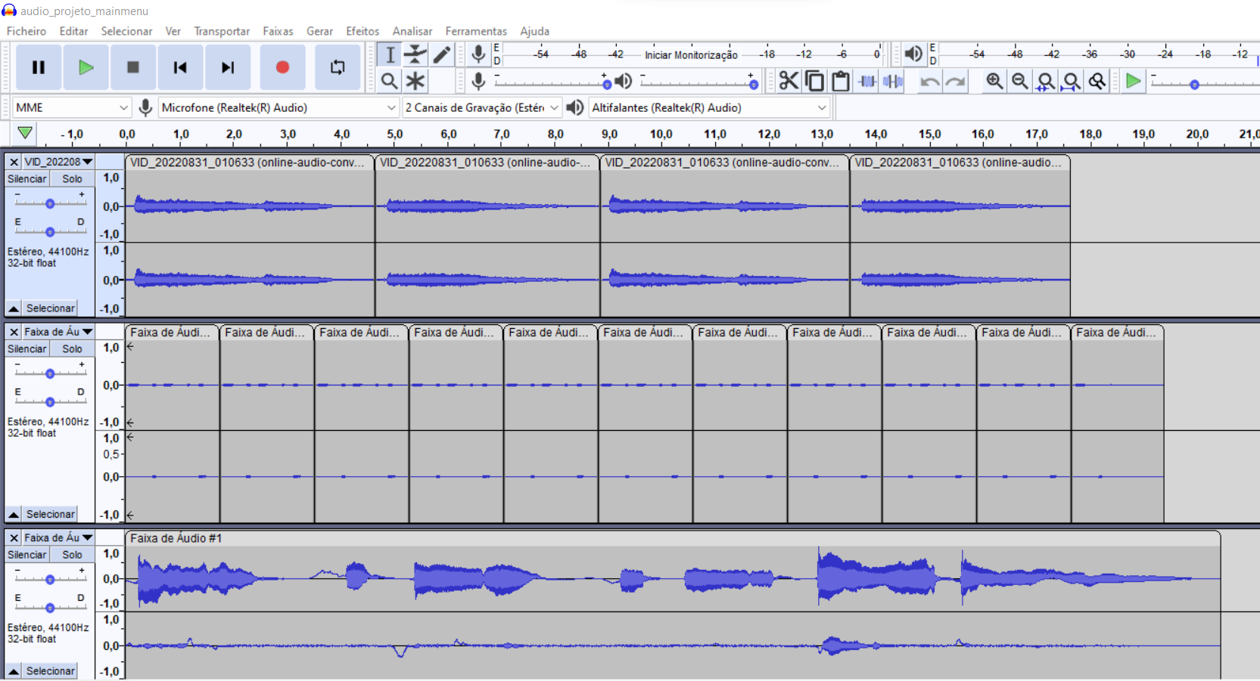

I also reflected on making more sounds, such as when the character dies, when he falls down, when he dashes, or even when he collects a gummy or collides with an obstacle with a non-identical colour. But then I realized that it would cut the main goal of the level audio background – to immerse the player into the game’s atmosphere, to give a psychotic vibe, that something is wrong but that you can be playful about it. And, of course, to distract the player. So, I dropped this idea and considered only making these if I had time to make them. Also, and because of the already explained reason, I did not add a configuration audio option so that the player can turn off the sound (they can always turn off the computer’s sound, but that is something completely ahead of me).

User testing

To test the first build of the game, a survey form was made keeping in mind that it would be delivered to a group of five people – since, according to Nielsen, five users is typically enough to identify the design's most important usability problems.

The questions were based on the heuristics discussed by Hochleitner and his colleagues in 2015 when they ended up defining 49 heuristics, divided into 12 categories about game play, game story, and visual interface.

In total, 16 heuristics were chosen based on what the game offers to the players and supposing that the tester’s opinion would be favourable.

